Product information 48/2016

BMW 4 Series F32/F33/36

BMW 3 Series F30 Sedan, type 3K / F31 Touring, Type 3K, from 2015
340i LCI 3.0l 240/265 kW; 340i xDrive LCI 3.0l 240/265 kW

BMW 4 Series F32 Coupe / F33 Cabrio / F36 Gran Coupe, from 2016
440i 3.0l 240/265 kW; 440i xDrive 3.0l 240/265 kW
REMUS Cat-back-system
- 100% stainless steel
- Powerful sound
- Performance and torque increase
- EEC homologation
+ 6,9 HP
+ 10,3 Nm

BMW 340i F30/31, 240 kW

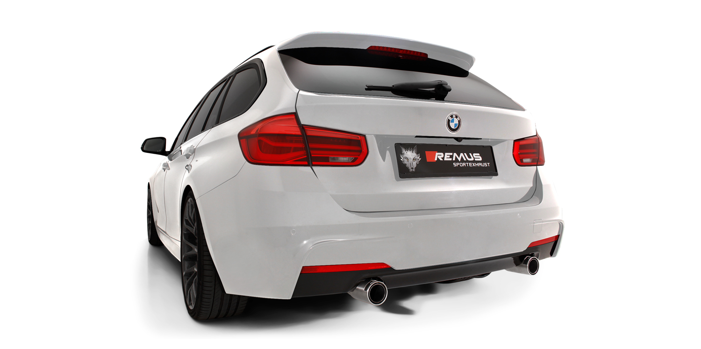

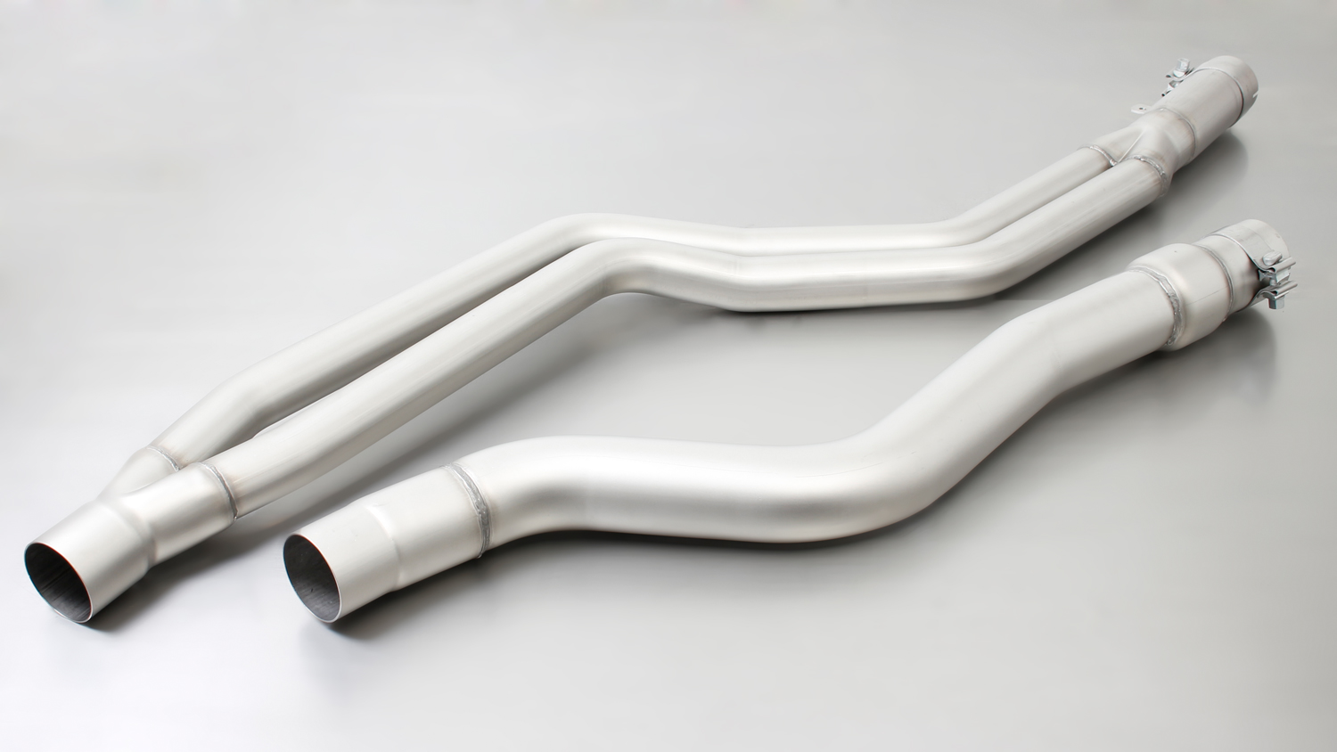
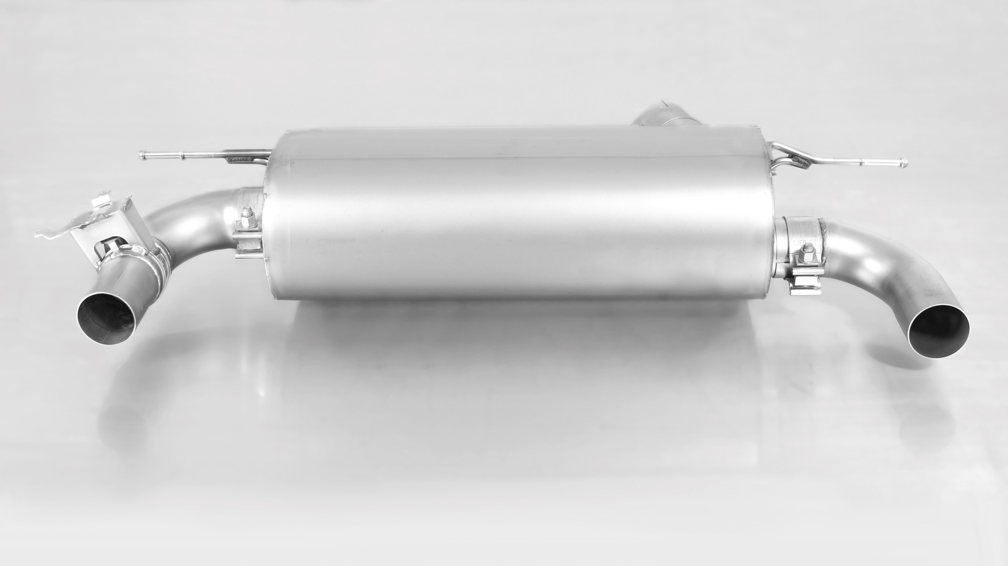
088015 0300

088015 1500

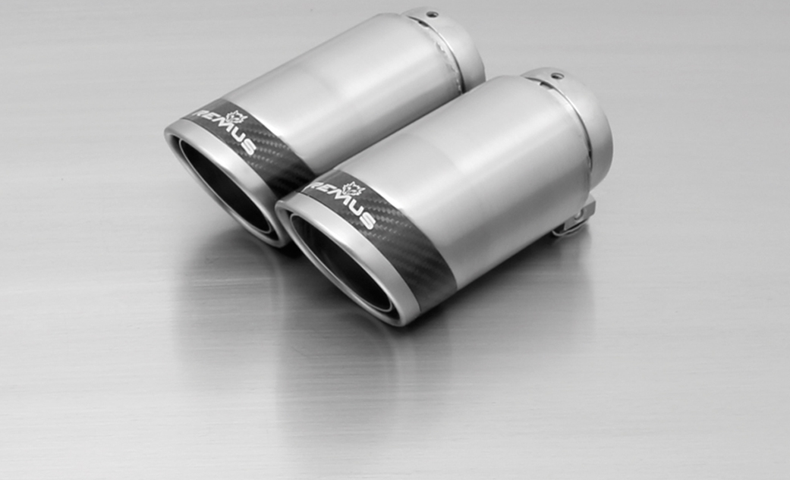
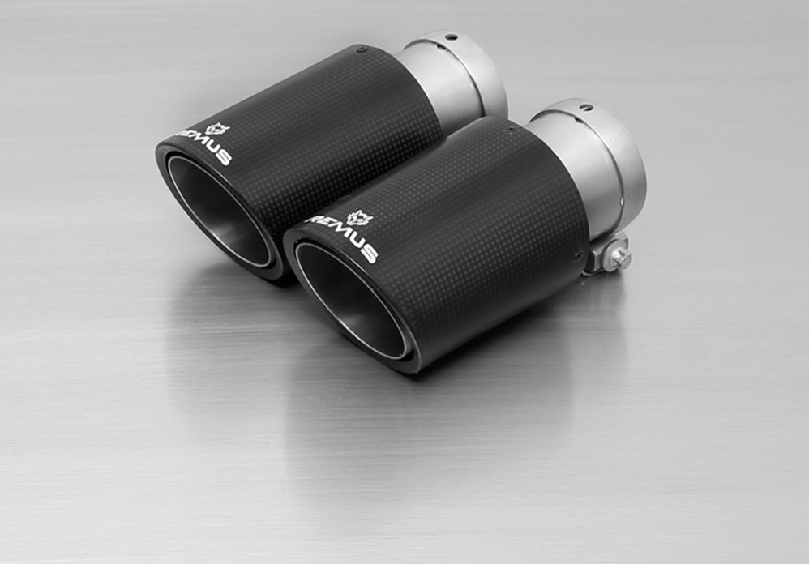
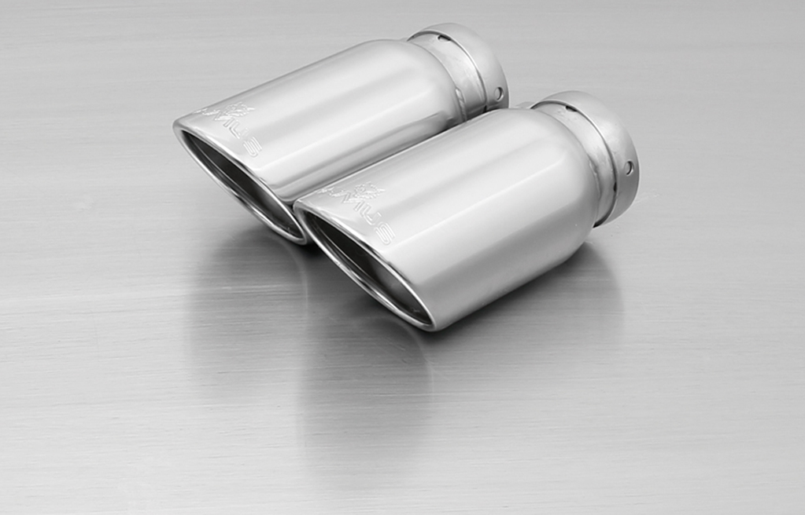
#83CS: tail pipe Ø 84 mm Carbon Race, angled, polished

#83CTS: Carbon-tail pipes Ø 84 mm angled, Titanium internals

#55S: tail pipes Ø 84 mm
angled, chromed

#83CB: tail pipes Ø 84 mm
Street Race Black Chrome

#83C: tail pipes Ø 84 mm
Street Race, polished
#05: tail pipes Ø 90 mm
chromed

Car and engine specification
BMW 3er F30 Sedan, type 3K / F31 Touring, type 3K, 2015=>
340i LCI 3.0l 240/265 kW; 340i xDrive LCI 3.0l 240/265 kW
BMW 4er F32 Coupe / F33 Cabrio / F36 Gran Coupe, 2015=>
440i 3.0l 240/265 kW; 440i xDrive 3.0l 240/265 kW
Part no. | Description | € RRP price excl. VAT
088015 1100 | Stainless steel RACING downpipe with sport catalytic convertor (200 CPSI), without homologation  Only suitable for:  BMW 3 Series340i(x) F30/F31 from 2015  BMW 4 Series 440i(x) F32/F33/F36 from 4/2015 | 1.050,--
088015 0300 | Stainless steel resonated cat-back section, incl. EC homologation | 562,--
088015 1500 | Stainless steel sport exhaust centered for L/R system (without tail pipes),  with integrated valves, incl. EC homologation  The activation of the valve is carried out using the original actuator via the vehicle onboard electronics. | 625,--
choose from following tail pipe package:
0026 55S | Stainless steel tail pipe set 2 tail pipes Ø 84 mm angled, rolled edge, chromed, with adjustable spherical clamp connection | 160,--
0026 05 | Stainless steel tail pipe set 2 tail pipes Ø 90 mm straight, rolled edge, chromed, with adjustable spherical clamp connection | 160,--
0026 83C | Stainless steel tail pipe set 2 tail pipes Ø 84 mm Street Race, straight, carbon insert, with adjustable spherical clamp connection | 196,--
0026 83CS | Stainless steel tail pipe set 2 tail pipes Ø 84 mm Carbon Race, angled, carbon ring, with adjustable spherical clamp connection | 204,--
0026 83CB | Stainless steel tail pipe set 2 tail pipes Ø 84 mm Street Race Black Chrome, straight, carbon insert, with adjustable spherical clamp connection | 220,--
0026 83CTS | Carbon tail pipe set 2 tail pipes Ø 84 mm angled, Titanium internals, with adjustable spherical clamp connection | 390,--
INFOBOX:
- Axle-back-system L/R: 088015 1500 + tail pipe set! The original exhaust must be cut! No rear skirt modifications required! Suitable for standard bumper and M sport option!
- Cat-back-system L/R: 088015 0300 + 088015 1500 + tail pipe set! No vehicle modifications required! Suitable for standard bumper and M sport option!
- Turbo-back-system L/R: 088015 1100 (Racing) + 088015 0300 + 088015 1500 + tail pipe set! No vehicle modifications required! Suitable for standard bumper and M sport option!
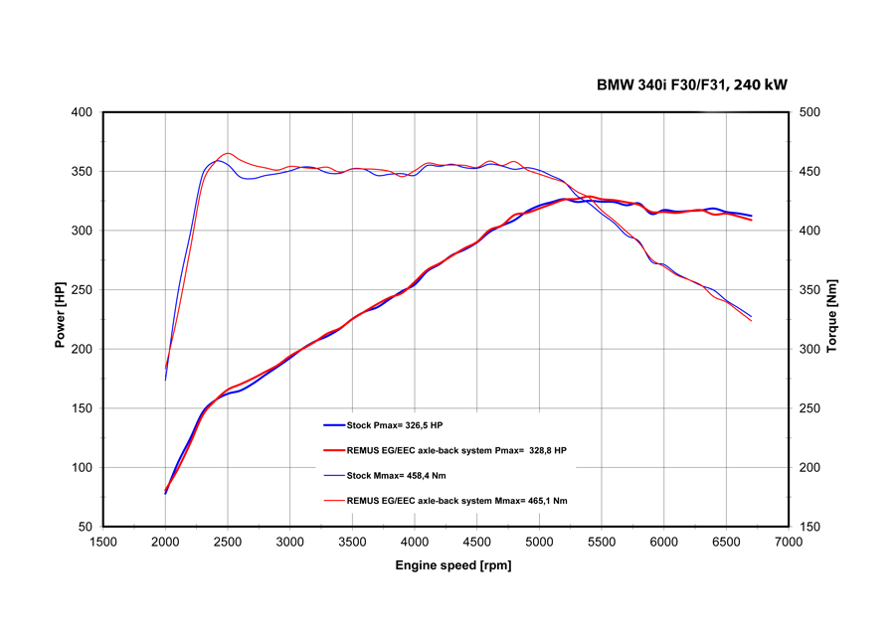
Cat-back: 088015 0300 + 088015 1500
+ tail pipe set

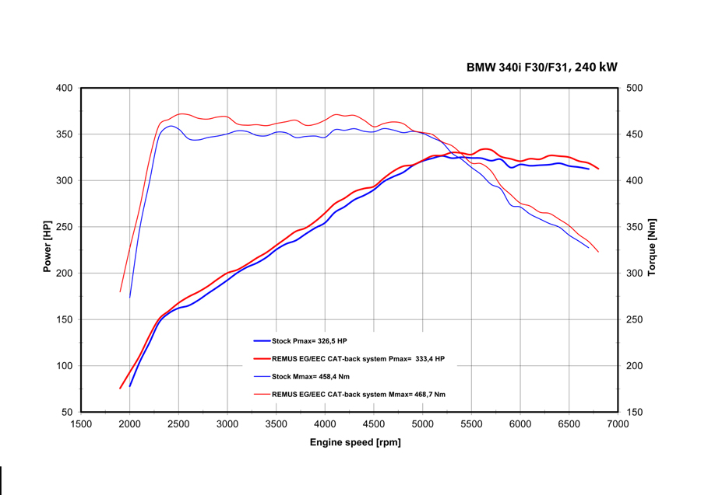
Axle-back-system: 088015 1500 + tail pipe set

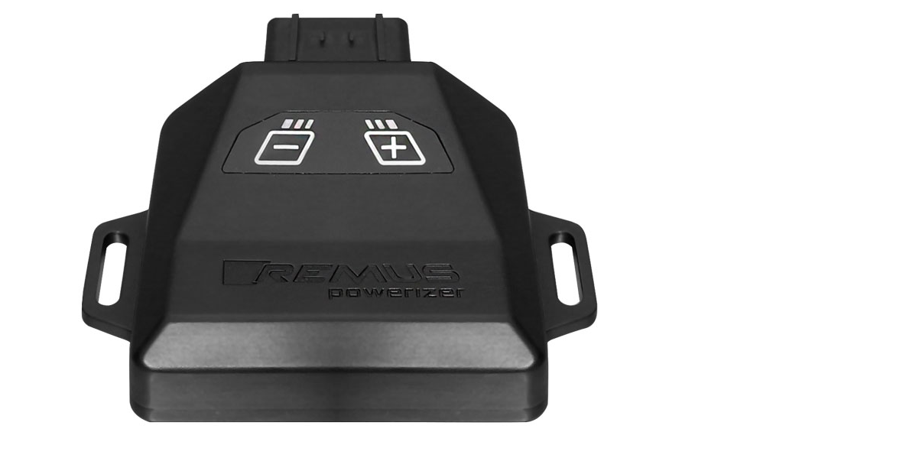
REMUS Powerizer
More power, more economy and more fun!
The electronics of the REMUS Powerizer enhances in real time
the engine management parameters. The engine mapping
is optimized in excess of 1000 times per second and ensures for a
considerable and noticeable power increase. The engine safety parameters and management remains totally original to ensure that individual engine components are not overstrained. Furthermore, the original mapping software remains totally untouched.
Due to the plug & play concept, the REMUS Powerizer is simple to install and can be easily removed or decommissioned using the supplied blind connector. Due to the torque increase, the engine has more power at lower RPM which leads to a reduction in fuel consumption. The power increase of the engine can be fine-tuned by means of seven preset levels. The REMUS Powerizer is available for over 3000 petrol and diesel powered cars.

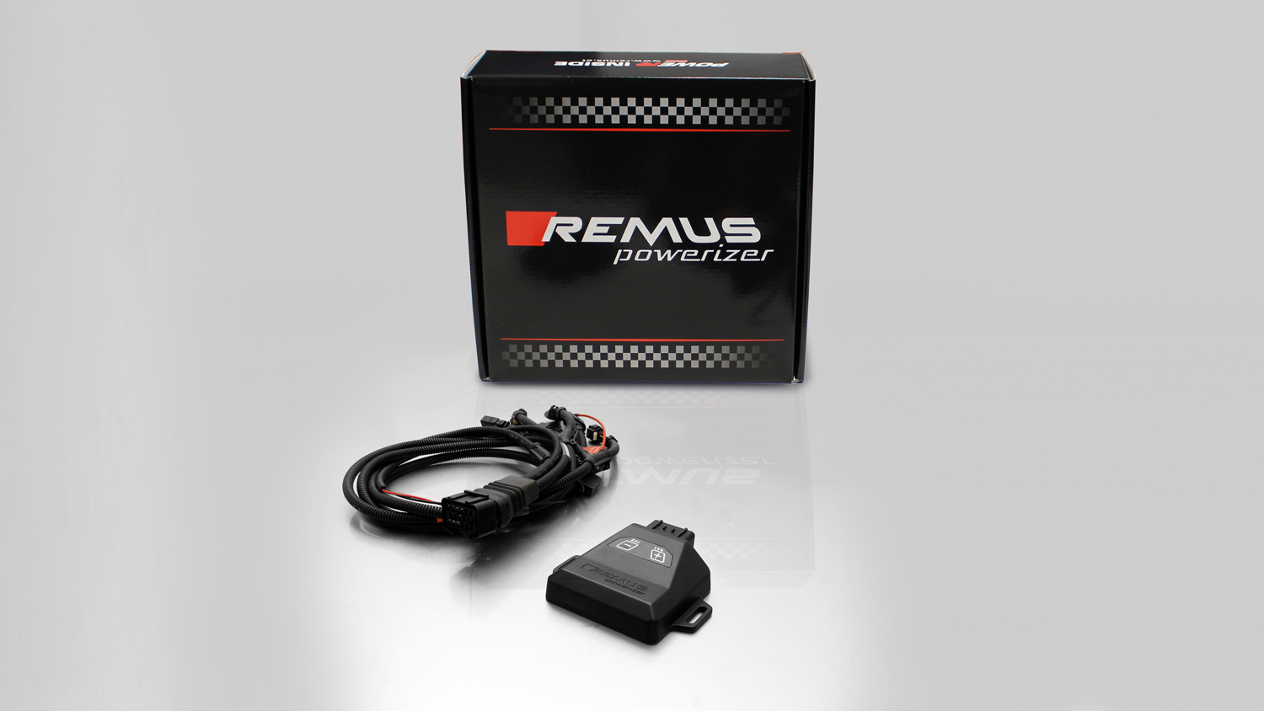

- Up to 25% more power
- Up to 20% more torque
- Easy installation and removal (plug & play)
- Up to 1l/100 km fuel saving
- No modifications on the ECU
- 7 preset power levels

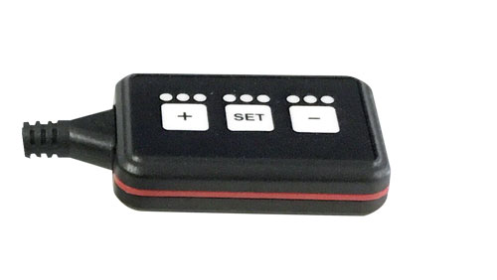
REMUS Responder

Improved throttle response, more dynamic!

Der REMUS ResponderThe REMUS Responder improves throttle response by means
of modifying the accelerator pedal output signal.

No more throttle delay and reduced lag during automatic shifting makes driving
with the REMUS Responder more fun. The Responder attaches between the
OEM pedal sensor and the OEM connector, ready to use in seconds due to plug & play technology.

Sophisticated adjustable programming profiles can lead to improved fuel consumption and
more efficiency. The four individual user selectable and adjustable performance settings
allow drivers to select according to their own preferences. The REMUS Responder totally eliminates the delay in modern electronic accelerator pedals!

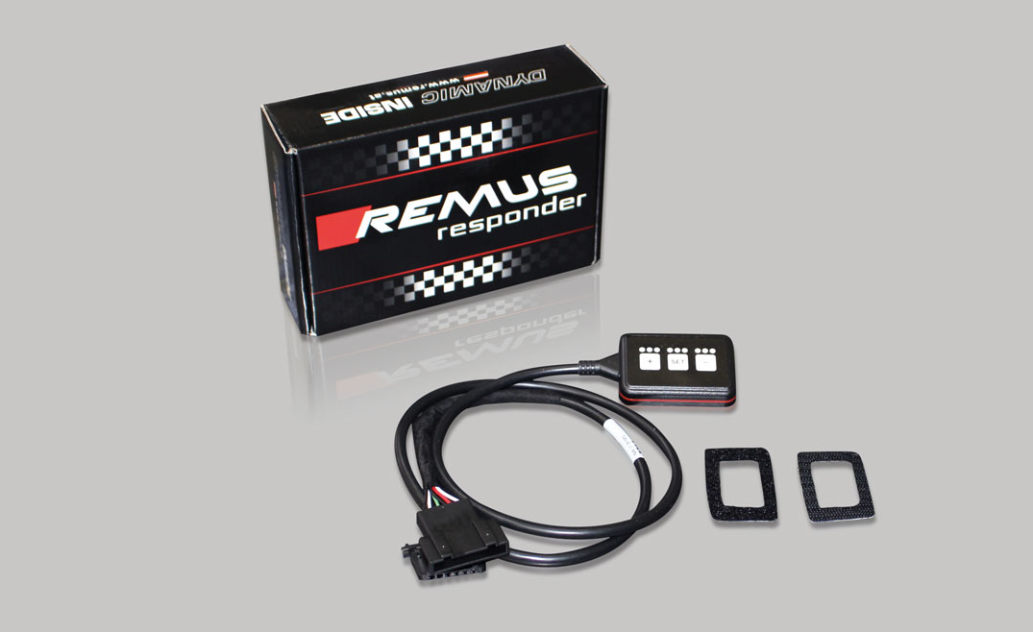

- Improved throttle response, reduced lag during gear changes
- Quicker reaction times, more dynamic without changing engine parameters
- 4 individual user selectable and adjustable performance settings
- Vehicle specific programming using OEM quality connectors
- Simple plug & play installation and easily removed without leaving traces

