Product information 45/2016

AUDI RS6, RS7

S6 C7 Avant, type 4G, from 02/2013 - 4.0l V8 412 kW
RS7 Sportback, type 4G, from 08/2013 - 4.0l V8 412 kW
REMUS Cat-back-system
- 100% stainless steel
- Powerful sound
- Performance and torque increase
- Light weight construction

+ 3,7 HP
+ 9,7 Nm

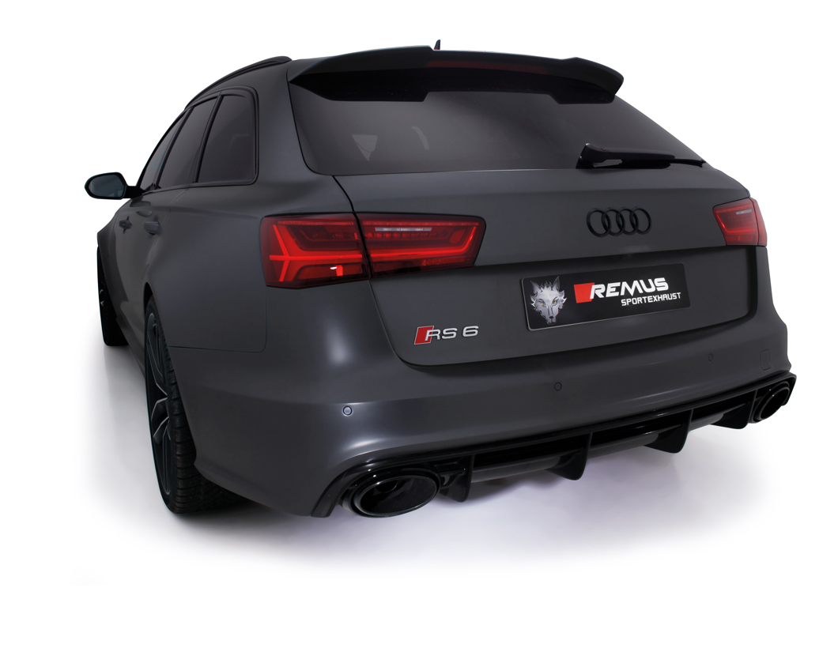

Car and engine specification
AUDI RS6 C7 Avant, type 4G, 02/2013=>
4.0l V8 412 kW
AUDI RS7 Sportback, type 4G, 08/2013=>
4.0l V8 412 kW
Part no. | Description | € RRP price excl. VAT
048015 0000 | Stainless steel RACING cat-back tube instead of original front silencer section, without homologation  Original tube Ø 60 mm, REMUS tube Ø 65 mm | 390,--
048015 0400 | Stainless steel resonated center section, from original front silencer section back, incl. EC homologation  Original tube Ø 60 mm, REMUS tube Ø 65 mm | 680,--
048015 0500LR | Stainless steel sport exhausts left and right, fits within the original exhaust outlets, with integrated valves, incl. EC homologation  Original tube Ø 60 mm, REMUS tube Ø 65 mm  The supplied actuators activate the valves to factory preset positions via the vehicle onboard electronics | 1.850,--
INFOBOX:
- Axle-back-system: 048015 0500LR. The original exhaust must be cut!
- Axle-back-system, from original front silencer section back: 048015 0400 + 048015 0500LR! No cutting of the original exhaust system required!
- Cat-back-system: 048015 0000 (Racing) + 048015 0400 + 048015 0500LR! No cutting of the original exhaust system required!
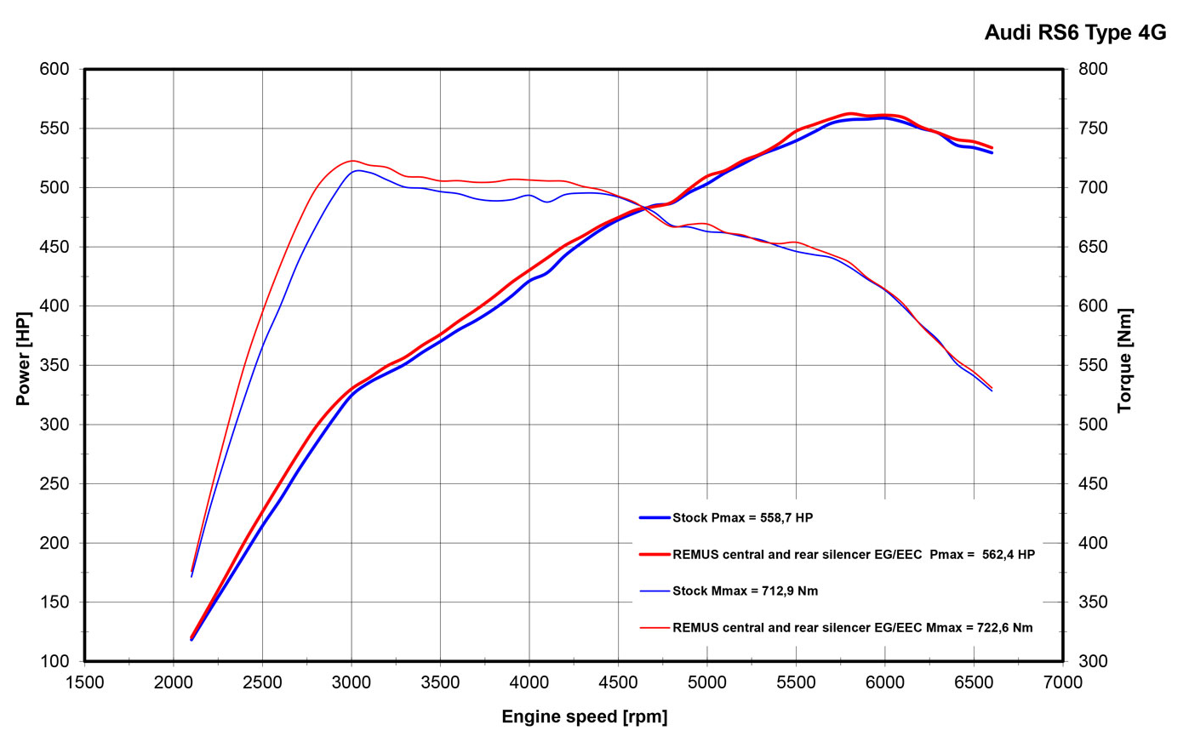

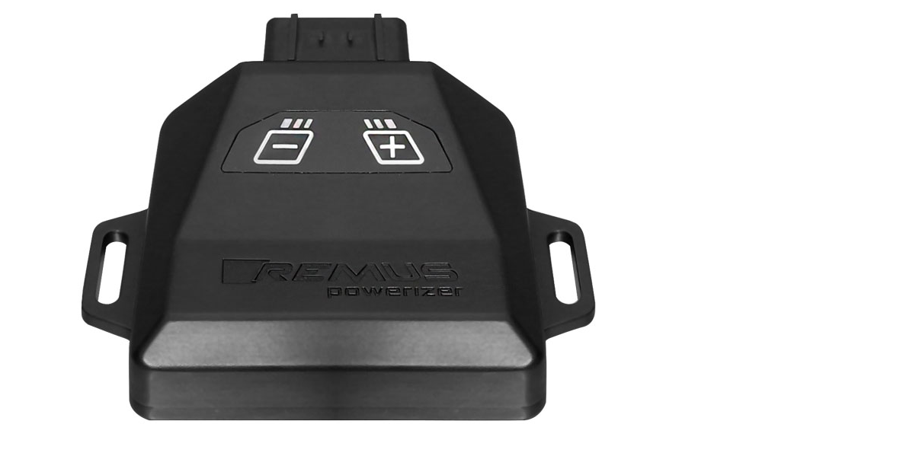
REMUS Powerizer
More power, more economy and more fun!
The electronics of the REMUS Powerizer enhances in real time
the engine management parameters. The engine mapping
is optimized in excess of 1000 times per second and ensures for a
considerable and noticeable power increase. The engine safety parameters and management remains totally original to ensure that individual engine components are not overstrained. Furthermore, the original mapping software remains totally untouched.
Due to the plug & play concept, the REMUS Powerizer is simple to install and can be easily removed or decommissioned using the supplied blind connector. Due to the torque increase, the engine has more power at lower RPM which leads to a reduction in fuel consumption. The power increase of the engine can be fine-tuned by means of seven preset levels. The REMUS Powerizer is available for over 3000 petrol and diesel powered cars.

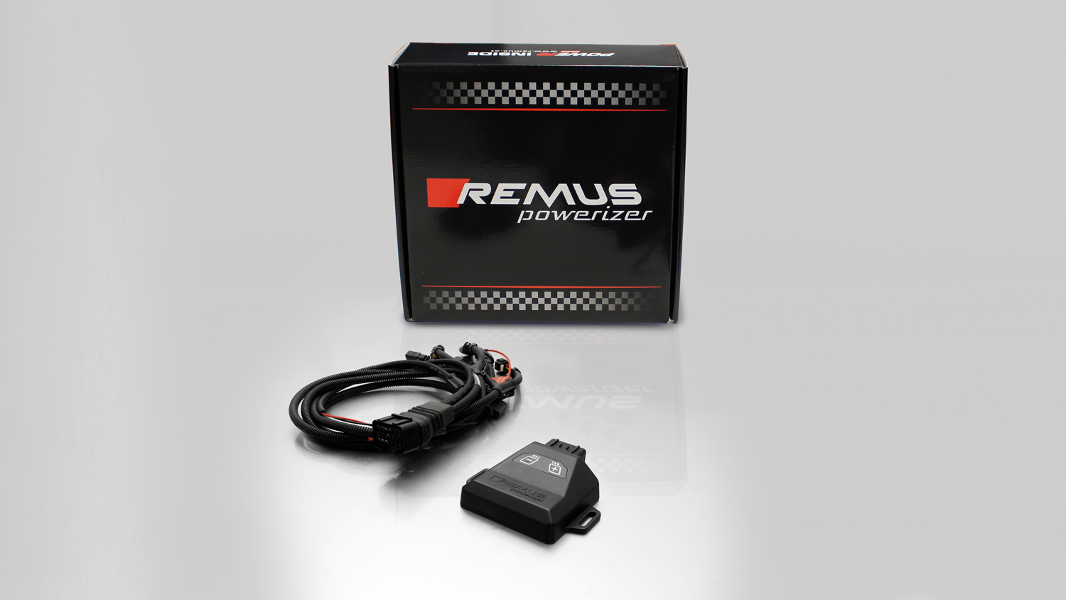

- Up to 25% more power
- Up to 20% more torque
- Easy installation and removal (plug & play)
- Up to 1l/100 km fuel saving
- No modifications on the ECU
- 7 preset power levels

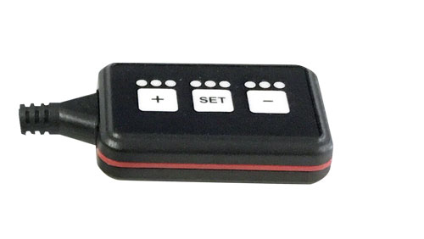
REMUS Responder

Improved throttle response, more dynamic!

Der REMUS ResponderThe REMUS Responder improves throttle response by means
of modifying the accelerator pedal output signal.

No more throttle delay and reduced lag during automatic shifting makes driving
with the REMUS Responder more fun. The Responder attaches between the
OEM pedal sensor and the OEM connector, ready to use in seconds due to plug & play technology.

Sophisticated adjustable programming profiles can lead to improved fuel consumption and
more efficiency. The four individual user selectable and adjustable performance settings
allow drivers to select according to their own preferences. The REMUS Responder totally eliminates the delay in modern electronic accelerator pedals!

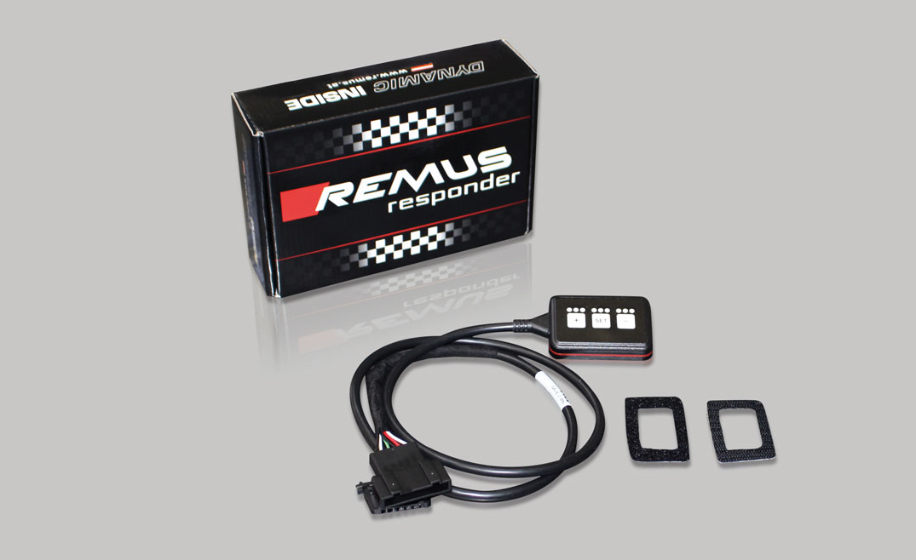

- Improved throttle response, reduced lag during gear changes
- Quicker reaction times, more dynamic without changing engine parameters
- 4 individual user selectable and adjustable performance settings
- Vehicle specific programming using OEM quality connectors
- Simple plug & play installation and easily removed without leaving traces

