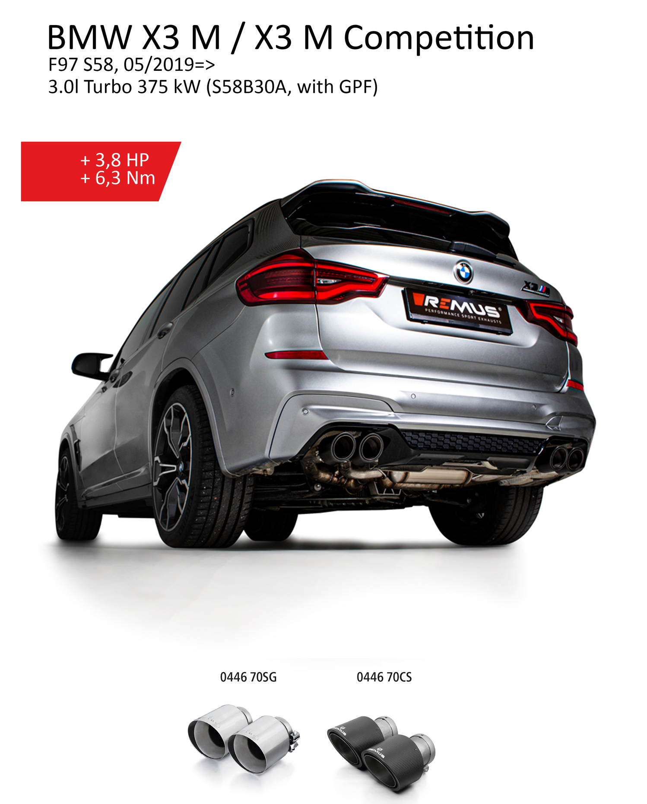
Product information 04/2020

Car and engine specification
BMW X3 M Competition F97 S58, 05/2019=>
3.0l Turbo 375 kW (S58B30A, with GPF)
BMW X3 M F97 S58, 05/2019=>
3.0l Turbo 353 kW (S58B30A, with GPF)
INFOBOX:
- Axle-back-system L/R: 086219 6000 + 086219 1500 (No EC type approval for 3.0l Turbo 353 kW) or 086319 1500 (No EC type approval) + tail pipe set! The original exhaust will need to be cut! No rear skirt modifications required!
- RACING cat-back-system L/R: 086219 1000 (No EC type approval) + 086219 6000 + 086219 1500 (No EC type approval for 3.0l Turbo 353 kW) or 086319 1500 (No EC type approval) + tail pipe set! No cutting modifications required!
- The use of racing products and products which do not have EC approval is generally not permitted on public roads.
- When installing REMUS axle-back and cat-back or catalyst delete tubes on vehicles which are used for closed road driving, it is advisable to tune the ECU for a maximum gain in performance and to ensure that the CEL does not come on.
Part no. | Description | € RRP price excl. VAT
086219 1000 | Non-resonated RACING Cat-back-section (GPF replacement section)  Original tube Ø 70 mm - REMUS tube Ø 70 mm  No EC type approval | 394,--
086219 6000 | Set of connection tubes for mounting the L/R sport exhaust | 269,--
086219 1500 | Sport exhaust, L/R (without tail pipes),  with 2 integrated valves,  incl. EC type approval for Competition 3.0l Turbo 375 kW - No EC type approval for 3.0l Turbo 353 kW!  Original tube Ø 70 mm - REMUS tube Ø 70 mm  The activation of the valves is carried out using the original actuators via the vehicle onboard electronics. | 2.190,--
086319 1500 | RACING sport exhaust, L/R (without tail pipes),  with 2 integrated valves,  No EC type approval  Original tube Ø 70 mm - REMUS tube Ø 70 mm  The activation of the valves is carried out using the original actuators via the vehicle onboard electronics. | 1.990,--
Choose from following tail pipe package:
0446 70SG | Stainless steel tail pipe set 4 tail pipes Ø 102 mm angled (shorter length 145 mm), straight cut, chromed, with adjustable spherical clamp connection | 308,--
0446 70CS | Carbon tail pipe set 4 tail pipes Ø 102 mm angled (shorter length 145 mm), Titanium internals, with adjustable spherical clamp connection | 876,--

