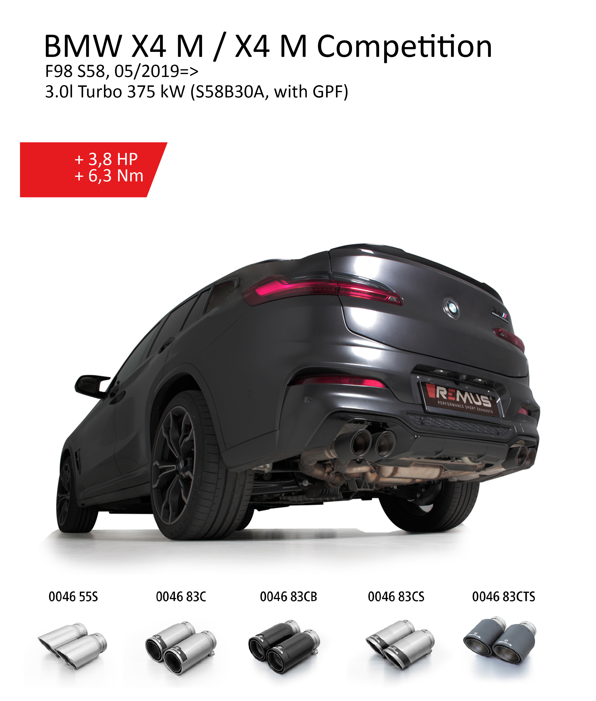
Product information 02/2020

Car and engine specification
BMW X4 M Competition F98 S58, 05/2019=>
3.0l Turbo 375 kW (S58B30A, with GPF)
BMW X4 M F98 S58, 05/2019=>
3.0l Turbo 353 kW (S58B30A, with GPF)
INFOBOX:
- Axle-back-system L/R: 086219 6000 + 086219 1500 (No EC type approval for 3.0l Turbo 353 kW) or 086319 1500 (No EC type approval) + tail pipe set! The original exhaust will need to be cut! No rear skirt modifications required!
- RACING cat-back-system L/R: 086219 1000 (No EC type approval) + 086219 6000 + 086219 1500 (No EC type approval for 3.0l Turbo 353 kW) or 086319 1500 (No EC type approval) + tail pipe set! No cutting modifications required!
- The use of racing products and products which do not have EC approval is generally not permitted on public roads.
- When installing REMUS axle-back and cat-back or catalyst delete tubes on vehicles which are used for closed road driving, it is advisable to tune the ECU for a maximum gain in performance and to ensure that the CEL does not come on.

Part no. | Description | € RRP price excl. VAT
086219 1000 | Non-resonated RACING Cat-back-section (GPF replacement section)  Original tube Ø 70 mm - REMUS tube Ø 70 mm  No EC type approval | 394,--
086219 6000 | Set of connection tubes for mounting the L/R sport exhaust | 269,--
086219 1500 | Sport exhaust, L/R (without tail pipes),  with 2 integrated valves,  incl. EC type approval for Competition 3.0l Turbo 375 kW - No EC type approval for 3.0l Turbo 353 kW!  Original tube Ø 70 mm - REMUS tube Ø 70 mm  The activation of the valves is carried out using the original actuators via the vehicle onboard electronics. | 2.190,--
086319 1500 | RACING sport exhaust, L/R (without tail pipes),  with 2 integrated valves,  No EC type approval  Original tube Ø 70 mm - REMUS tube Ø 70 mm  The activation of the valves is carried out using the original actuators via the vehicle onboard electronics. | 1.990,--
Choose from following tail pipe package:
0046 83C | Stainless steel tail pipe set 4 tail pipes Ø 84 mm Street Race, straight, carbon insert, with adjustable spherical clamp connection | 408,--
0046 83CS | Stainless steel tail pipe set 4 tail pipes Ø 84 mm Carbon Race, angled, carbon ring, with adjustable spherical clamp connection | 424,--
0046 83CB | Stainless steel tail pipe set 4 tail pipes Ø 84 mm Street Race Black Chrome, straight, carbon insert, with adjustable spherical clamp connection | 460,--
0046 83CTS | Carbon tail pipe set 4 tail pipes Ø 84 mm angled, Titanium internals, with adjustable spherical clamp connection | 812,--
0046 55S | Stainless steel tail pipe set 4 tail pipes Ø 84 mm angled, rolled edge, chromed, with adjustable spherical clamp connection | 336,--

