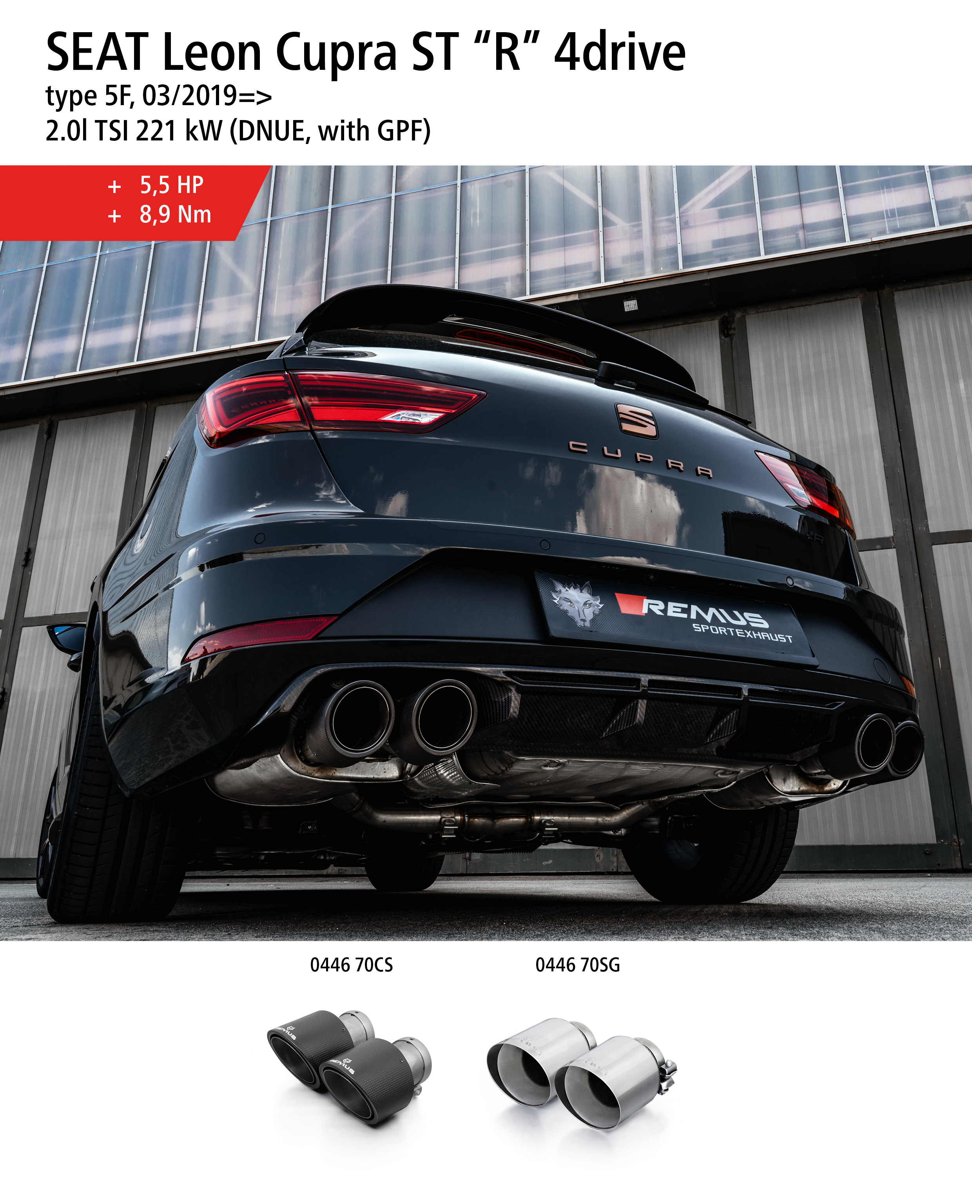
Product information 19/2019

Car and engine specification
SEAT Leon Cupra ST “R” 4drive, type 5F, 03/2019=>
2.0l TSI 221 kW (DNUE, with GPF)
INFOBOX:
- GPF-back-system L/R: 794019 0500LR + tail pipe set! No vehicle modifications required!
Part no. | Description | € RRP price excl. VAT
794019 0500LR | GPF-back-system consisting of  connection tube and sport exhausts left & right (without tail pipes)  incl. EC type approval  Original tube Ø 65 mm - REMUS tube Ø 70 mm | 895,--
Choose from following tail pipe package:
0446 70CS | Carbon tail pipe set 4 tail pipes Ø 102 mm angled (shorter length 145 mm), Titanium internals, with adjustable spherical clamp connection | 876,--
0446 70SG | Stainless steel tail pipe set 4 tail pipes Ø 102 mm angled (shorter length 145 mm), straight cut, chromed, with adjustable spherical clamp connection | 308,--

