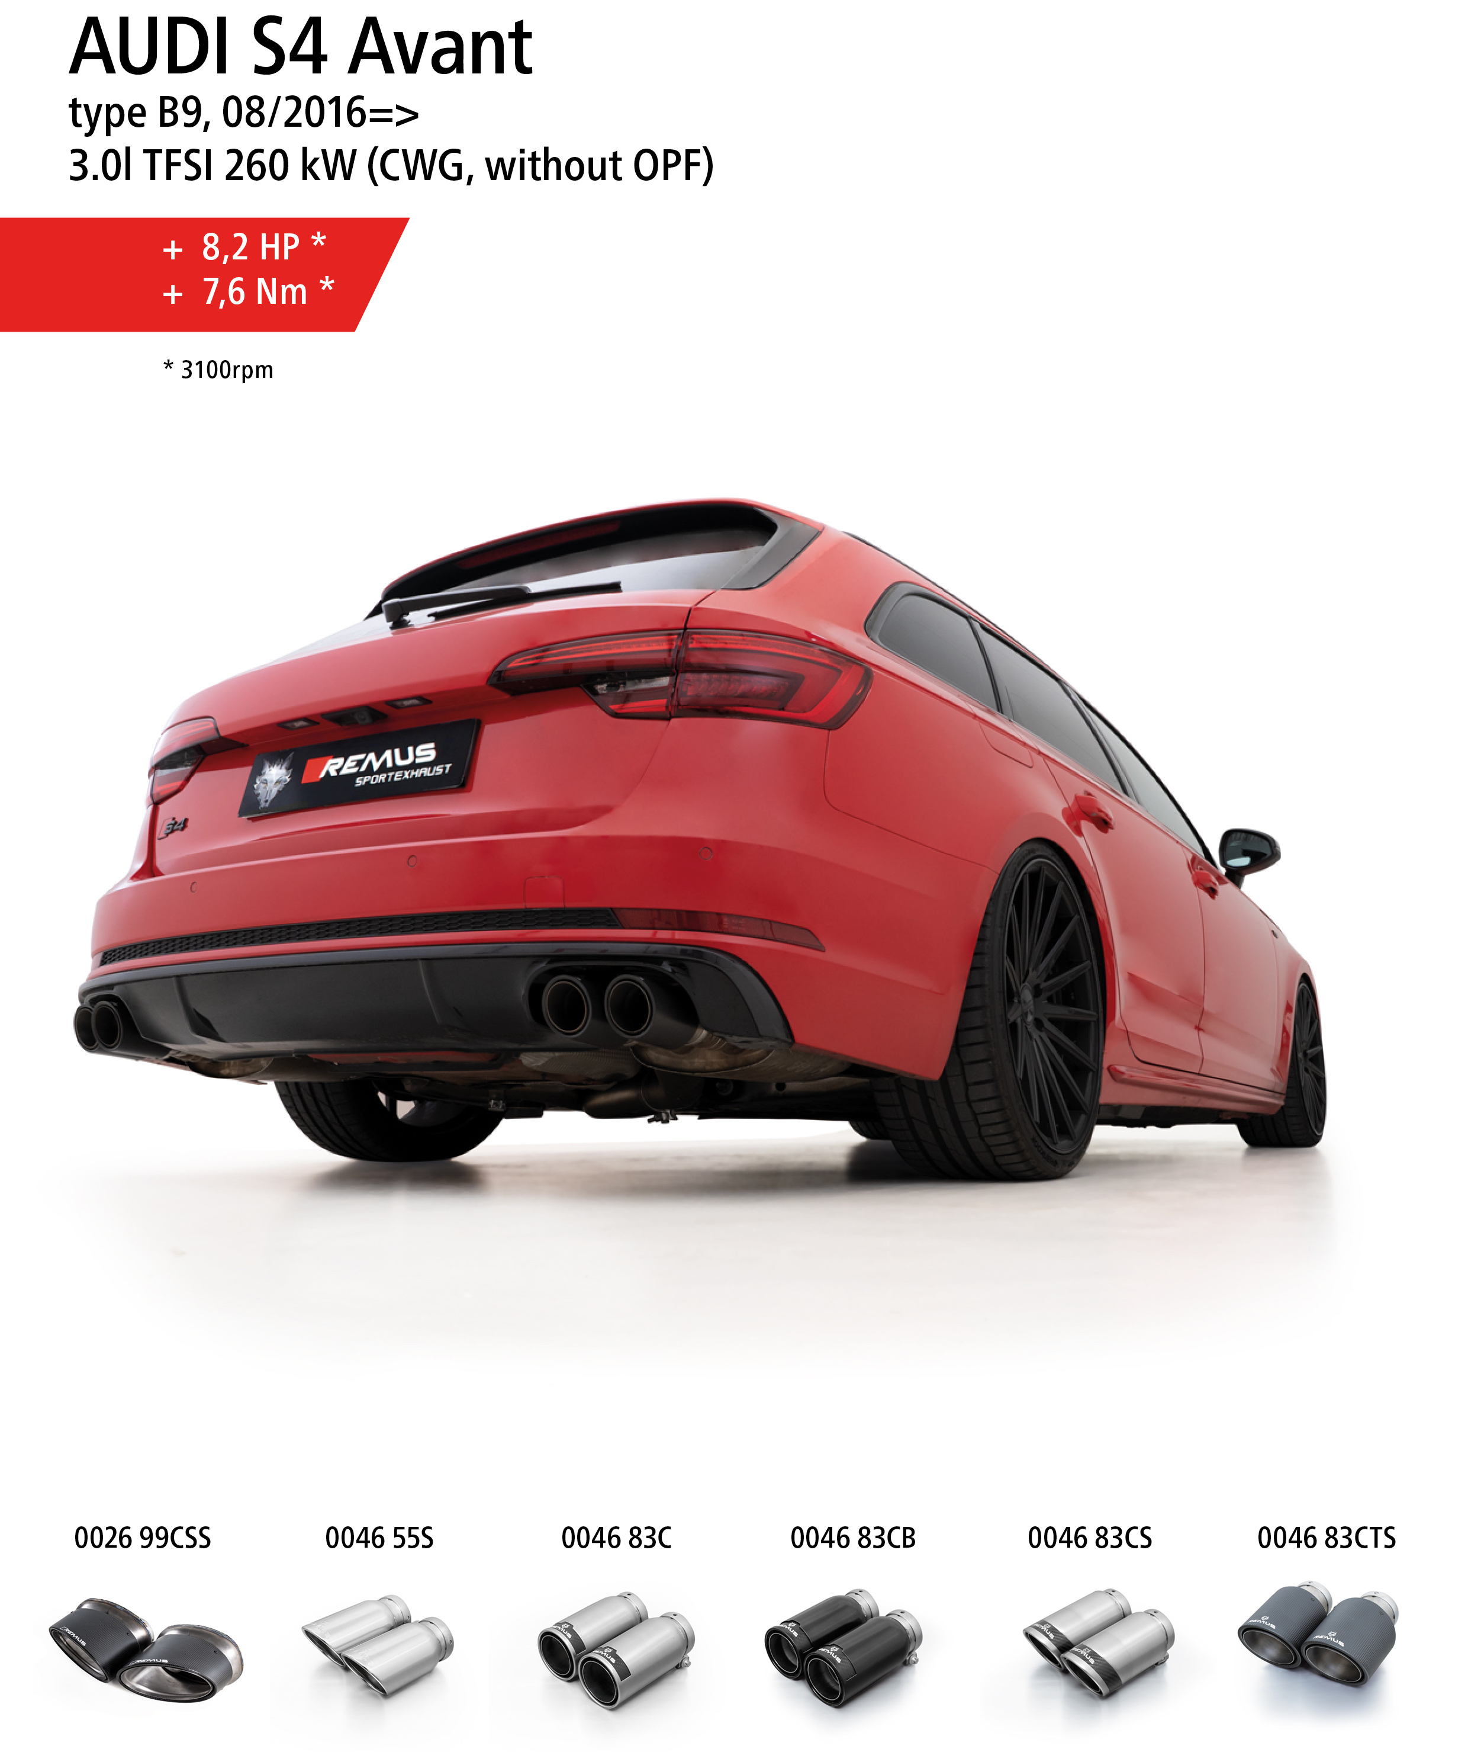
Product information 12/2019

Car and engine specification
AUDI S4 Avant, type B9, 08/2016=>
3.0l TFSI 260 kW (CWG, without GPF)
INFOBOX:
- Axle-back-system (including center-section): 047017 0000 + 045019 0500LR + tail pipe set! No vehicle modifications required!
Part no. | Description | € RRP price excl. VAT
047017 0000 | Non-resonated center section, incl. EC type approval  Original tube Ø 60 mm - REMUS tube Ø 70 mm | 495,00
045019 0500LR | Sport exhaust L/R system (without tail pipes)  with 2 integrated valves, incl. EC type approval  Original tube Ø 60 mm, REMUS tube Ø 70 mm  The activation of the valves is carried out using the vehicle onboard electronics. | 980,00
Choose from following tail pipe package:
0046 55S | Stainless steel tail pipe set 4 tail pipes Ø 84 mm angled, rolled edge, chromed, with adjustable spherical clamp connection | 336,00
0046 83C | Stainless steel tail pipe set 4 tail pipes Ø 84 mm Street Race, straight, carbon insert, with adjustable spherical clamp connection | 408,00
0046 83CS | Stainless steel tail pipe set 4 tail pipes Ø 84 mm Carbon Race, angled, carbon ring, with adjustable spherical clamp connection | 424,00
0046 83CB | Stainless steel tail pipe set 4 tail pipes Ø 84 mm Street Race Black Chrome, straight, carbon insert, with adjustable spherical clamp connection | 460,00
0046 83CTS | Carbon tail pipe set 4 tail pipes Ø 84 mm angled, Titanium internals, with adjustable spherical clamp connection | 812,00
0026 99CSS | Carbon tail pipe set 2 tail pipes 175x108 mm angled/angled, Titanium internals, with adjustable spherical clamp connection | 810,00

