Product information 08/2019

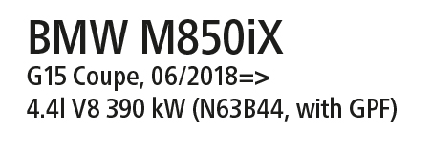

Car and engine specification
BMW M850iX G15 Coupe, 06/2018=>
4.4l V8 390 kW (N63B44, with GPF)
INFOBOX:
- Axle-back-system L/R: 089718 1500 + original exhaust outlets! The original exhaust must be cut! Has to be installed in combination with the original exhaust outlets!
- RACING GPF-back-system L/R (No EC type approval): 089718 0000 (No EC type approval) + 089718 1500 + original exhaust outlets! No vehicle modifications required! Has to be installed in combination with the original exhaust outlets!
- The use of racing products and products which do not have EC approval is generally not permitted on public roads.
- When installing REMUS axle-back and cat-back or catalyst delete tubes on vehicles which are used for closed road driving, it is advisable to tune the ECU for a maximum gain in performance and to ensure that the CEL does not come on..
Part no. | Description | € RRP price excl. VAT
089718 0000 | Non-resonated RACING GPF-back-section (center section replacement pipe)  Original tube Ø 70 mm - REMUS tube Ø 76 mm  No EC type approval | 590,--
089718 1500 | Sport exhaust centered for L/R system (without tail pipes),  with integrated valves, incl. EC type approval  Has to be installed in combination with the original exhaust outlets!  Original tube Ø 70 mm - REMUS tube Ø 76 mm  The activation of the valves is carried out using the original actuators via the vehicle onboard electronics. | 1.590,--

