REMUS Sound Controller (APP compatible) for
Product information 07/2018

- MINI Cooper S F55/F56/F57, MINI John Cooper Works "JCW" F56 / F57, MINI Cooper S Clubman F54
- FORD Mustang Coupe & Cabrio, FORD Mustang GT Coupe & Cabrio
- PEUGEOT 308 GTI
- SKODA Octavia III RS/vRS
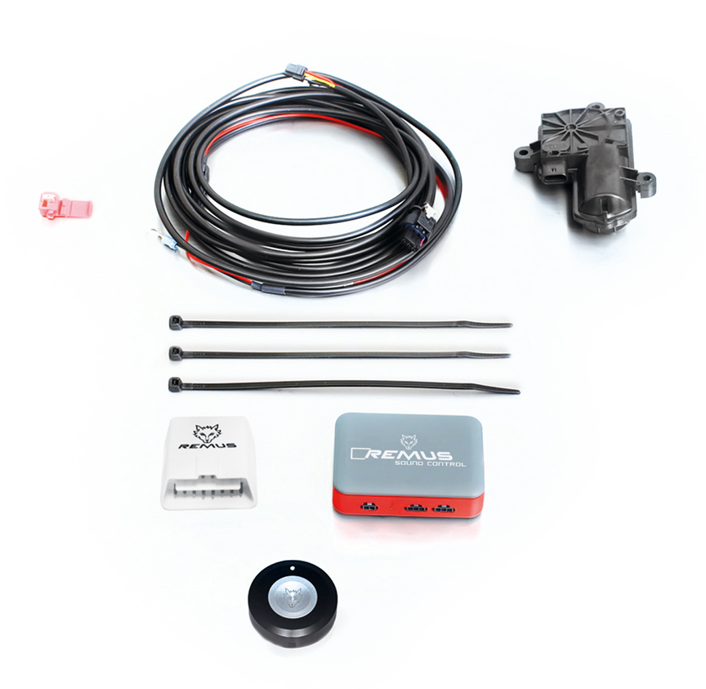
- VW Polo 5 GTI Facelift

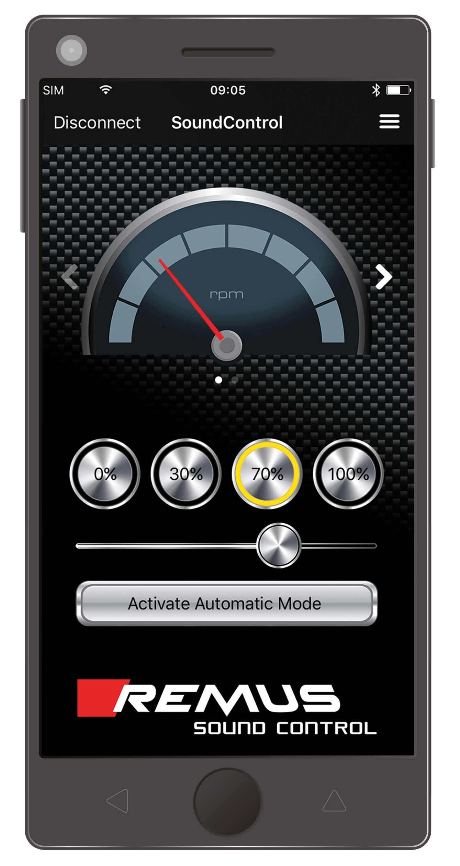

Car and engine specification
MINI Cooper S F55 (5 door), 2014=>
2.0l Turbo 141 kW
MINI Cooper S F56 (3 door), 2014=>
2.0l Turbo 141 kW
MINI Cooper S F57 (Cabrio 3 door), 2015=>
2.0l Turbo 141 kW
MINI John Cooper Works "JCW" F56 (3 door), 2015=>
MINI John Cooper Works "JCW" F57 (Cabrio 3 door), 2015=>
2.0l Turbo 170 kW
INFOBOX:
- STE 0003BT replaces STE 0003 which is only available as long as stock lasts!
- The use of racing products and products which do not have EC approval is generally not permitted on public roads.
Optional: REMUS Sound Controller (APP compatible)
STE 0003BT | The REMUS Sound Controller (APP compatible) consisting of the electronic module, the OBDII plug, the remote control button as well as the electrical actuator including the cables.  No EC type approval | 480,--

Car and engine specification
FORD Mustang Coupe & Cabrio, 2015=>
2.3l EcoBoost Turbo 231 kW
FORD Mustang GT Coupe & Cabrio, 2015=>
5.0l V8 310 kW
INFOBOX:
- STE 0006BT replaces STE 0006 which is only available as long as stock lasts!
- The use of racing products and products which do not have EC approval is generally not permitted on public roads.
Optional: REMUS Sound Controller (APP compatible)
STE 0006BT | The REMUS Sound Controller (APP compatible) consisting of the electronic module, the OBDII plug, the remote control button as well as 2 electrical actuators including the cables.  No EC type approval | 580,--

Car and engine specification
MINI Cooper S Clubman F54 (5 door), 2016=>
2.0l Turbo 141 kW
PEUGEOT 308 GTI, type T9, 2015=>
1.6l Turbo 200 kW
INFOBOX:
- STE 0007BT replaces STE 0007 which is only available as long as stock lasts!
- The use of racing products and products which do not have EC approval is generally not permitted on public roads.
Optional: REMUS Sound Controller (APP compatible)
STE 0007BT | The REMUS Sound Controller (APP compatible) consisting of the electronic module, the OBDII plug, the remote control button as well as the electrical actuator including the cables.  No EC type approval | 480,--

Car and engine specification
SKODA Octavia III RS/vRS sedan & wagon, type 5E, 2013=>
2.0l TSI 162/169 kW
INFOBOX:
- STE 0009BT replaces STE 0009 which is only available as long as stock lasts!
- The use of racing products and products which do not have EC approval is generally not permitted on public roads.
Optional: REMUS Sound Controller (APP compatible)
STE 0009BT | The REMUS Sound Controller (APP compatible) consisting of the electronic module, the OBDII plug, the remote control button as well as 2 electrical actuators including the cables.  No EC type approval | 580,--

Car and engine specification
VW Polo 5 GTI Facelift, type 6R, 2014=>
1.8l TSI 141 kW (DAJ)
INFOBOX:
- STE 0011BT replaces STE 0011 which is only available as long as stock lasts!
- The use of racing products and products which do not have EC approval is generally not permitted on public roads.
Optional: REMUS Sound Controller (APP compatible)
STE 0011BT | The REMUS Sound Controller (APP compatible) consisting of the electronic module, the OBDII plug, the remote control button as well as the electrical actuator including the cables.  No EC type approval | 480,--

