Product information 37/2016

MERCEDES BENZ AMG C63 / C63S

C63/C63S Coupe / Cabrio, type 205, from 2016 - 4.0l V8 350/375 kW
C63/C63S Limousine / T-model, type 205, from 2016 - 4.0l V8 350/375 kW

REMUS cat-back sport exhaust system with integrated valves
- 100% stainless steel
- Powerful sound
- Flap control by series electronics
- EEC homologation
+ 11,3 PS
+ 12,5 Nm

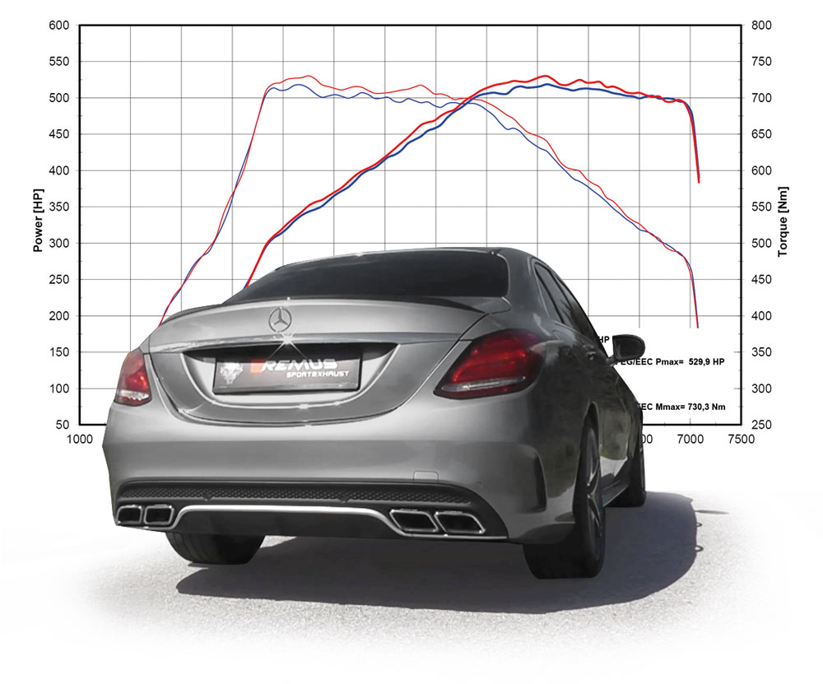

Car and engine specification
MB AMG C63/C63S Coupe & Cabrio with performance exhaust system, type 205, 2016=>
4.0l V8 350/375 kW
MB AMG C63/C63S Limousine & T-model with performance exhaust system, type 205, 2016=>
4.0l V8 350/375 kW
Part no. | Description | € RRP price excl. VAT
509115 0500LR | Stainless steel cat-back system L/R, incl. EEC homologation  Original tube Ø 65 mm, REMUS tube Ø 70 mm | 1.650,--
509115 1600 | Stainless steel outlet pipe bends for AMG C63/C63S Coupe & Cabrio with integrated valves suitable to the tail integrated tailpipes incl. EEC homologation | 640,--
509215 1600 | Stainless steel outlet pipe bends for AMG C63/C63S Limousine & T-model with integrated valves suitable to the tail integrated tailpipes incl. EEC homologation | 640,--
INFOBOX:
- Cat-back-system: 509115 0500LR + 509115 1600 (AMG C63/C63S Coupe & Cabrio) or
509215 1600 (AMG C63/C63S Limousine & T-model)! No cutting of the original exhaust system required!
- The supplied actuators activate the valves to factory preset positions via the vehicle onboard electronics.
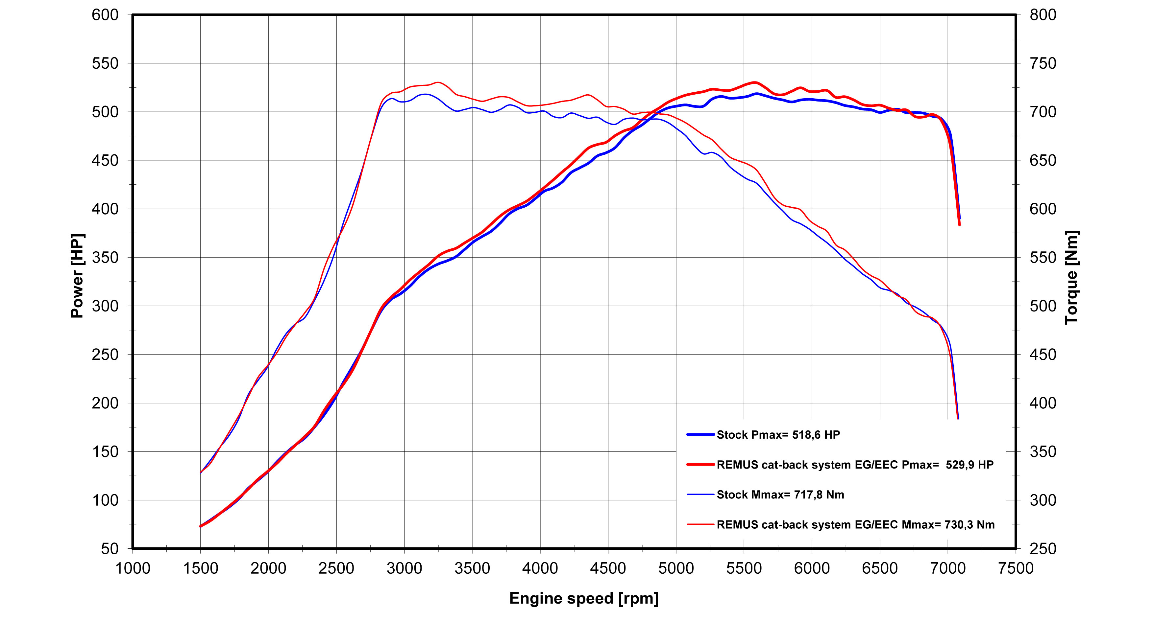

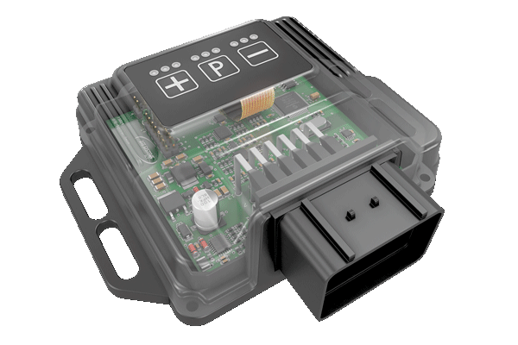
REMUS Powerizer
More power, more economy and more fun!
The electronics of the REMUS Powerizer enhances in real time
the engine management parameter. The engine mapping
is optimized in excess of 1000 times per second and ensures for a
considerable and noticeable power increase. The engine safety parameters and management remains totally original to ensure that individual engine components are not overstrained. Furthermore, the original mapping software remains totally untouched.
Due to the Plug & Play concept, the REMUS Powerizer is simple to install and can be easily removed or decommissioned using the supplied blind connector. Due to the torque increase, the engine has more power at lower RPM which leads to a reduction in fuel consumption. The power increase of the engine can be adjusted according to different driving styles by means of a „maximum power setting“, „eco fuel saving mode“ or a combination of both. The REMUS Powerizer is available for over 3000 petrol and diesel powered cars.

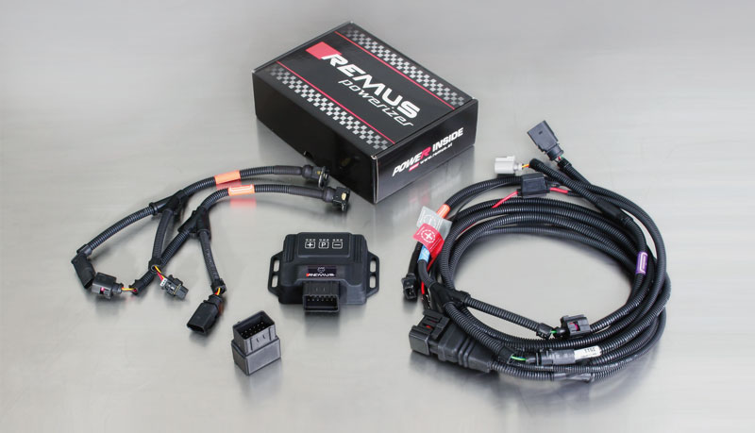

- Up to 25% more power
- Up to 20% more torque
- Easy installation and removal (Plug & Play)
- Up to 1l/100 km fuel saving
- 3 preset programs (RACE/SPORT/ECO) with individual power adjustment

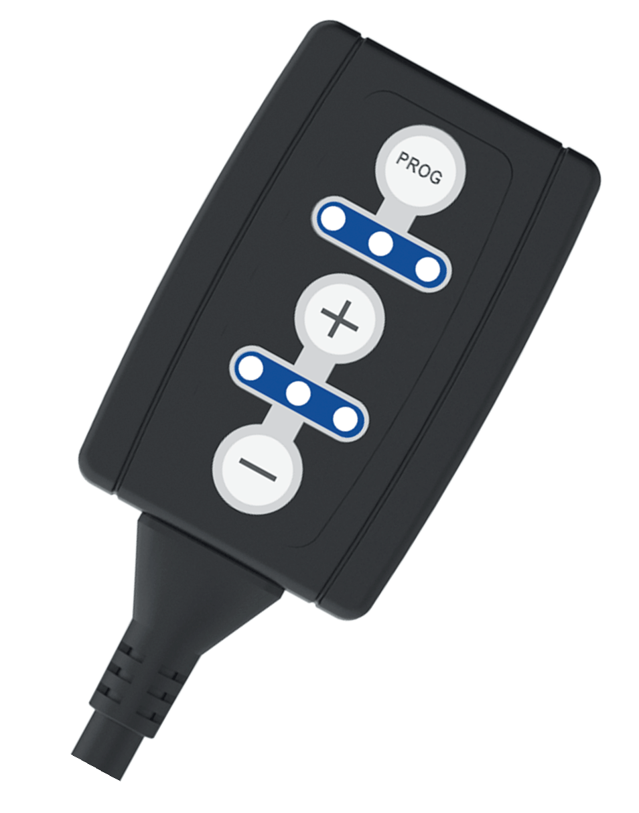
REMUS Responder

Improved throttle response, more dynamic!

Der REMUS ResponderThe REMUS Responder improves throttle response by means
of modifying the accelerator pedal output signal.
No more throttle delay and reduced lag during automatic shifting makes driving
with the REMUS Responder more fun. The Responder attaches between the
OEM pedal sensor and the OEM connector, ready to use in seconds due to plug & play technology.
Sophisticated adjustable programming profiles can lead to improved fuel consumption and
more efficiency. The 4 individual user selectable and adjustable performance settings
allow drivers to select according to their own preferences. The REMUS Responder totally eliminates the delay in modern electronic accelerator pedals!

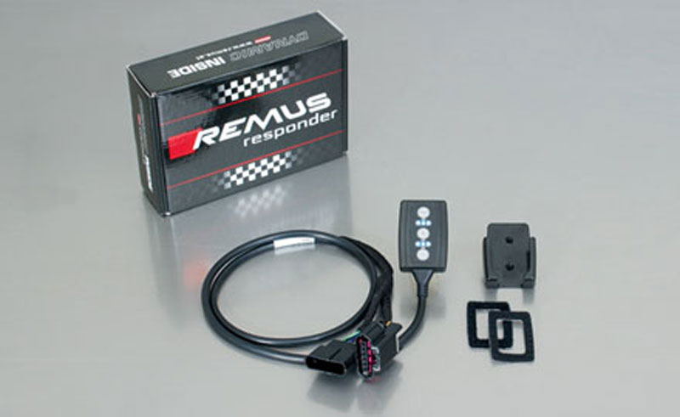

- Improved throttle response, reduced lag during gear changes
- Quicker reaction times, more dynamic without changing engine parameters
- 4 individual user selectable and adjustable performance settings
- Vehicle specific programming using OEM quality connectors
- Simple plug & play installation and easily removed without leaving traces

