Product information 38/2016

VW Golf VI, Golf VI Cabrio & Scirocco

VW Golf VI, Typ 1K / VW Cabrio Typ 1K, from 2011 - 1.2l TSI 77 kW
VW Scirocco III, Typ 13, from 2008 - 1.4l TSI 90 kW (CAXA); 1.4l TSI 118 kW (CAV/CTHD)
REMUS sport exhaust
- 100% stainless steel
- Powerful sound
- Performance and torque increase
- EEC homologation

+ 5,5 HP
+ 12,2 Nm

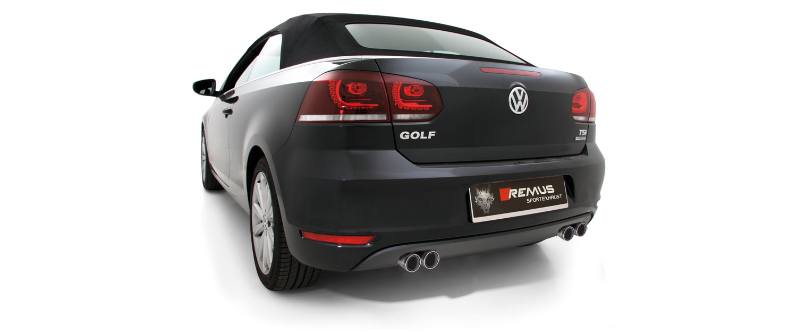

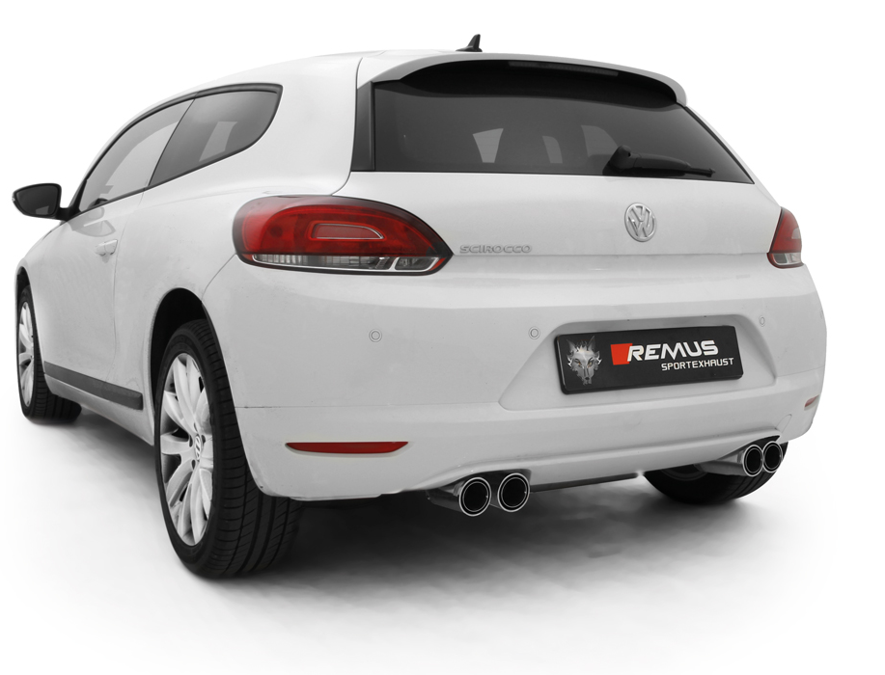

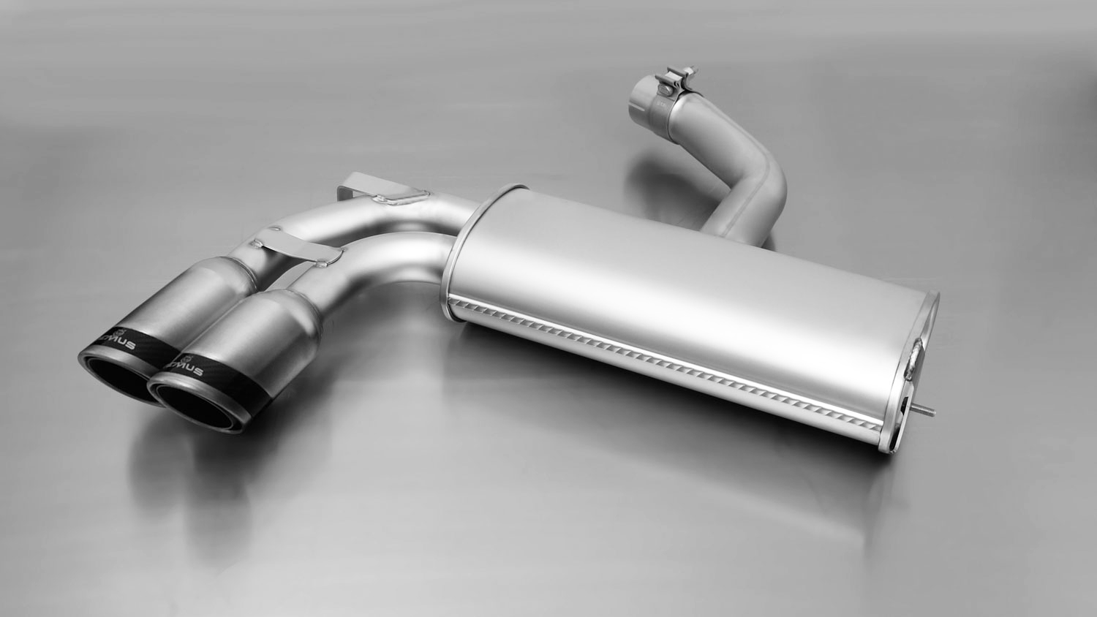

952608 0584CS

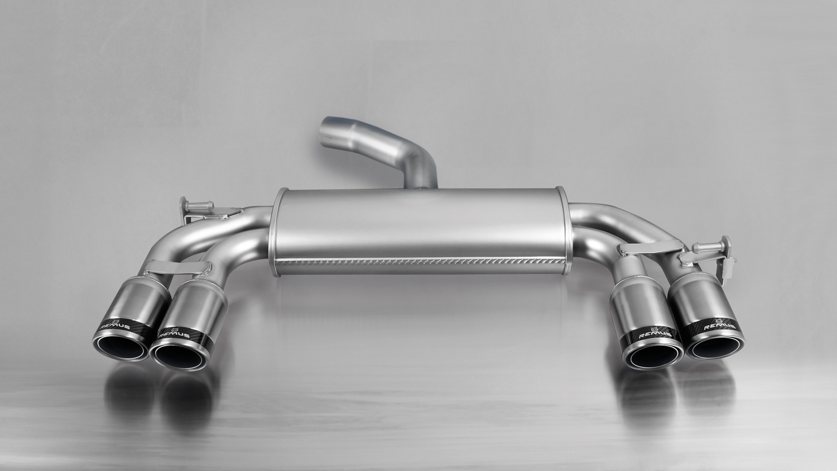
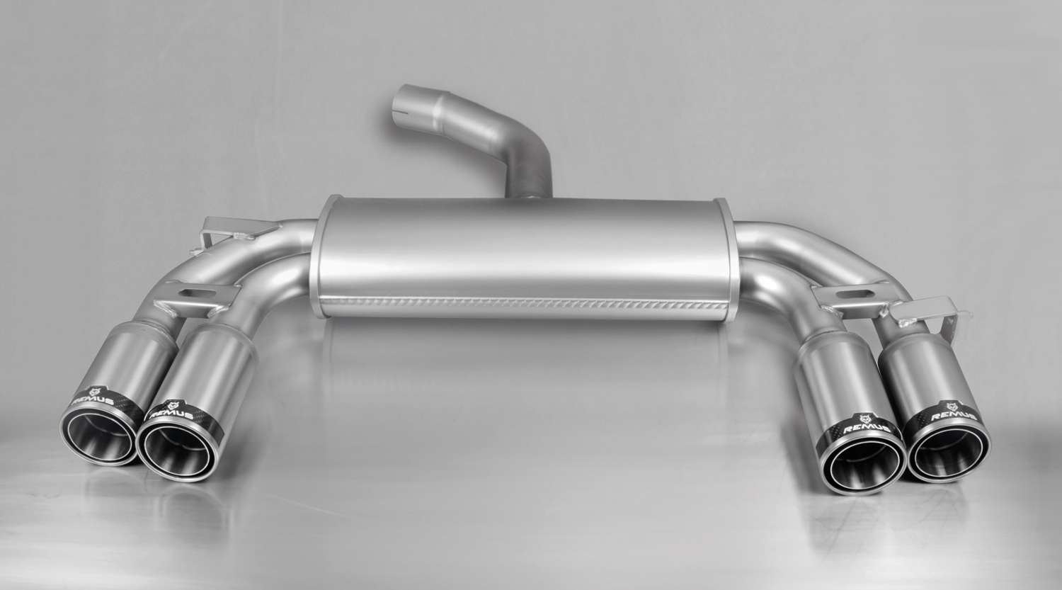

955108 1584C
955108 1584CS

Car and engine specification
VW Golf VI, type 1K, 2011=>
VW Golf VI Cabrio, type 1K, 2011=>
1.2l TSI 77 kW
VW Scirocco III, type 13, 2008=>
1.4l TSI 90 kW (CAXA); 1.4l TSI 118 kW (CAV/CTHD)
Part no. | Description | € RRP price excl. VAT
Axle-back-system left:
952608 0584CS | Stainless sport exhaust with 2 tail pipes Ø 84 mm Carbon Race | 499,--
Axle-back-system left / right:
955108 1584C | Stainless sport exhaust with left/right 2 tail pipes Ø 84 mm Street Race, with EEC homologation. | 637,--
955108 1584CS | Stainless sport exhaust with left/right 2 tail pipes Ø 84 mm Carbon Race, with EEC homologation. | 658,--
INFOBOX:
- 955108 1584C and 955108 1584CS replaces part number 952608 1500, which
will be available as long as stock lasts.
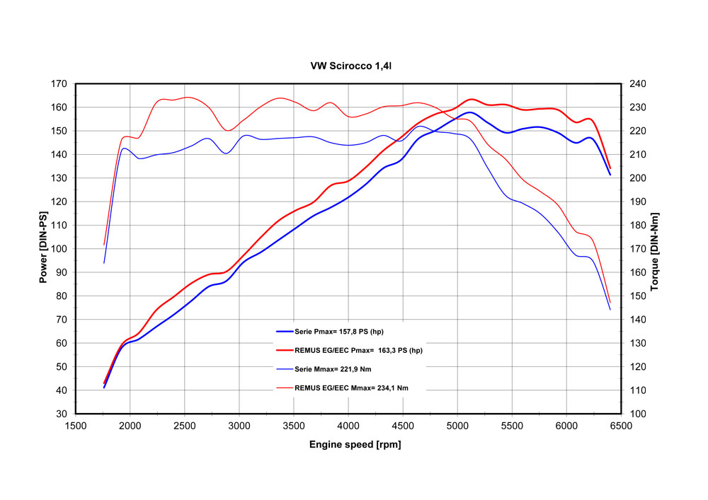
- Axle-back-system: 952608 0584CS! The original exhaust will need to be cut! When mounting sport exhaust left on VW Golf VI and VW Golf VI Cabrio the skirt must be trimmed as per the supplied template!
- Axle-back-system L/R: 955108 1584C resp. 955108 1584CS! The original exhaust will need to be cut! When mounting sport exhaust L/R on VW Golf VI/Golf VI Cabrio and VW Scirocco the skirt must be trimmed as per the supplied template!

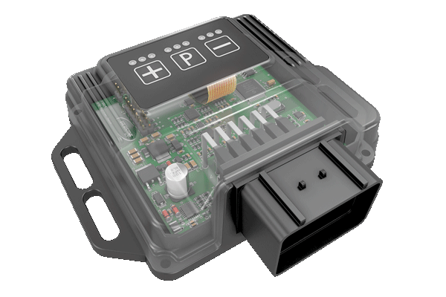
REMUS Powerizer
More power, more economy and more fun!
The electronics of the REMUS Powerizer enhances in real time
the engine management parameter. The engine mapping
is optimized in excess of 1000 times per second and ensures for a
considerable and noticeable power increase. The engine safety parameters and management remains totally original to ensure that individual engine components are not overstrained. Furthermore, the original mapping software remains totally untouched.
Due to the Plug & Play concept, the REMUS Powerizer is simple to install and can be easily removed or decommissioned using the supplied blind connector. Due to the torque increase, the engine has more power at lower RPM which leads to a reduction in fuel consumption. The power increase of the engine can be adjusted according to different driving styles by means of a „maximum power setting“, „eco fuel saving mode“ or a combination of both. The REMUS Powerizer is available for over 3000 petrol and diesel powered cars.

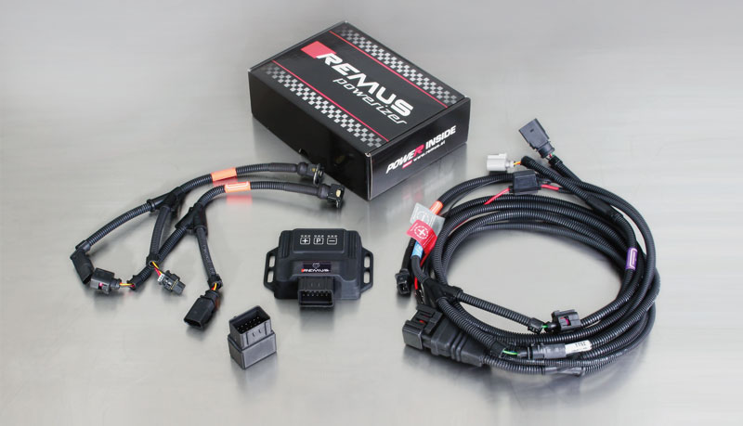

- Up to 25% more power
- Up to 20% more torque
- Easy installation and removal (Plug & Play)
- Up to 1l/100 km fuel saving
- 3 preset programs (RACE/SPORT/ECO) with individual power adjustment

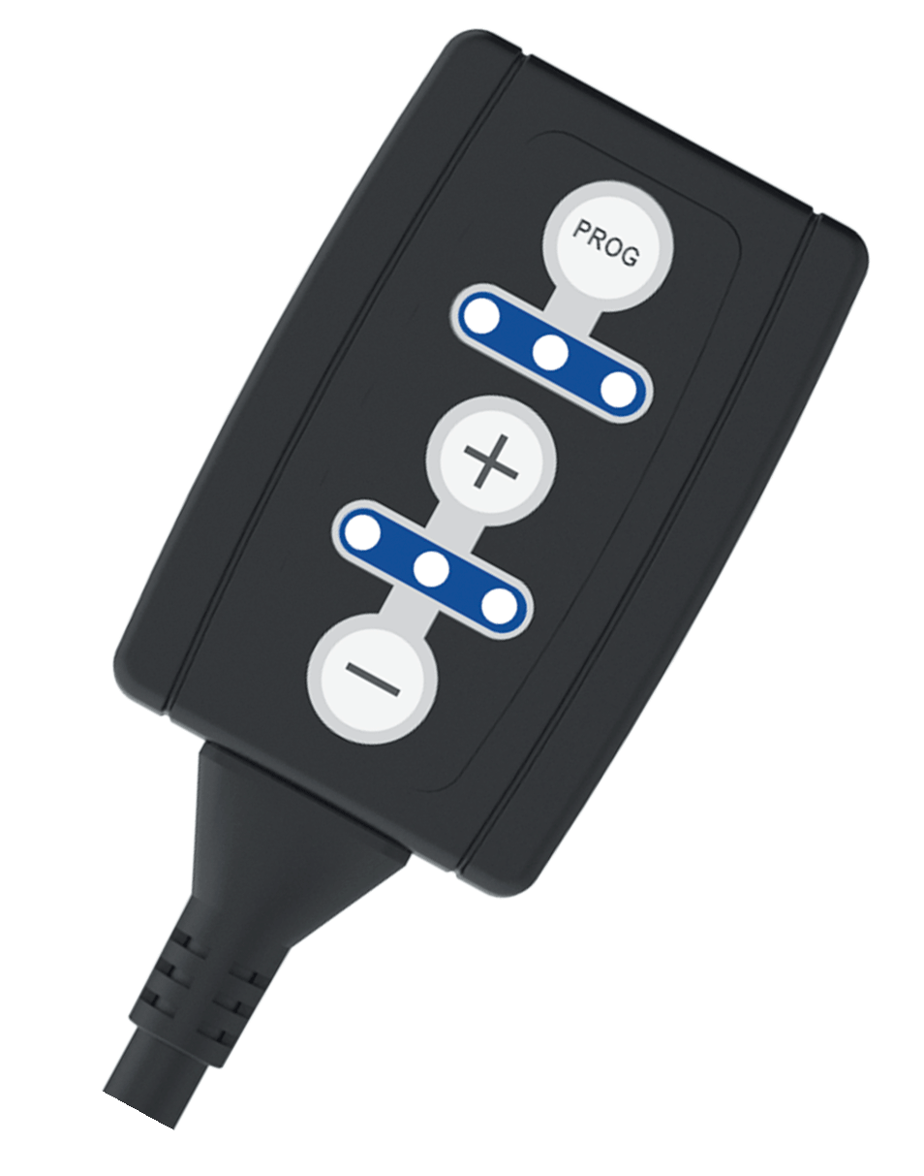
REMUS Responder

Improved throttle response, more dynamic!

Der REMUS ResponderThe REMUS Responder improves throttle response by means
of modifying the accelerator pedal output signal.
No more throttle delay and reduced lag during automatic shifting makes driving
with the REMUS Responder more fun. The Responder attaches between the
OEM pedal sensor and the OEM connector, ready to use in seconds due to plug & play technology.
Sophisticated adjustable programming profiles can lead to improved fuel consumption and
more efficiency. The 4 individual user selectable and adjustable performance settings
allow drivers to select according to their own preferences. The REMUS Responder totally eliminates the delay in modern electronic accelerator pedals!

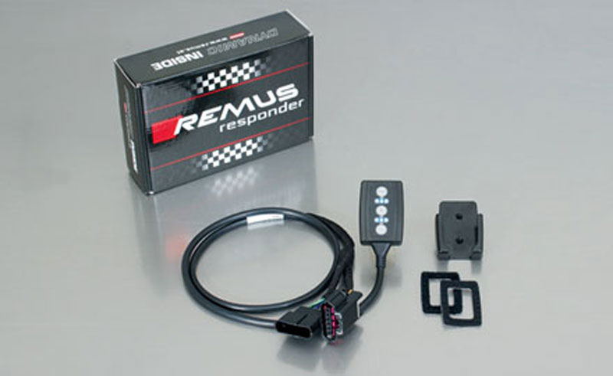

- Improved throttle response, reduced lag during gear changes
- Quicker reaction times, more dynamic without changing engine parameters
- 4 individual user selectable and adjustable performance settings
- Vehicle specific programming using OEM quality connectors
- Simple plug & play installation and easily removed without leaving traces

