REMUS product information 36-2016 2016-09-14

Dear REMUS Partner,
We are pleased to inform you that we have extended the EC approval of
REMUS sport exhaust and REMUS cat-back- system for
MINI Cooper S Cabrio F57, 2015=> and MINI JCW Cabrio F57, 2015=>.

It would be a pleasure for us to receive your orders.

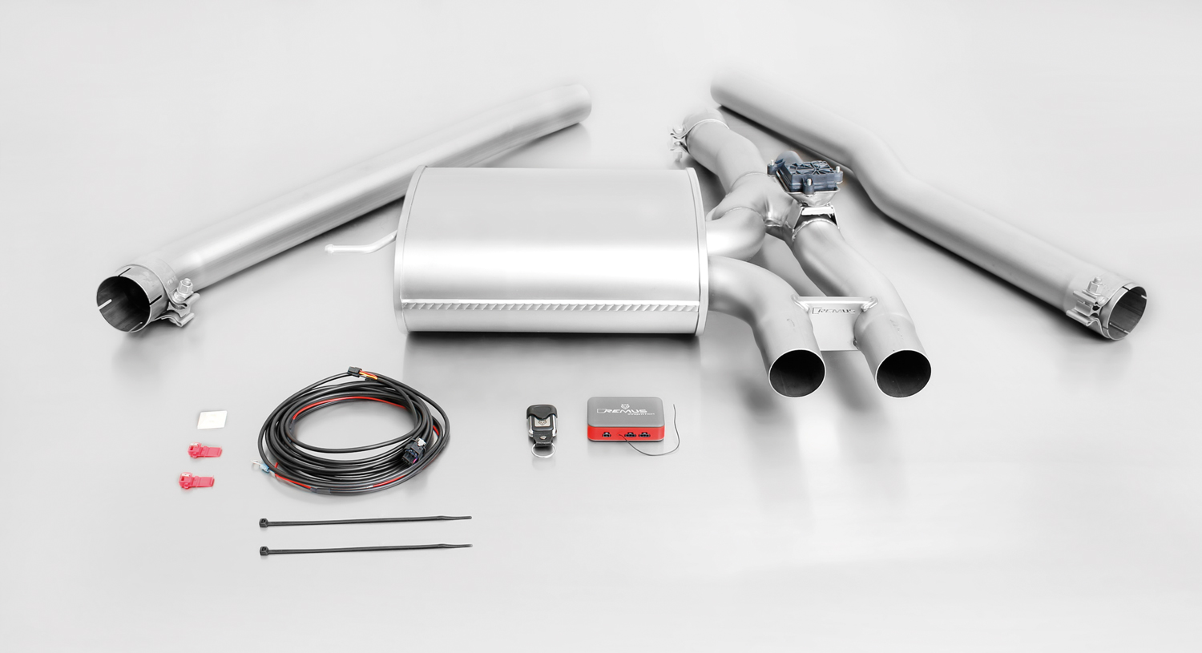
Stay tuned!

Your REMUS Team

756015 397

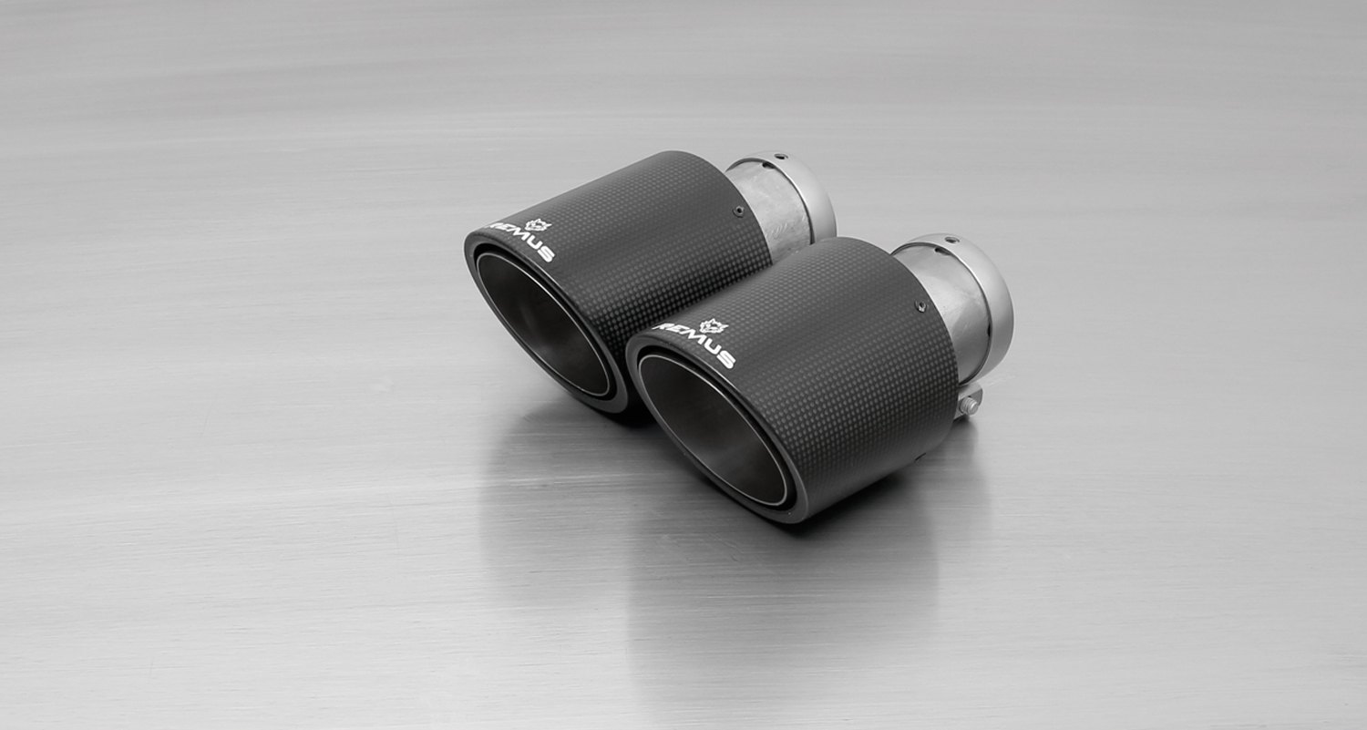
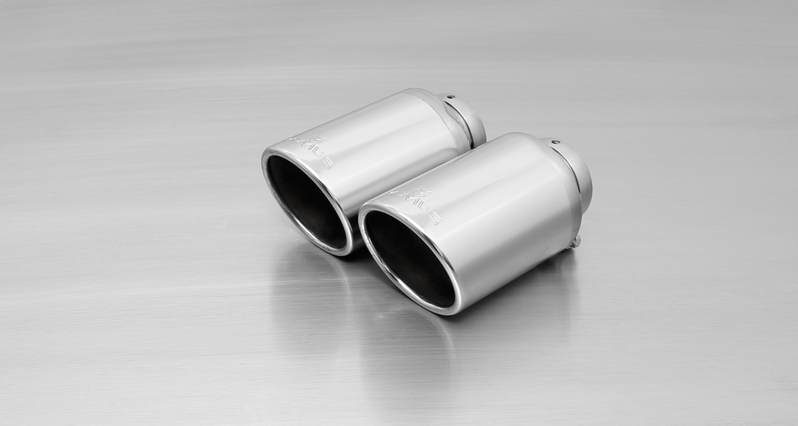
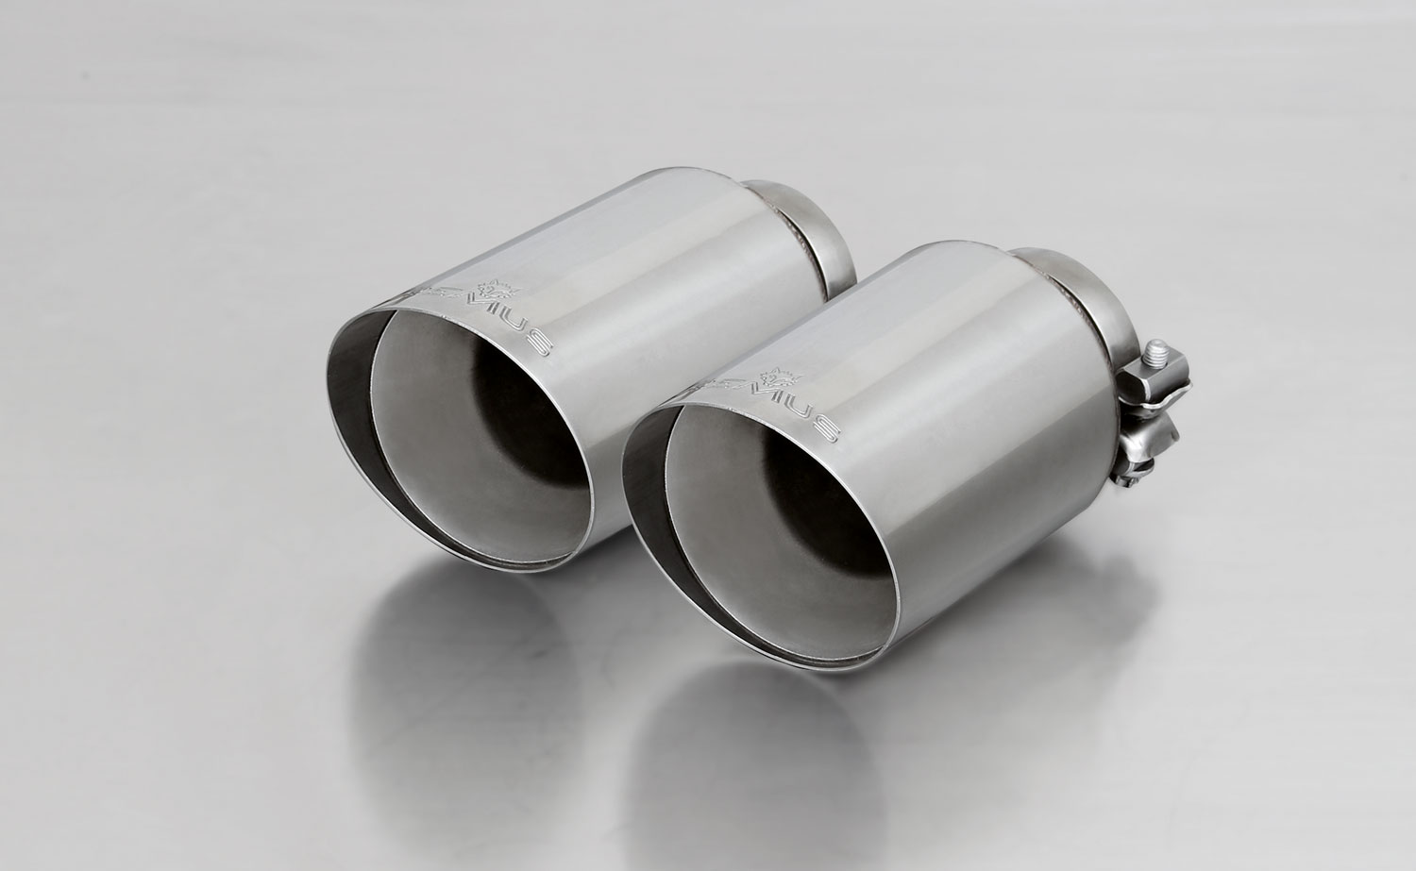

#70S: tail pipes Ø 102 mm
angled, chromed

#70CS: Carbon tail pipes Ø 84 mm
angled, Titanium internals

#70SG: tail pipes Ø 102 mm
angled, straight cut, chromed

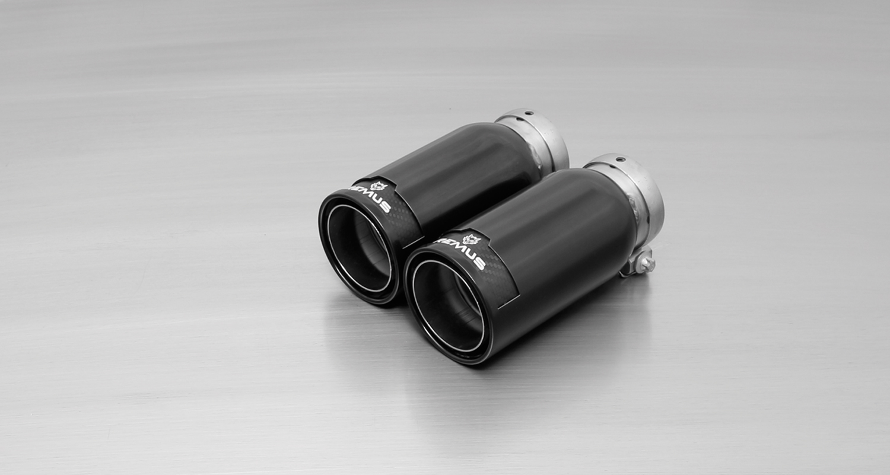
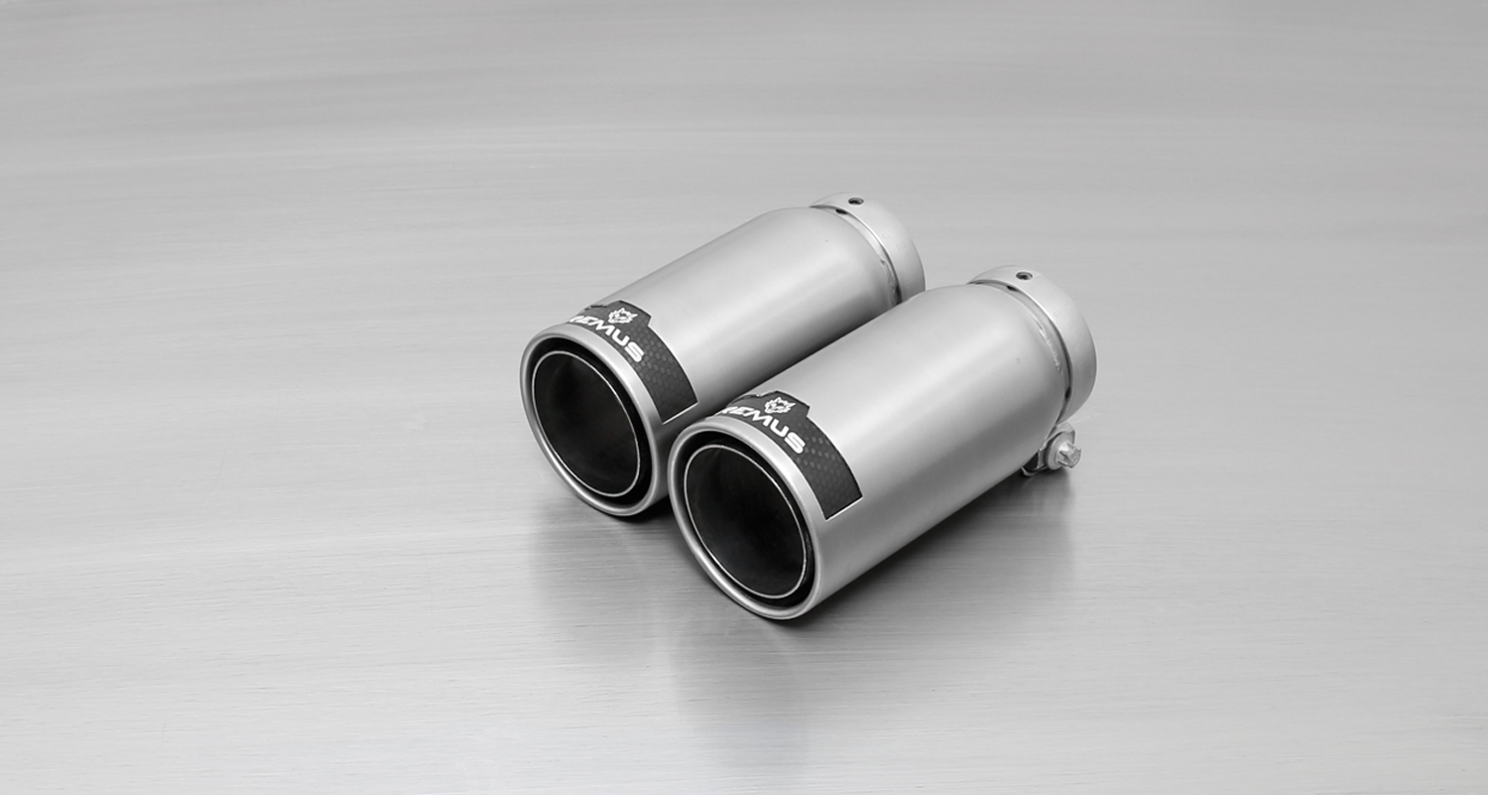
#98CB: tail pipes Ø 98 mm
Street Race Black Chrome

#98C: tail pipes Ø 98 mm
Street Race, polished

Car and engine specification
MINI Cooper S F56 (3 door), 2014=>
MINI Cooper S F57 Cabrio (3 door), 2015=>
MINI John Cooper Works “JCW” F56 (3 door), 2015=>
MINI John Cooper Works “JCW” Cabrio F57 (3 door), 2015=>
2.0l Turbo 141 kW
Part no. | Description | € RRP price excl. VAT
AD0181 | Distance tube U7 for mounting of 756015 397 on China/USA/Korean models | 15,--
756015 397 | REMUS cat-back system consisting of:  Ø 70 mm stainless steel front silencer replacement tube, 1 stainless steel connection tube and stainless steel sport exhaust (without tail pipes) with integrated valve and remote control unit, and EEC homologation. | 790,--
choose from following tail pipe package:
0026 70SG | Stainless steel tail pipe set L/R consisting of 2 tail pipes Ø 102 mm angled, straight cut, chromed, with adjustable spherical clamp connection | 140,--
0026 70S | Stainless steel tail pipe set L/R consisting of 2 tail pipes Ø 102 mm angled, chromed, with adjustable spherical clamp connection | 160,--
0026 70CS | Stainless steel tail pipe set L/R consisting of 2 Carbon tail pipes Ø 102 mm angled, Titanium internals, with adjustable spherical clamp connection | 370,--
0026 98C | Stainless steel tail pipe set L/R consisting of 2 tail pipes Ø 98 mm Street Race, with adjustable spherical clamp connection | 196,--
0026 98CB | Stainless steel tail pipe set L/R consisting of 2 tail pipes Ø 98 mm Street Race Black Chrome, with adjustable spherical clamp connection | 220,--
INFOBOX:
- Cat-Back-Anlage: (AD0181) + 756015 397 + tail pipe set! No vehicle modifications required! No rear skirt modifications required!
- It is not permissible to activate the valve on public roads as per the EU transport authority. The activation of the valve is carried out using the supplied remote control key fob. The sound controller and electrical actuator which allows the valve to be operated in 4 different positions.

‚

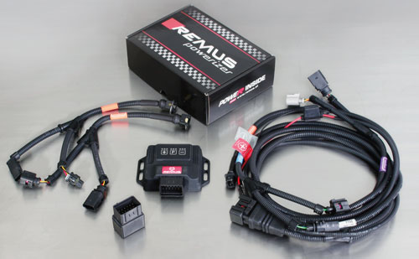

Under http://www.remus.eu/powerizer/ and http://www.remus.eu/remusresponder you will find the entire product range, prices and installation instructions.

REMUS Powerizer: More power, more economy and more fun.
- Up to 25 % more power
- Up to 20 % more torque
- Up to 1l/100 km fuel saving
- Fully adjustable power increase
- Simple DIY installation (Plug & Play)
REMUS POWERIZER: The performance figures represent the maximum achievable values. The actual performance output depends on the original tolerances of each engine. REMUS delivers the POWERIZER with the best possible setting for your vehicle type. You can adjust the performance according to your requirements as per the POWERIZER instructions

Legal references

1. Completion and registration of chip tuning in the car documents
Due to chip tuning, the operating license of the vehicle will terminate if the installation and registration of the POWERIZER is not carried out or immediately reported to an official approved testing facility. Please consider that driving a vehicle without the required operating license will cause legal penalties.

2. Vehicle insurance must be informed upon installing a POWERIZER
The installation of the POWERIZER can have influence on the insurance policy of your vehicle. You must inform the insurance company if you install a POWERIZER in your vehicle.

3. Effect of chip tuning on warranty and guarantee claims
a) When installing a POWERIZER, you will lose all guarantee claims regarding the engine against the vehicle manufacturer.
b) Installing a POWERIZER, can have influence on warranty claims against the seller of the vehicle.
c) REMUS excludes any claims regarding compensation for damages on the engine and drivetrain.

Under http://www.remus.eu/powerizer/ and http://www.remus.eu/remusresponder you will find the entire product range, prices and installation instructions.

REMUS RESPONDER:
Improved throttle response, more dynamic!
The REMUS Responder improves throttle response by means of modifying the accelerator pedal output signal. No more throttle delay and reduced lag during automatic shifting makes driving with the REMUS Responder more fun. The Responder attaches between the OEM pedal sensor and the OEM connector, ready to use in seconds due to plug & play technology. Sophisticated adjustable programming profiles can lead to improved fuel consumption and more efficiency. The 4 individual user selectable and adjustable performance settings allow drivers to select according to their own preferences.
The REMUS Responder totally eliminates the delay in modern electronic accelerator pedals!
