REMUS product information 36-2015

ATTENTION – Change of product information 24-2015

MASERATI Ghibli III, type M157, 2013=>

Dear REMUS Partner,

Please note following changes of resonated front sections according to drivetrain (Q4 or 2WD) specification:
REMUS sport exhaust system left/right with integrated valves and selectable tail pipes for the
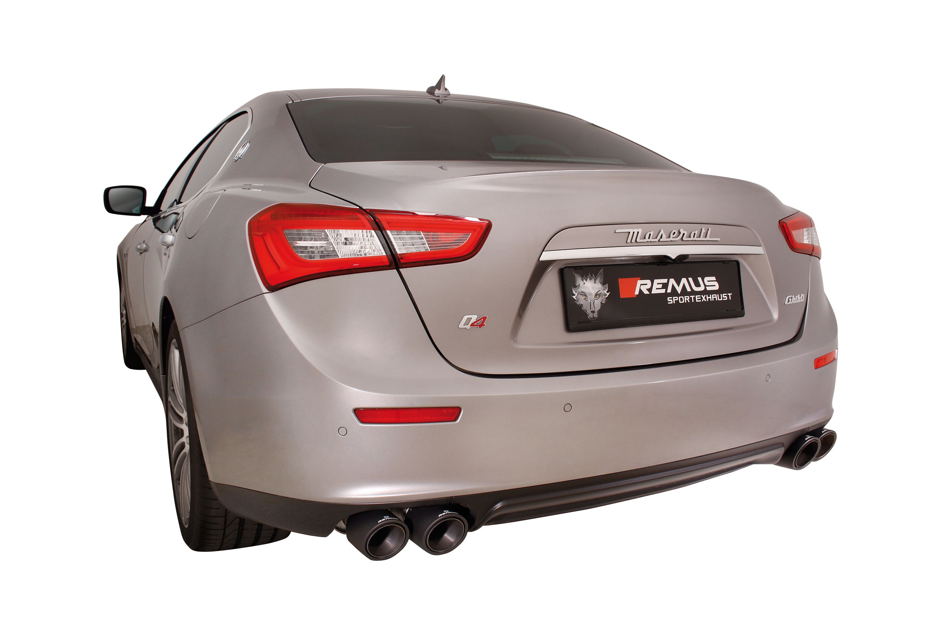
MASERATI Ghibli III, 2013=>

It would be a pleasure for us to receive your order.

Stay tuned!
Your REMUS Team
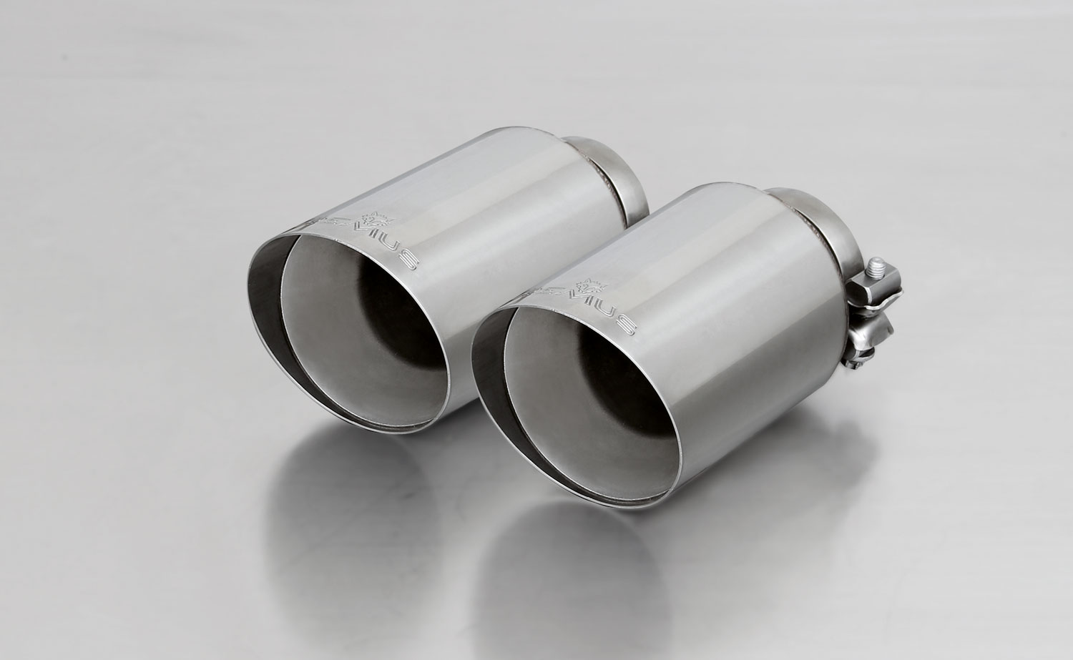
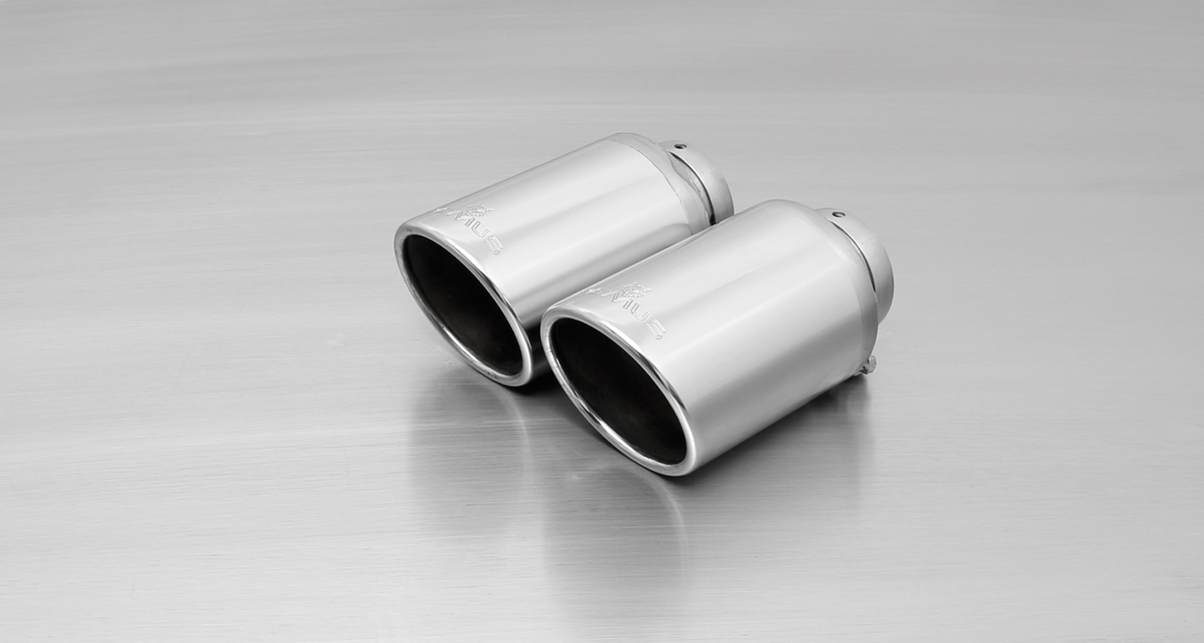
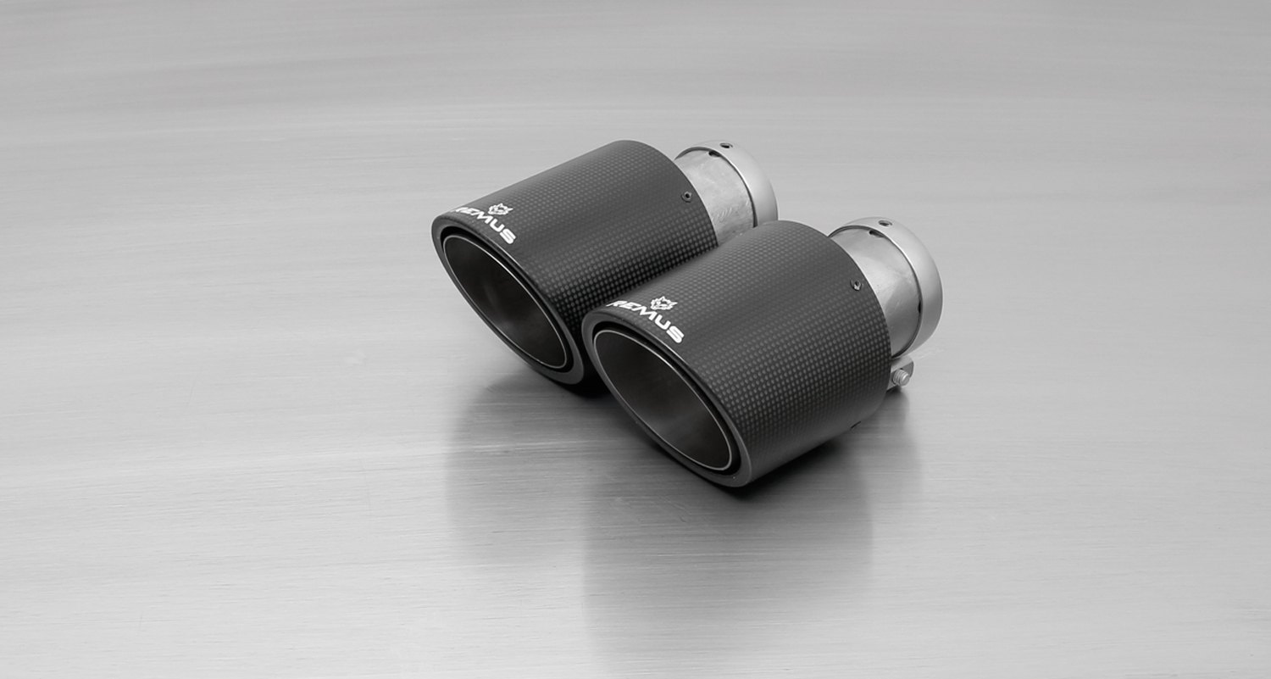
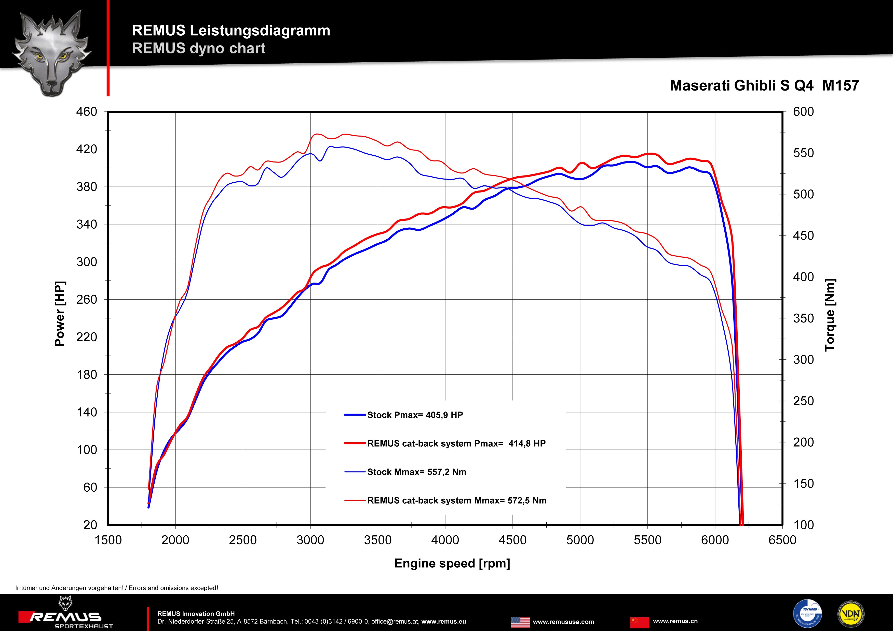
#70SG: tail pipe Ø 102 mm
angled, straight cut, chromed

#70S: tail pipes Ø 102 mm angled, chromed

#70CS: Carbon tail pipes
Ø 102 mm angled, Titanium internals

Car and engine specification
MASERATI Ghibli III, Type M157, 2013=>
3.0l 243 kW
MASERATI Ghibli III S, Type M157, 2013=>
3.0l 301 kW
MASERATI Ghibli III S Q4, Type M157, 2013=>
3.0l 301 kW
Part no. | Description | € RRP price excl. VAT
428014 0300 | Resonated front section for MASERATI Ghibli III S Q4, Type M157, 2013=> 3.0l 301 kW, without homologation | 490,--
428514 0300 | Resonated front section for MASERATI Ghibli III, Type M157, 2013=> 3.0l 243 kW and MASERATI Ghibli III S, Type M157, 2013=> 3.0l 301 kW, without homologation | 490,--
428014 0500LR | Left / Right axle-back sport exhaust system (without tail pipes), incl. 2 vacuum operated mechanical valves, without homologation | 1.490,--
choose from following tail pipe package:
0046 70SG | Tail pipe set L/R consisting of 4 tail pipes Ø 102 mm angled, straight cut, chromed, with adjustable spherical clamp connection | 280,--
0046 70S | Tail pipe set L/R consisting of 4 tail pipes Ø 102 mm angled, chromed, with adjustable spherical clamp connection | 320,--
0046 70CS | Tail pipe set L/R consisting of 4 Carbon tail pipes Ø 102 mm angled, Titanium internals, with adjustable spherical clamp connection | 740,--
ATTENTION:
- The sport exhaust can only be installed using the above mentioned tip sets as axle-back or as cat-back configuration. No cutting required!
- The RACING cat-back section instead of front silencer, part no. 428014 1300 is no longer available!

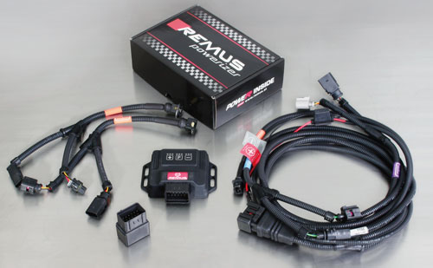

Under http://www.remus.eu/powerizer/ and http://www.remus.eu/remusresponder you will find the entire product range, prices and installation instructions.

REMUS Powerizer: More power, more economy and more fun.
- Up to 25 % more power
- Up to 20 % more torque
- Up to 1l/100 km fuel saving
- Fully adjustable power increase
- Simple DIY installation (Plug & Play)
REMUS POWERIZER: The performance figures represent the maximum achievable values. The actual performance output depends on the original tolerances of each engine. REMUS delivers the POWERIZER with the best possible setting for your vehicle type. You can adjust the performance according to your requirements as per the POWERIZER instructions

Legal references

1. Completion and registration of chip tuning in the car documents
Due to chip tuning, the operating license of the vehicle will terminate if the installation and registration of the POWERIZER is not carried out or immediately reported to an official approved testing facility. Please consider that driving a vehicle without the required operating license will cause legal penalties.

2. Vehicle insurance must be informed upon installing a POWERIZER
The installation of the POWERIZER can have influence on the insurance policy of your vehicle. You must inform the insurance company if you install a POWERIZER in your vehicle.

3. Effect of chip tuning on warranty and guarantee claims
a) When installing a POWERIZER, you will lose all guarantee claims regarding the engine against the vehicle manufacturer.
b) Installing a POWERIZER, can have influence on warranty claims against the seller of the vehicle.
c) REMUS excludes any claims regarding compensation for damages on the engine and drivetrain.
c) REMUS schließt Ansprüche des Kunden auf Schadenersatz für etwaige Schäden an Motor und Antriebsstrang aus..
c) REMUS schließt Ansprüche des Kunden auf Schadenersatz für etwaige Schäden an Motor und Antriebsstrang aus.

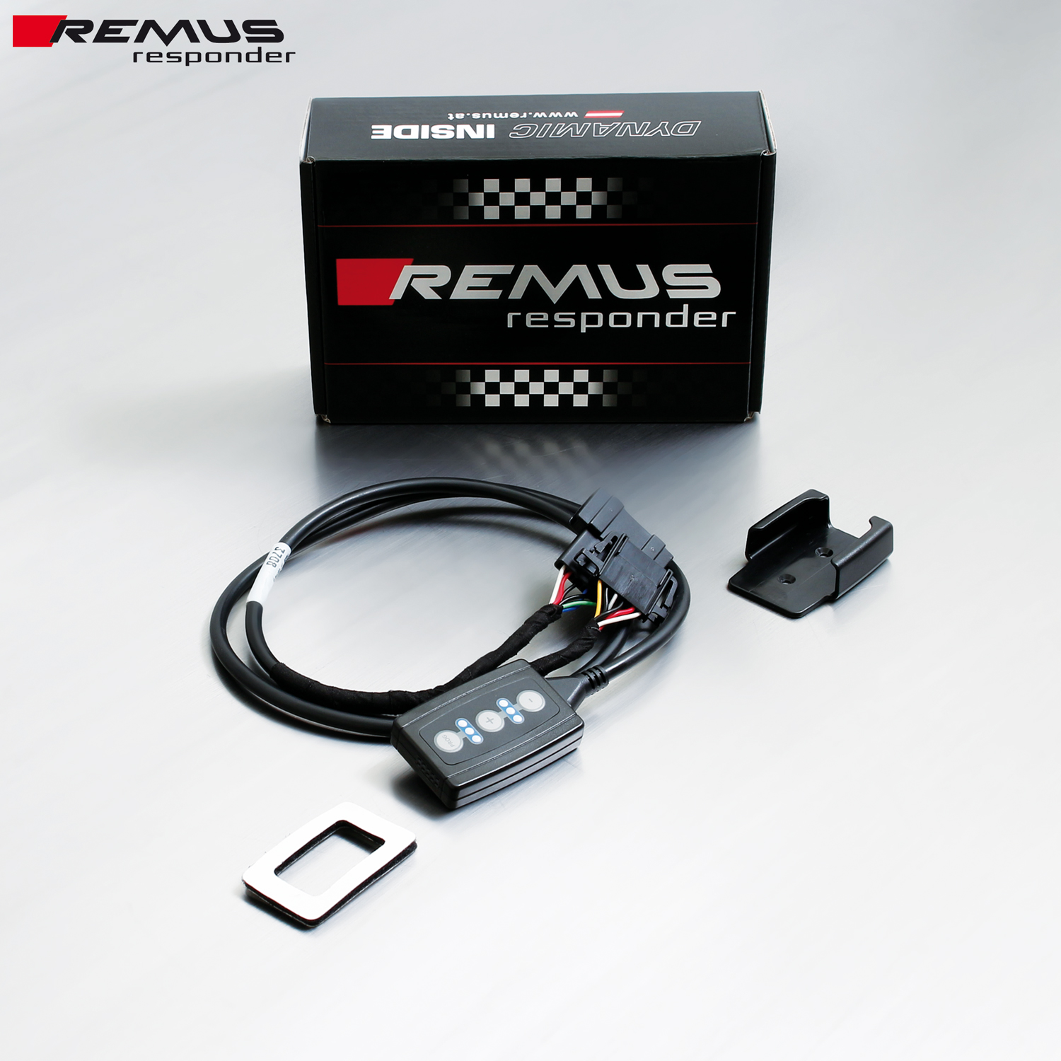

Under http://www.remus.eu/powerizer/ and http://www.remus.eu/remusresponder you will find the entire product range, prices and installation instructions.

REMUS RESPONDER:
Improved throttle response, more dynamic!
The REMUS Responder improves throttle response by means of modifying the accelerator pedal output signal. No more throttle delay and reduced lag during automatic shifting makes driving with the REMUS Responder more fun. The Responder attaches between the OEM pedal sensor and the OEM connector, ready to use in seconds due to plug & play technology. Sophisticated adjustable programming profiles can lead to improved fuel consumption and more efficiency. The 4 individual user selectable and adjustable performance settings allow drivers to select according to their own preferences.
The REMUS Responder totally eliminates the delay in modern electronic accelerator pedals!
