REMUS product information 34-2015

FORD Mustang 2.3 EcoBoost Coupe & Cabrio, 2015=>
FORD Mustang GT 5.0 Coupe & Cabrio, 2015=>

Dear REMUS-Partner,

We are pleased to inform you that we have completed our next development:
REMUS Cat-Back sport exhaust system left/right with integrated valves and
selectable tail pipes and
REMUS Racing Cat-Back sport exhaust system left/right with selectable tail pipes for the
FORD Mustang / Mustang GT, Coupe & Cabrio, 2015=>.

It would be a pleasure for us to receive your order.
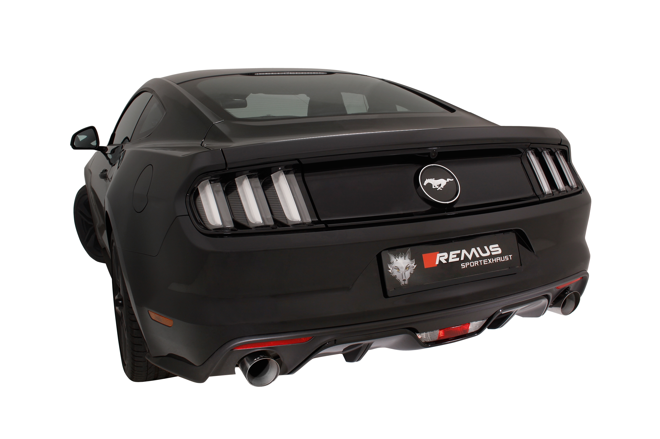
Stay tuned!
Your REMUS Team

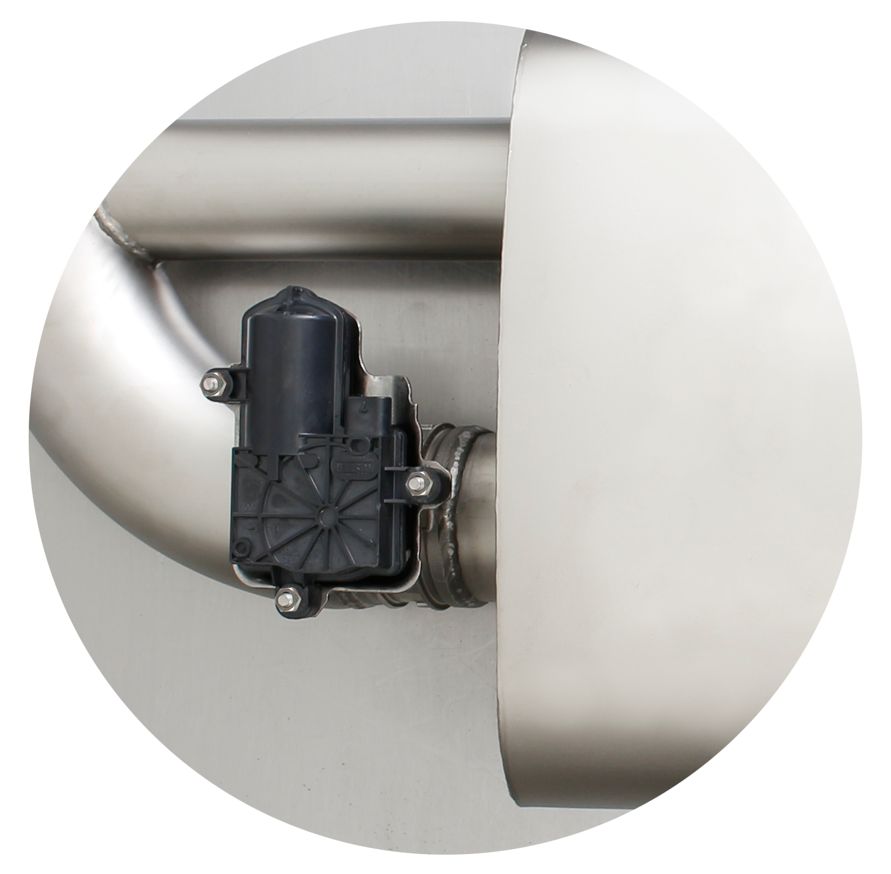
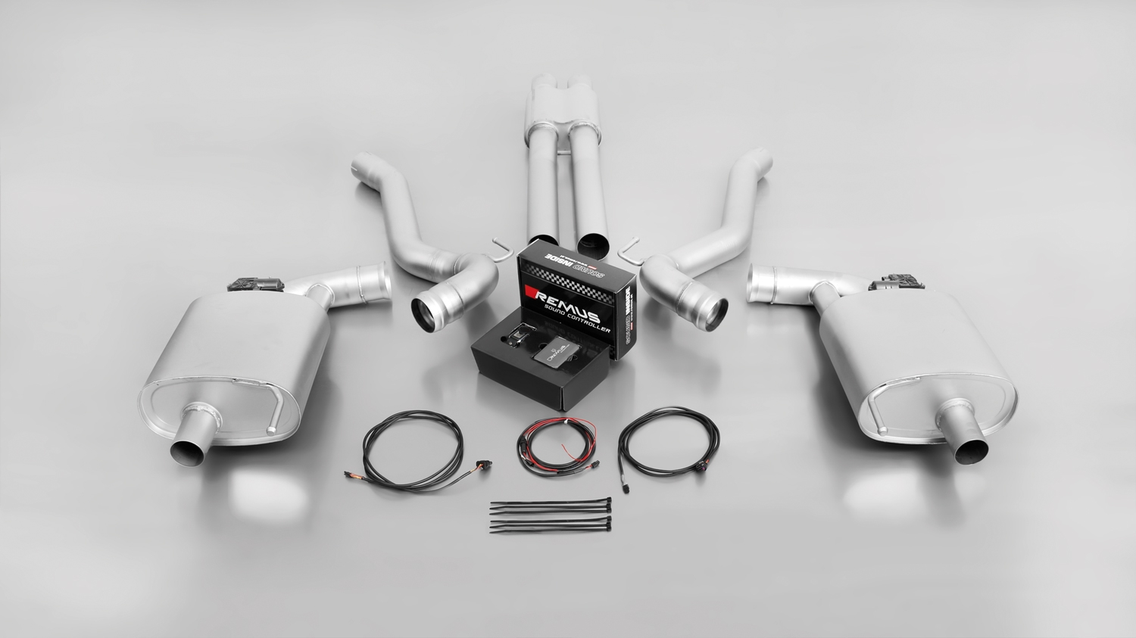

REMUS Cat-Back-System for Mustang GT 5.0l V8: 206615 0300 + 206515 0500LR

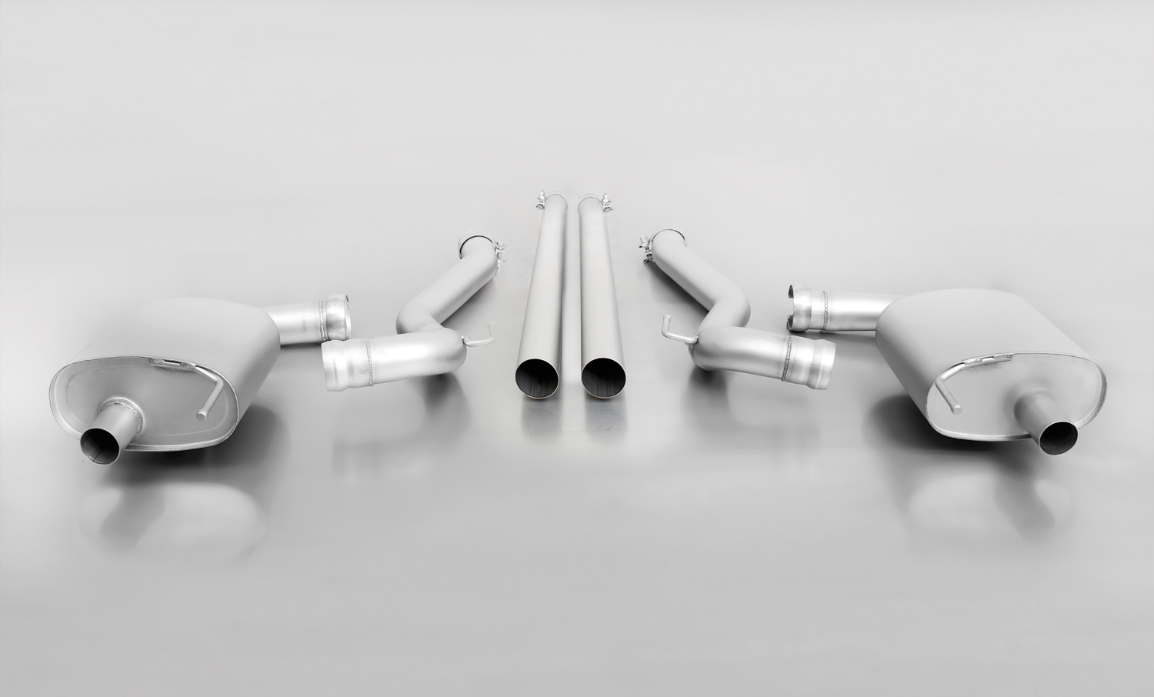
REMUS RACING Cat-Back-System for Mustang GT 5.0l V8: 206615 1300 + 206815 0500LR

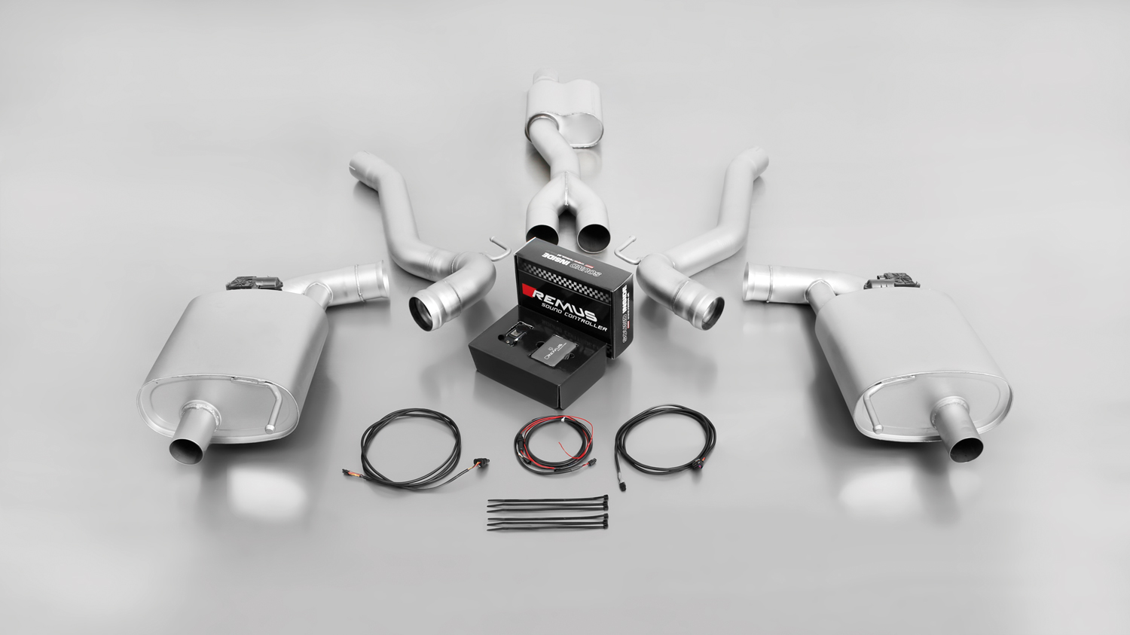
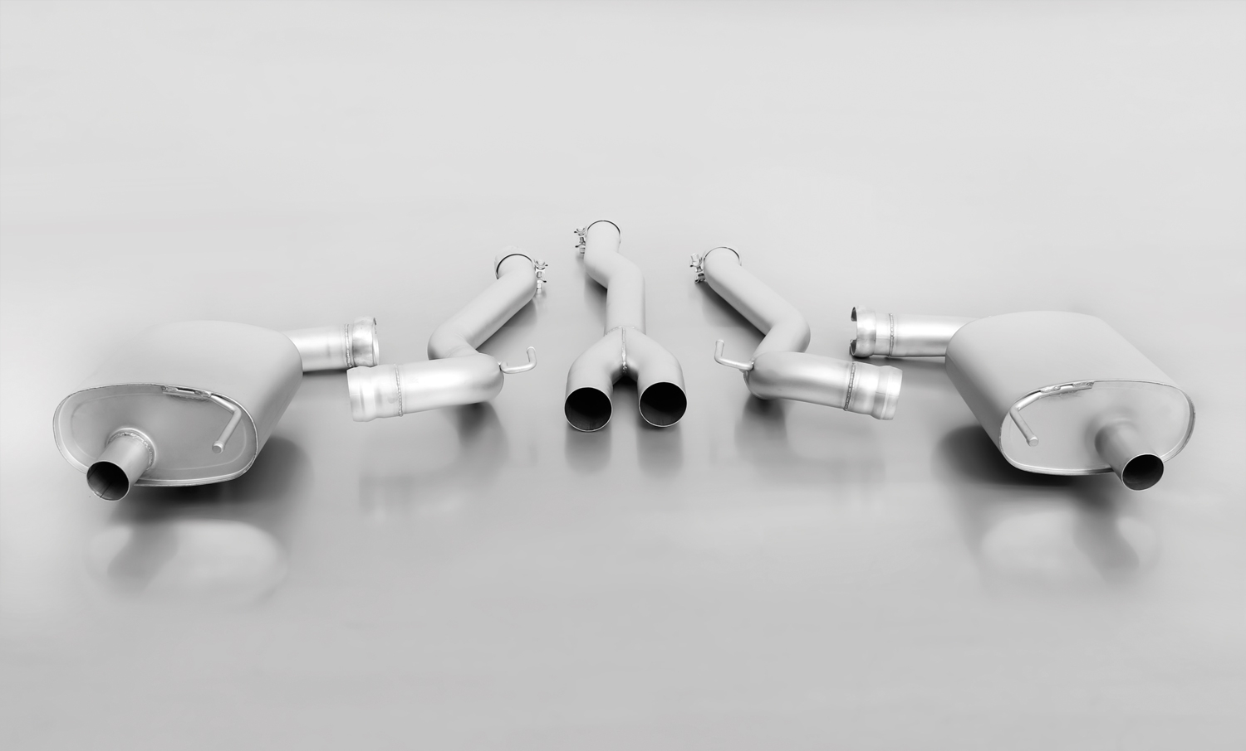
REMUS RACING Cat-Back-System for Mustang 2.3l Turbo: 206215 1300 + 206815 0500LR

REMUS Cat-Back-System for Mustang 2.3l Turbo: 206215 0300 + 206515 0500LR

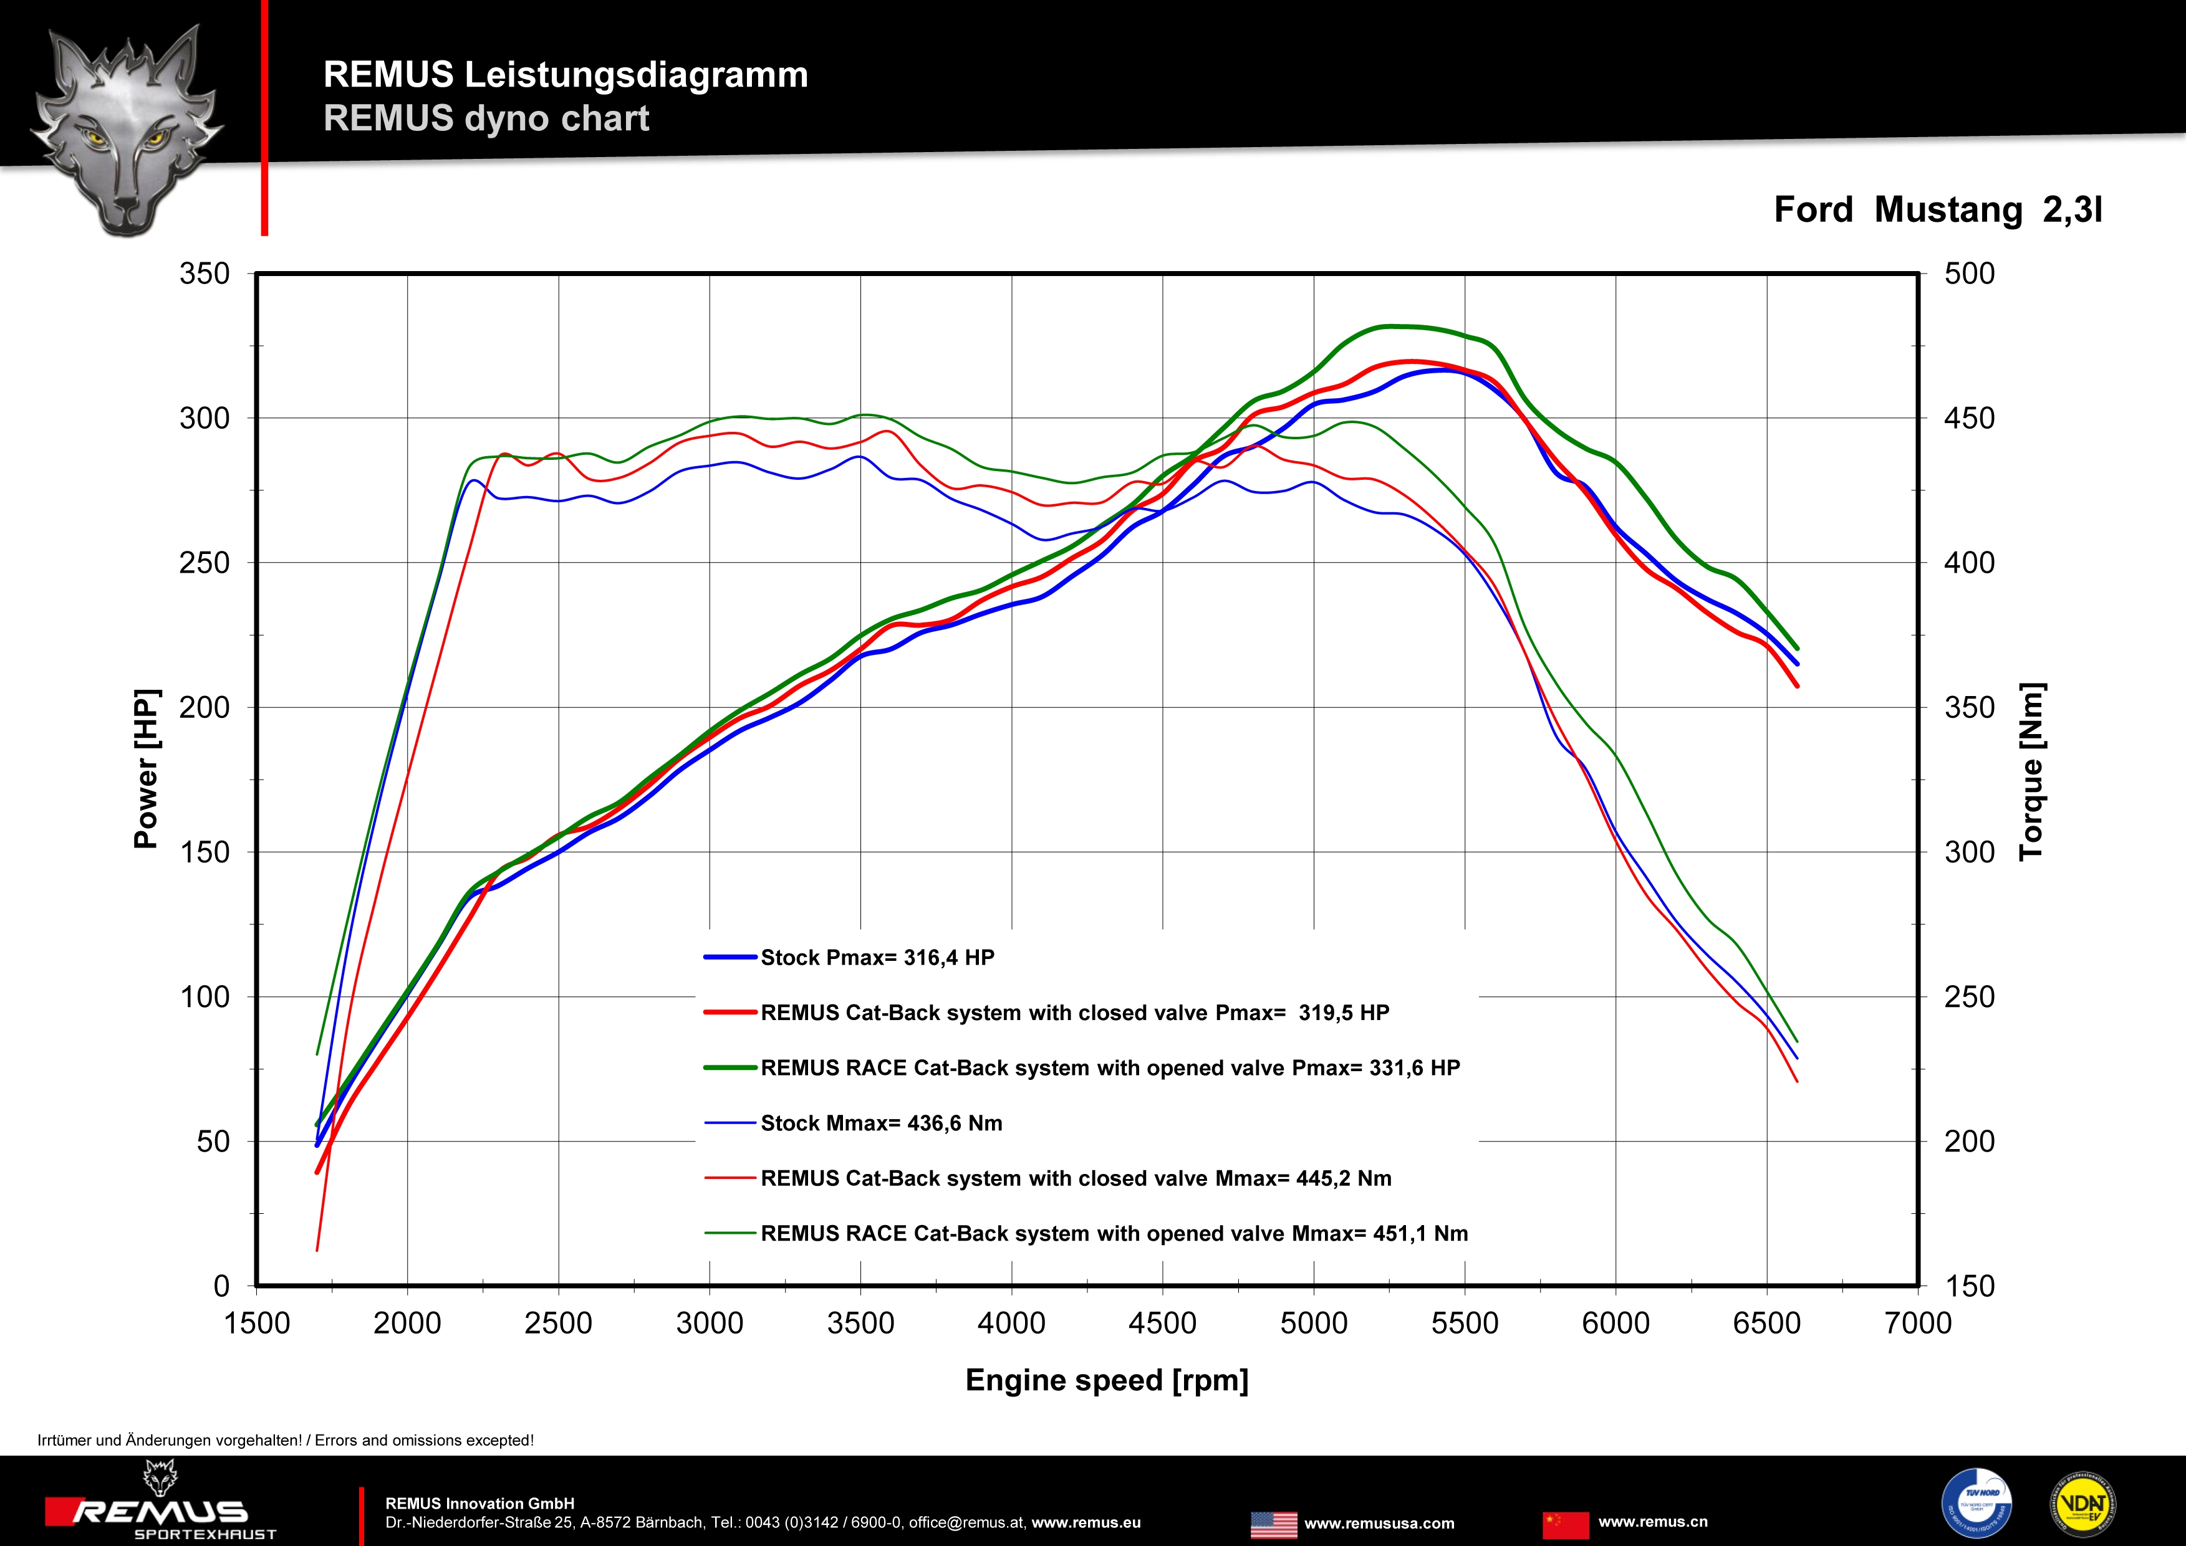

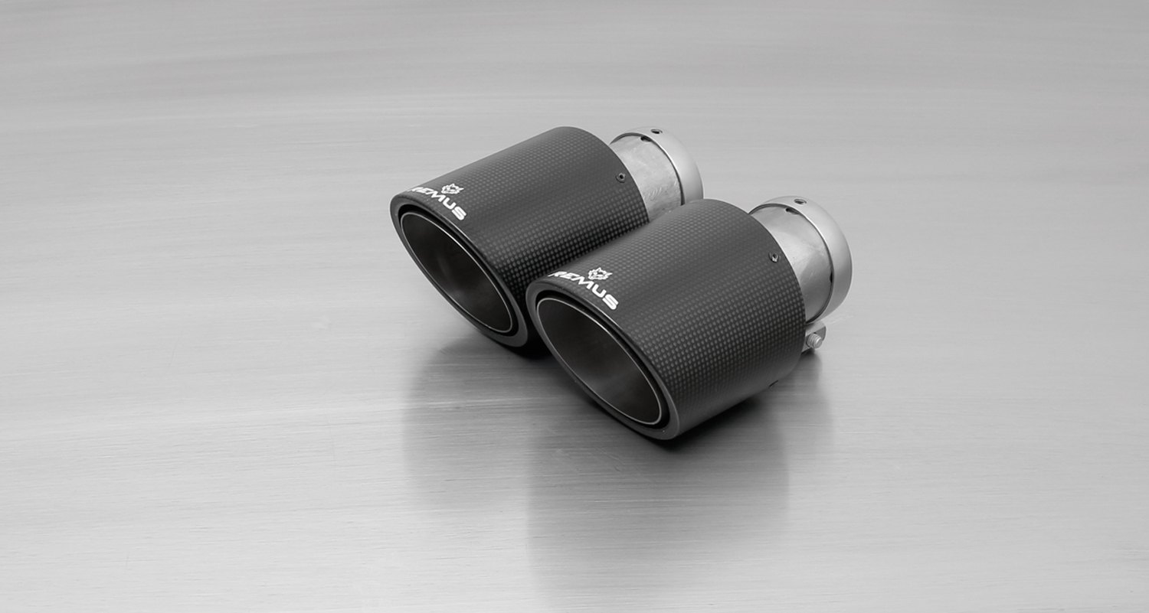
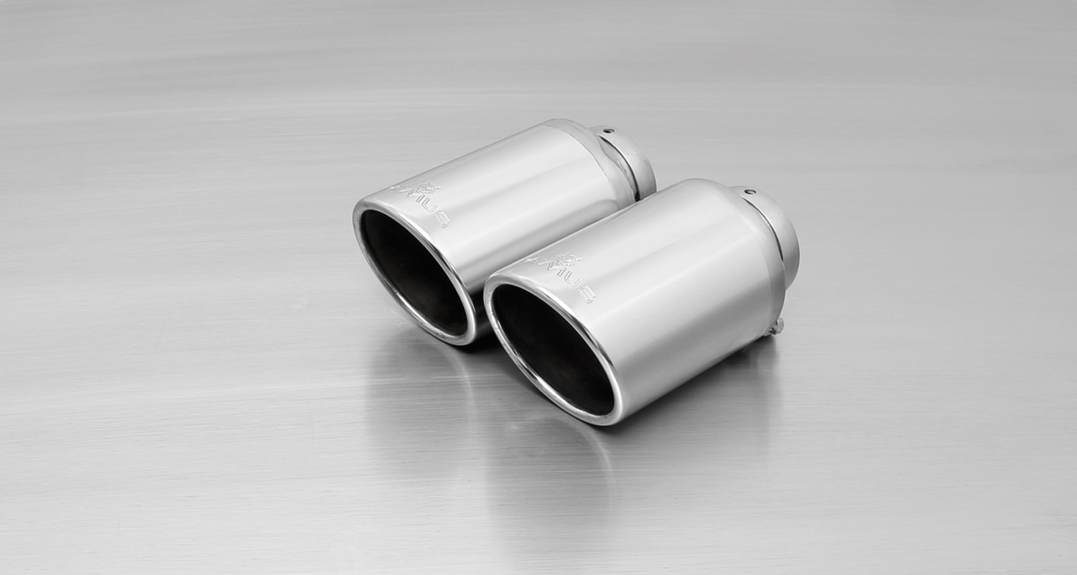
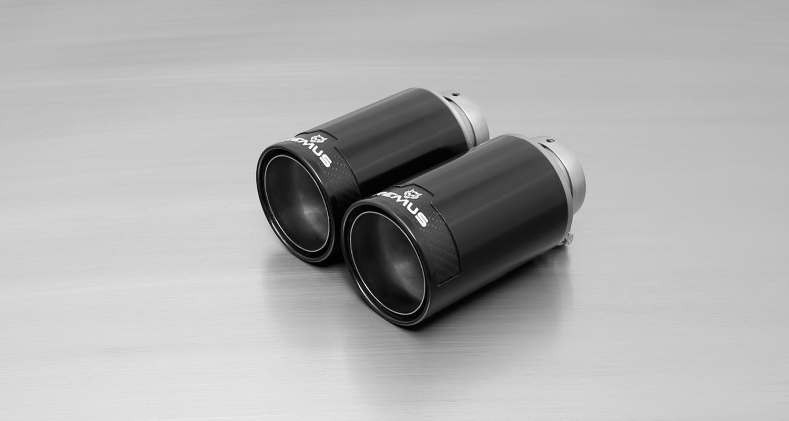
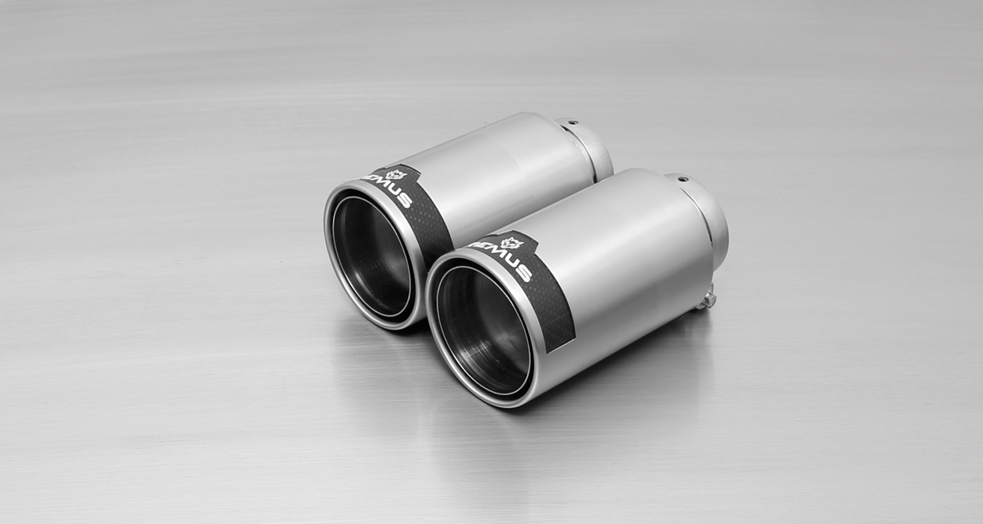
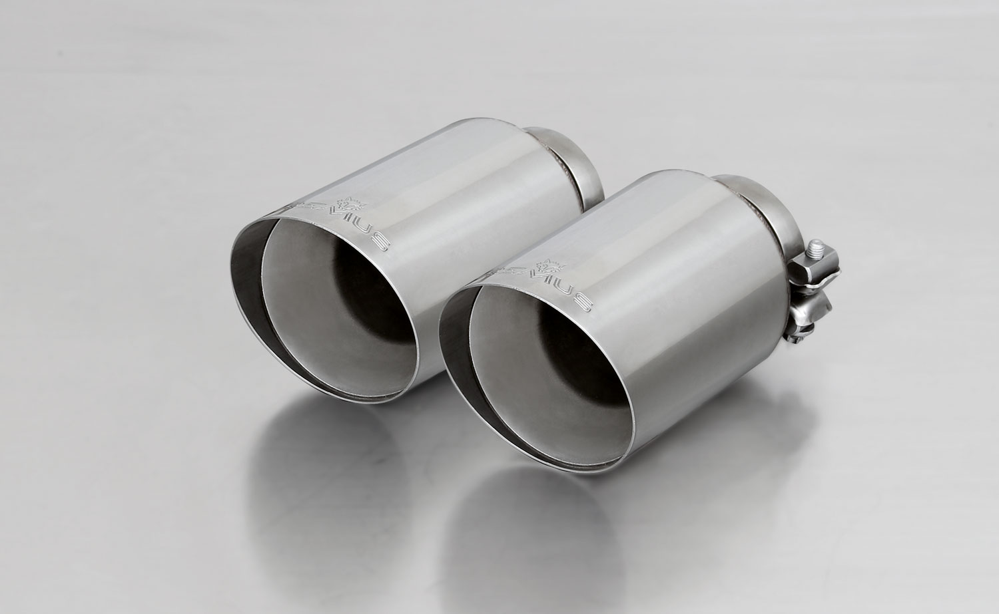
#70CS: Carbon tail pipes
Ø 102 mm angled, Titanium internals

#70S: tail pipes Ø 102 mm angled, chromed

#98CB: tail pipe Ø 98 mm
Street Race Black Chrome

#98C: tail pipe Ø 98 mm
Street Race, polished

#70SG: tail pipe Ø 102 mm
angled, straight cut, chromed

Car and engine specification
FORD Mustang Coupe & Cabrio, 2015=>
2.3l EcoBoost Turbo 231 kW
Part no. | Description | € RRP price excl. VAT
REMUS Cat-Back sport exhaust system incl. EEC homologation consisting of:
206215 0300 | Stainless steel front silencer for 2.3l Turbo, incl. EEC homologation  Original tube Ø 57mm = 2¼“  REMUS tube Ø 76mm = 3.0“ | 260,--
206215 1300 | Optional stainless steel RACING tube instead of front silencer for 2.3l Turbo, without homologation  Original tube Ø 57mm = 2¼“  REMUS tube Ø 76mm = 3.0“ | 90,--
206515 0500LR | Stainless steel sport exhaust left and stainless steel sport exhaust right (without tail pipes), with integrated valves, incl. 2 connection tubes, incl. EEC homologation  Original tube Ø 57mm = 2¼“  REMUS tube Ø 76mm = 3.0“  For the valve, a remote controlled unit is supplied for special applications. | 1.360,--
Alternative: REMUS RACING Cat-Back sport exhaust system consisting of:
206215 1300 | Stainless steel RACING tube instead of front silencer for 2.3l Turbo, without homologation  Original tube Ø 57mm = 2¼“  REMUS tube Ø 76mm = 3.0“ | 90,--
206815 0500LR | Stainless RACING steel sport exhaust left and stainless steel sport exhaust right (without tail pipes), incl. 2 connection tubes, without homologation  Original tube Ø 57mm = 2¼“  REMUS tube Ø 76mm = 3.0“ | 660,--
choose from following tail pipe package:
0026 70SG | Tail pipe set 2 tail pipes Ø 102 mm angled, straight cut, chromed, with adjustable spherical clamp connection | 140,--
0026 70S | Tail pipe set 2 tail pipes Ø 102 mm angled, chromed, with adjustable spherical clamp connection | 160,--
0026 70CS | Tail pipe set 2 Carbon tail pipes Ø 102 mm angled, Titanium internals, with adjustable spherical clamp connection | 370,--
0026 98C | Tail pipe set 2 tail pipes Ø 98 mm Street Race, with adjustable spherical clamp connection | 196,--
0026 98CB | Tail pipe set 2 tail pipes Ø 98 mm Street Race Black Chrome, with adjustable spherical clamp connection | 220,--
ATTENTION:
- REMUS Cat-Back systems only fits as a complete system!

Car and engine specification
FORD Mustang GT Coupe & Cabrio, 2015=>
5.0l V8 310 KW
Part no. | Description | € RRP price excl. VAT
REMUS Cat-Back sport exhaust system incl. EEC homologation consisting of:
206615 0300 | Stainless steel front silencer for 5.0l V8, incl. EEC homologation  Original tube Ø 63,5mm = 2½“  REMUS tube Ø 76mm = 3.0“ | 290,--
206515 0500LR | Stainless steel sport exhaust left and stainless steel sport exhaust right (without tail pipes), with integrated valves, incl. 2 connection tubes, incl. EEC homologation  Original tube Ø 63,5mm = 2½“  REMUS tube Ø 76mm = 3.0“  For the valve, a remote controlled unit is supplied for special applications. | 1.360,--
Alternative: REMUS RACING Cat-Back sport exhaust system consisting of:
206615 1300 | Stainless steel RACING tube instead of the front silencer for 5.0l V8, without homologation  Original tube Ø 63,5mm = 2½“  REMUS tube Ø 76mm = 3.0“ | 120,--
206815 0500LR | Stainless RACING steel sport exhaust left and stainless steel sport exhaust right (without tail pipes), incl. 2 connection tubes, without homologation  Original tube Ø 63,5mm = 2½“  REMUS tube Ø 76mm = 3.0“ | 660,--
choose from following tail pipe package:
0026 70SG | Tail pipe set 2 tail pipes Ø 102 mm angled, straight cut, chromed, with adjustable spherical clamp connection | 140,--
0026 70S | Tail pipe set 2 tail pipes Ø 102 mm angled, chromed, with adjustable spherical clamp connection | 160,--
0026 70CS | Tail pipe set 2 Carbon tail pipes Ø 102 mm angled, Titanium internals, with adjustable spherical clamp connection | 370,--
0026 98C | Tail pipe set 2 tail pipes Ø 98 mm Street Race, with adjustable spherical clamp connection | 196,--
0026 98CB | Tail pipe set 2 tail pipes Ø 98 mm Street Race Black Chrome, with adjustable spherical clamp connection | 220,--
ATTENTION:
- REMUS Cat-Back systems only fits as a complete system!

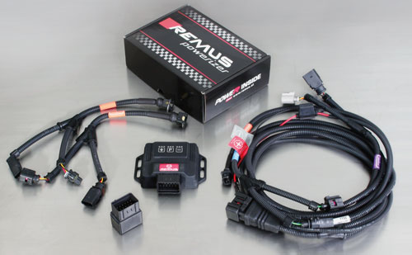

Under http://www.remus.eu/powerizer/ and http://www.remus.eu/remusresponder you will find the entire product range, prices and installation instructions.

REMUS Powerizer: More power, more economy and more fun.
- Up to 25 % more power
- Up to 20 % more torque
- Up to 1l/100 km fuel saving
- Fully adjustable power increase
- Simple DIY installation (Plug & Play)
REMUS POWERIZER: The performance figures represent the maximum achievable values. The actual performance output depends on the original tolerances of each engine. REMUS delivers the POWERIZER with the best possible setting for your vehicle type. You can adjust the performance according to your requirements as per the POWERIZER instructions

Legal references

1. Completion and registration of chip tuning in the car documents
Due to chip tuning, the operating license of the vehicle will terminate if the installation and registration of the POWERIZER is not carried out or immediately reported to an official approved testing facility. Please consider that driving a vehicle without the required operating license will cause legal penalties.

2. Vehicle insurance must be informed upon installing a POWERIZER
The installation of the POWERIZER can have influence on the insurance policy of your vehicle. You must inform the insurance company if you install a POWERIZER in your vehicle.

3. Effect of chip tuning on warranty and guarantee claims
a) When installing a POWERIZER, you will lose all guarantee claims regarding the engine against the vehicle manufacturer.
b) Installing a POWERIZER, can have influence on warranty claims against the seller of the vehicle.
c) REMUS excludes any claims regarding compensation for damages on the engine and drivetrain.
c) REMUS schließt Ansprüche des Kunden auf Schadenersatz für etwaige Schäden an Motor und Antriebsstrang aus..
c) REMUS schließt Ansprüche des Kunden auf Schadenersatz für etwaige Schäden an Motor und Antriebsstrang aus.

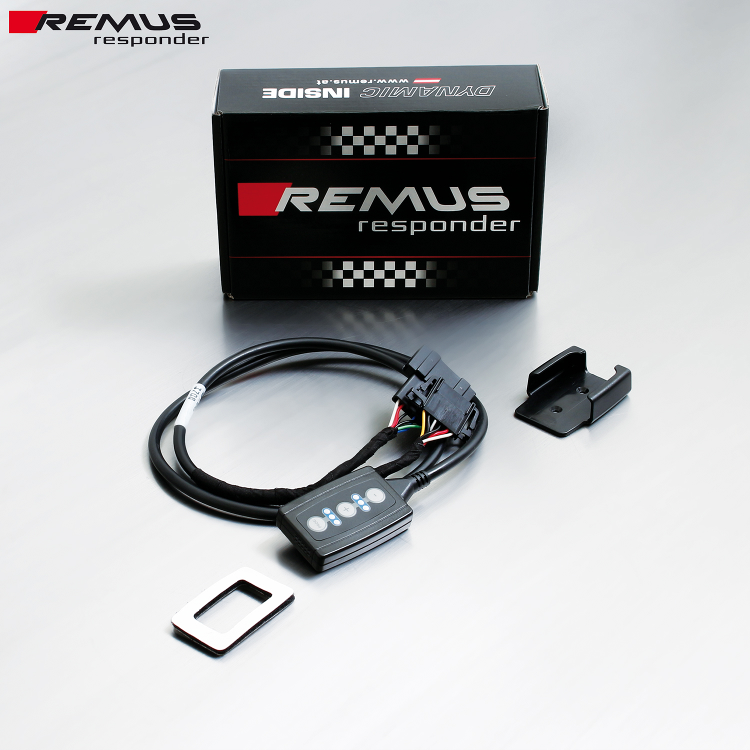

Under http://www.remus.eu/powerizer/ and http://www.remus.eu/remusresponder you will find the entire product range, prices and installation instructions.

REMUS RESPONDER:
Improved throttle response, more dynamic!
The REMUS Responder improves throttle response by means of modifying the accelerator pedal output signal. No more throttle delay and reduced lag during automatic shifting makes driving with the REMUS Responder more fun. The Responder attaches between the OEM pedal sensor and the OEM connector, ready to use in seconds due to plug & play technology. Sophisticated adjustable programming profiles can lead to improved fuel consumption and more efficiency. The 4 individual user selectable and adjustable performance settings allow drivers to select according to their own preferences.
The REMUS Responder totally eliminates the delay in modern electronic accelerator pedals!
