REMUS product information 33-2015 2015-11-10

BMW 220i F22 Coupe/F23 Cabrio, 2015=>

Dear REMUS-Partner,

We are pleased to inform you that we have completed our next development:
REMUS sport exhaust left/right with selectable tail pipes and
Racing front silencer replacement tube for the
BMW 220i F22 Coupe/F23 Cabrio, 2015=>.

It would be a pleasure for us to receive your order.

Stay tuned!
Your REMUS Team

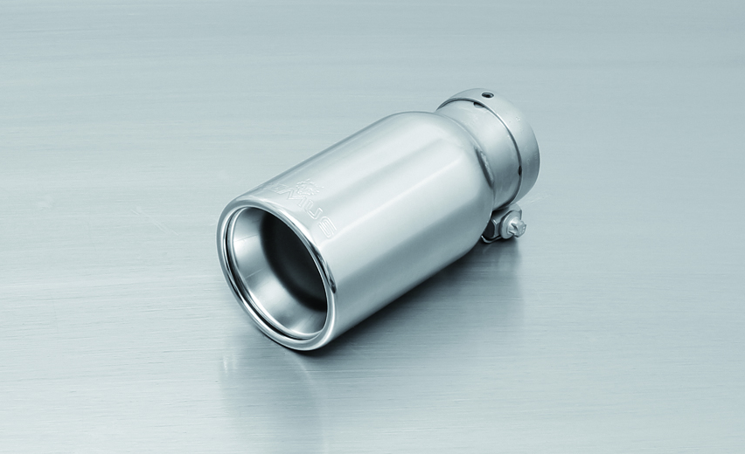

#83CB: tail pipe Ø 84 mm
Street Race Black Chrome
#83C: tail pipe Ø 84 mm
Street Race, polished
#05: tail pipe Ø 90 mm, chromed

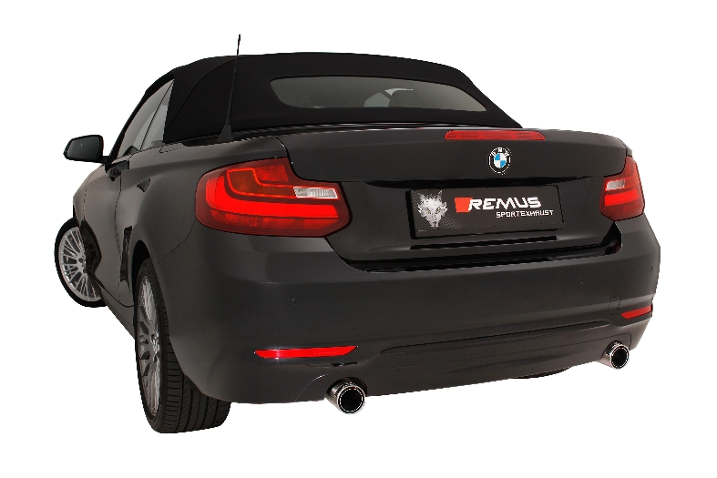

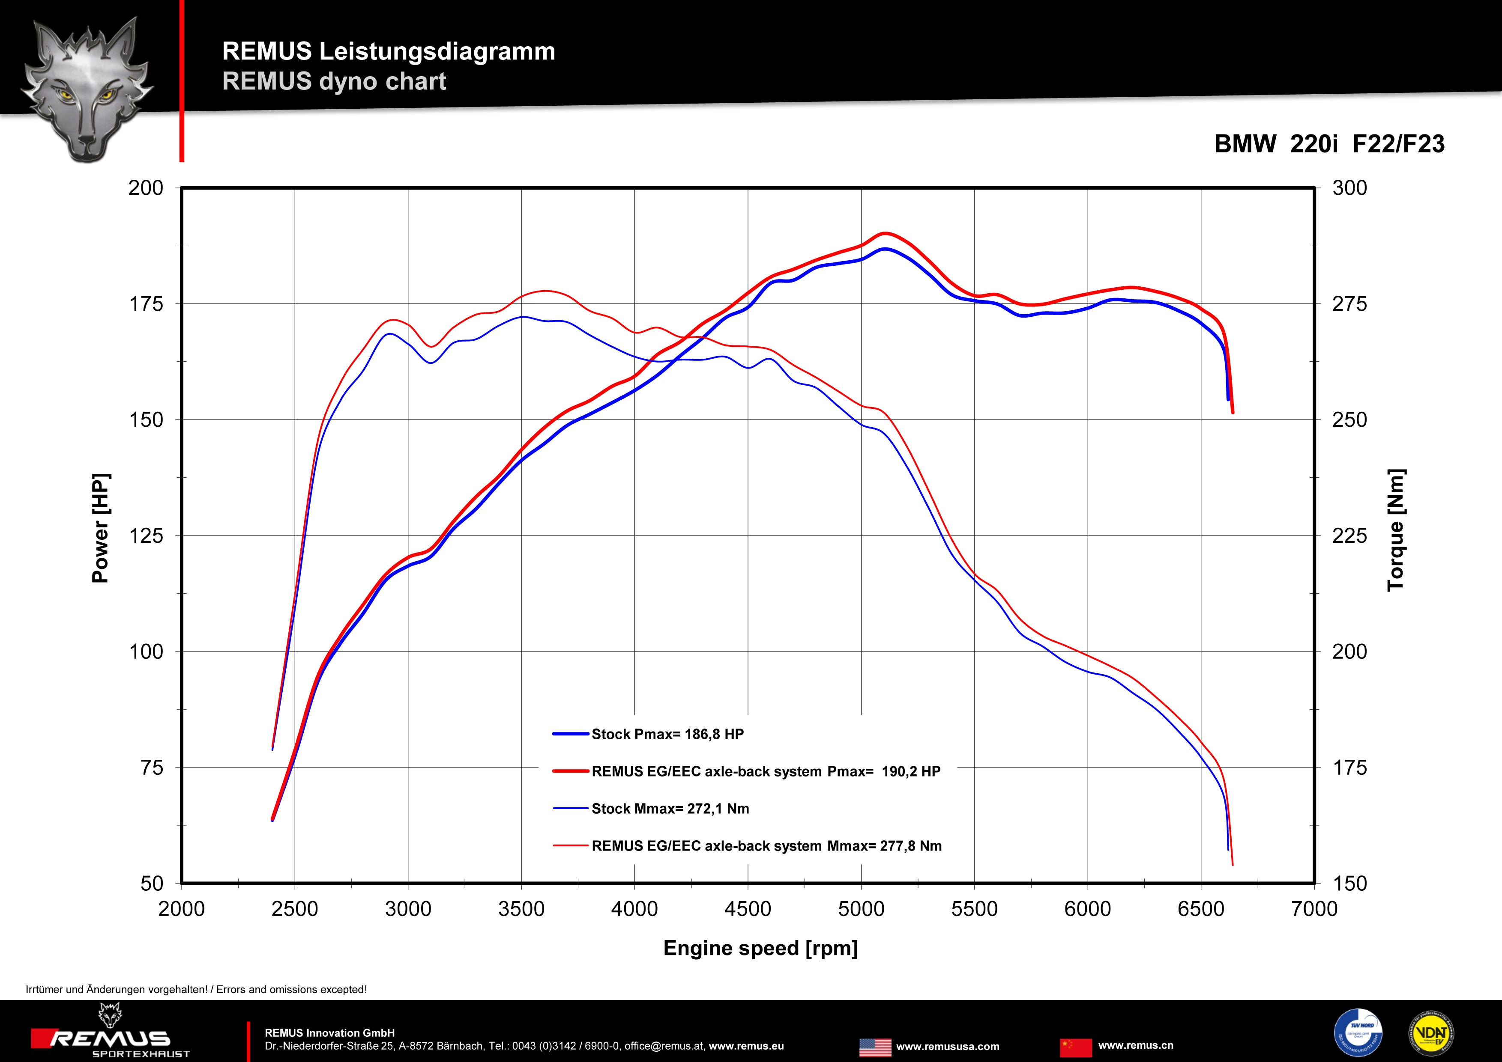

Car and engine specification
BMW 220i F22 Coupe, 2015=>
BMW 220i F23 Cabrio, 2015=>
2.0l 135 kW
Part no. | Description | € 2016 RRP price excl. VAT
085015 1300 | Stainless steel RACING cat-back section, replaces front silencer, without homologation | 190,--
085015 1500 | Stainless steel sport exhaust centered for L/R system (without tail pipes),with EEC homologation | 280,--
choose from following tail pipe package:
0025 05 | Tail pipe set L/R consisting of 2 tail pipes Ø 90 mm chromed, slip connection | 200,--
0025 83C | Tail pipe set L/R consisting of 2 tail pipes Ø 84 mm Street Race, polished, slip connection | 220,--
0025 83CB | Tail pipe set L/R consisting of 2 tail pipes Ø 84 mm Street Race Black Chrome, slip connection | 244,--
ATTENTION:
- The sport exhaust can only be installed using the above mentioned tip sets!

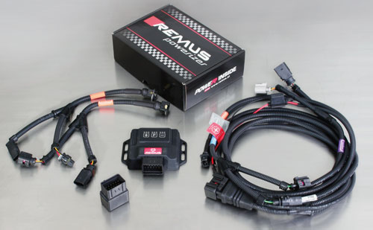

Under http://www.remus.eu/powerizer/ and http://www.remus.eu/remusresponder you will find the entire product range, prices and installation instructions.

REMUS Powerizer: More power, more economy and more fun.
- Up to 25 % more power
- Up to 20 % more torque
- Up to 1l/100 km fuel saving
- Fully adjustable power increase
- Simple DIY installation (Plug & Play)
REMUS POWERIZER: The performance figures represent the maximum achievable values. The actual performance output depends on the original tolerances of each engine. REMUS delivers the POWERIZER with the best possible setting for your vehicle type. You can adjust the performance according to your requirements as per the POWERIZER instructions

Legal references

1. Completion and registration of chip tuning in the car documents
Due to chip tuning, the operating license of the vehicle will terminate if the installation and registration of the POWERIZER is not carried out or immediately reported to an official approved testing facility. Please consider that driving a vehicle without the required operating license will cause legal penalties.

2. Vehicle insurance must be informed upon installing a POWERIZER
The installation of the POWERIZER can have influence on the insurance policy of your vehicle. You must inform the insurance company if you install a POWERIZER in your vehicle.

3. Effect of chip tuning on warranty and guarantee claims
a) When installing a POWERIZER, you will lose all guarantee claims regarding the engine against the vehicle manufacturer.
b) Installing a POWERIZER, can have influence on warranty claims against the seller of the vehicle.
c) REMUS excludes any claims regarding compensation for damages on the engine and drivetrain.

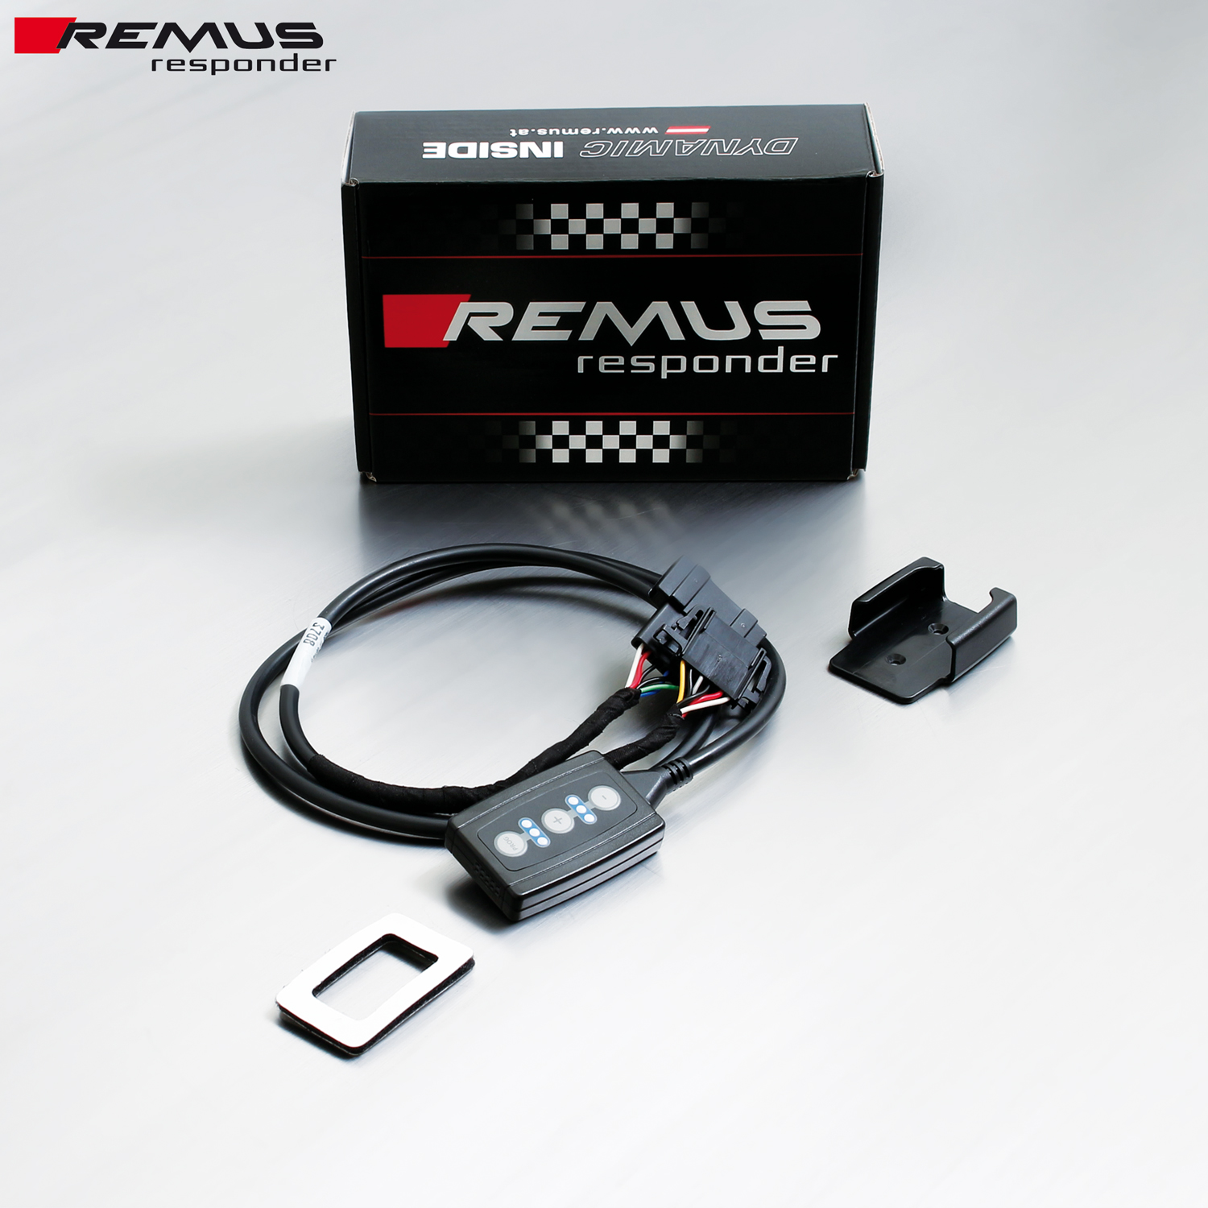

Under http://www.remus.eu/powerizer/ and http://www.remus.eu/remusresponder you will find the entire product range, prices and installation instructions.

REMUS RESPONDER:
Improved throttle response, more dynamic!
The REMUS Responder improves throttle response by means of modifying the accelerator pedal output signal. No more throttle delay and reduced lag during automatic shifting makes driving with the REMUS Responder more fun. The Responder attaches between the OEM pedal sensor and the OEM connector, ready to use in seconds due to plug & play technology. Sophisticated adjustable programming profiles can lead to improved fuel consumption and more efficiency. The 4 individual user selectable and adjustable performance settings allow drivers to select according to their own preferences.
The REMUS Responder totally eliminates the delay in modern electronic accelerator pedals!
