Product information 24/2017

HONDA Civic Type R
Honda Civic Type-R, type FK 8, from 2017
2.0l VTEC Turbo/Turbo GT 235 kW (K20C1)

REMUS Cat-back-system
- 100% stainless steel
- Powerful sound
- Performance and torque increase
- Light weight construction

+ 6,9 HP
+ 9,8 Nm

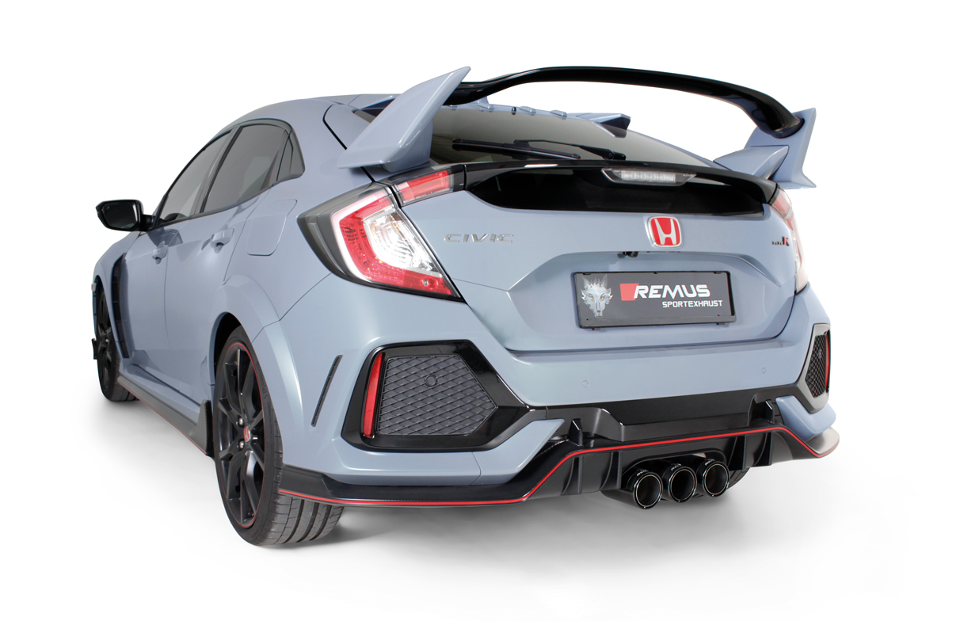

Car and engine specification
Honda Civic Type-R, FK 8, 2017=>
2.0l VTEC Turbo/Turbo GT 235 kW (K20C1)
INFOBOX:
- Cat-back-system: 206017 5500+ tail pipe set! No vehicle modifications are required!
- The use of racing products and products which do not have EC approval is generally not permitted on public roads.

Part no. | Description | € RRP price excl. VAT
256017 5500 | sport exhaust centered (without tail pipes)  with integrated valve, incl. EC homologation  Original tube Ø 60 mm - REMUS tube Ø 76 mm  It is not permissible to activate the valve on public roads as per the EU transport authority.  The activation of the valve can be carried out using the seperate available REMUS sound controller. The sound controller and electrical actuator allows the valve to be operated in 4 different positions. | 850,--
Optional: REMUS Sound Controller and electrical actuator
STE 0005BT | The REMUS Sound Controller consisting of the electronic module, the OBDII plug, the remote control button as well as the electrical actuator including the cables. Without EC homologation. | 480,--
choose from following tail pipe package:
0036 70S | Stainless steel tail pipe set 3 tail pipes Ø 102 mm angled, rolled edge, chromed, with adjustable spherical clamp connection | 255,--
0036 70CS | Carbon tail pipe set 3 tail pipes Ø 102 mm angled, Titanium internals, with adjustable spherical clamp connection | 630,--
0036 70SG | Stainless steel tail pipe set 3 tail pipes Ø 102 mm angled, straight cut, chromed, with adjustable spherical clamp connection | 222,--
0036 98C | Stainless steel tail pipe set 3 tail pipes Ø 98 mm Street Race, straight, carbon insert, with adjustable spherical clamp connection | 333,--
0036 98CB | Stainless steel tail pipe set 3 tail pipes Ø 98 mm Street Race Black Chrome, straight, carbon insert, with adjustable spherical clamp connection | 369,--

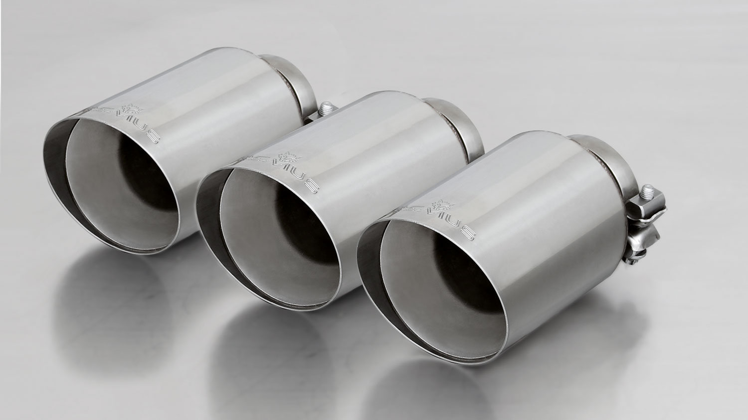
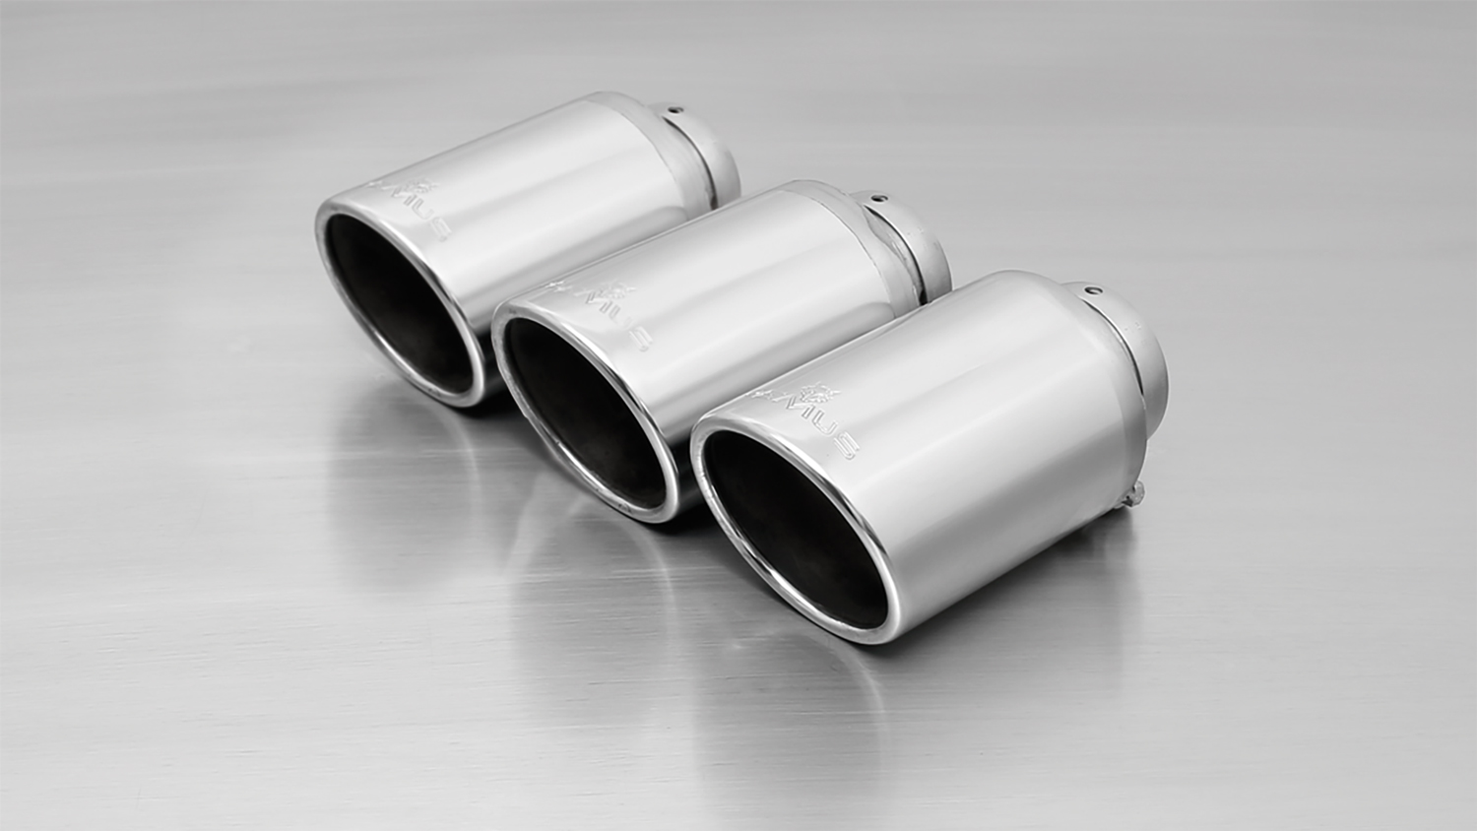
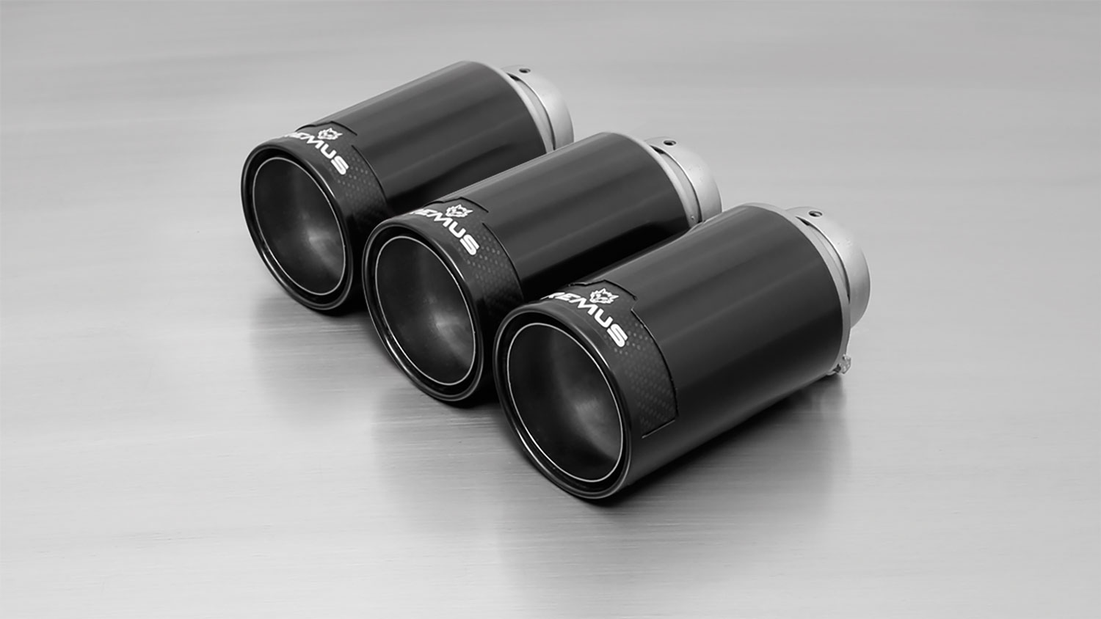
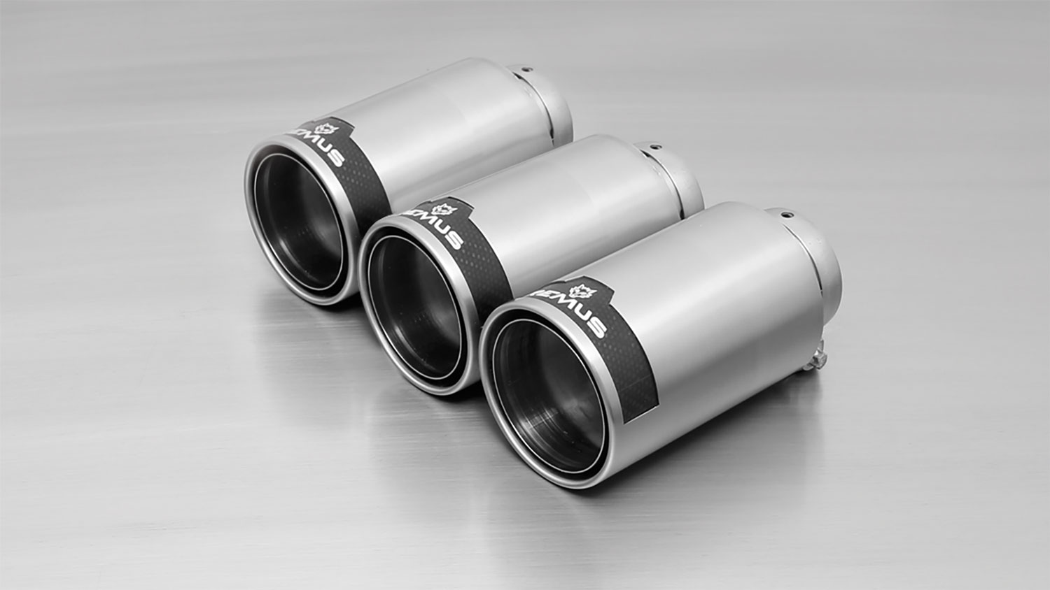
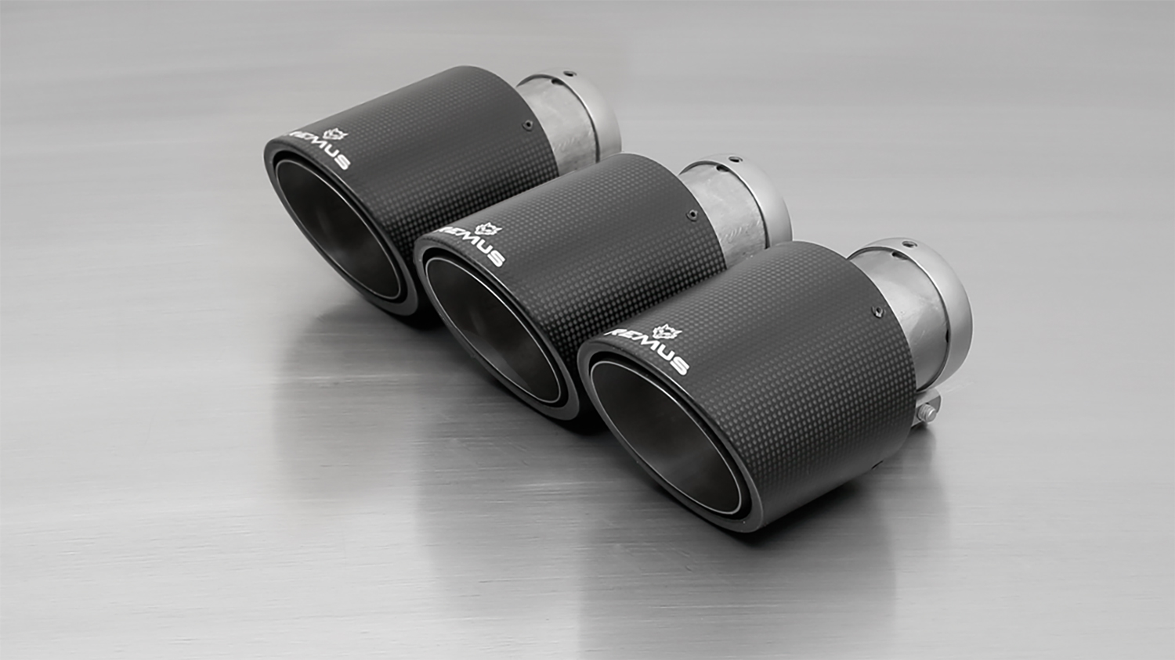

#70SG: tail pipes Ø 102 mm
angled, straight cut, chromed
#70CS: Carbon tail pipes Ø 84 mm angled, Titanium internals
#70S: tail pipes Ø 102 mm
angled, chromed

#98C: tail pipes Ø 98 mm
Street Race, polished
#98CB: tail pipes Ø 98 mm
Street Race Black Chrome

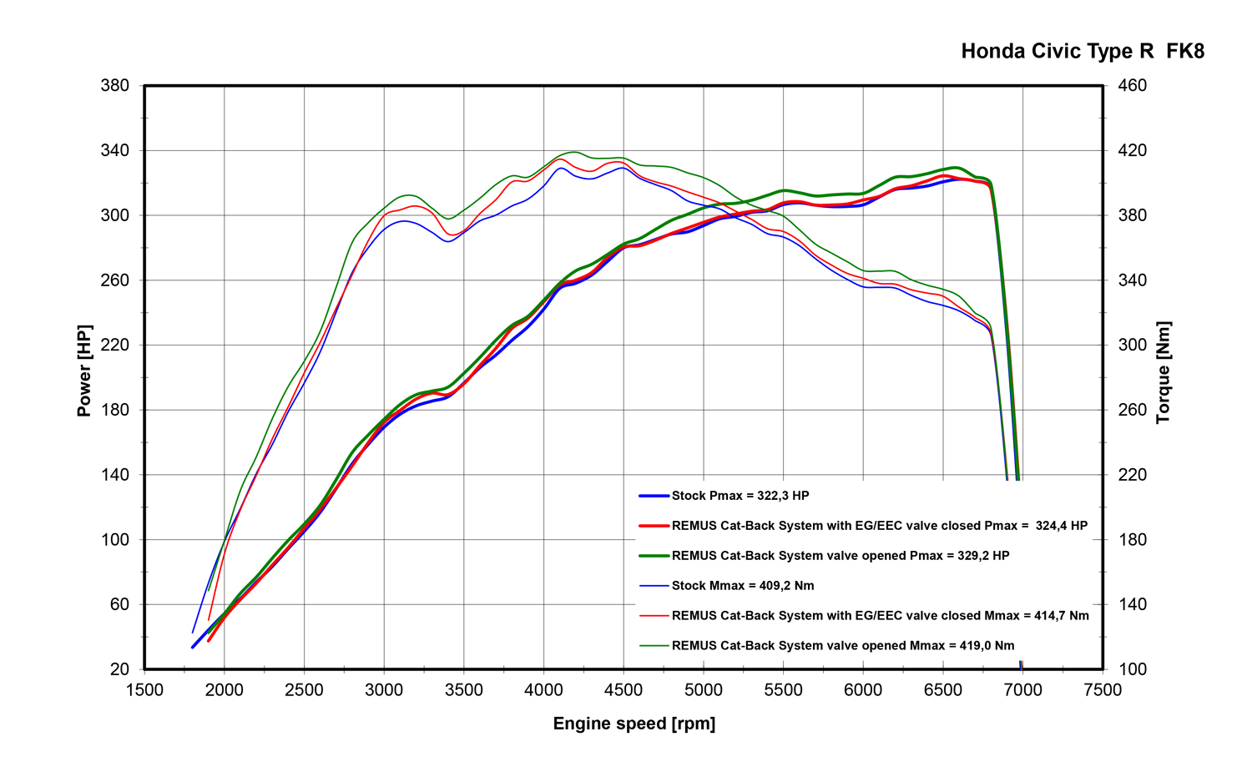

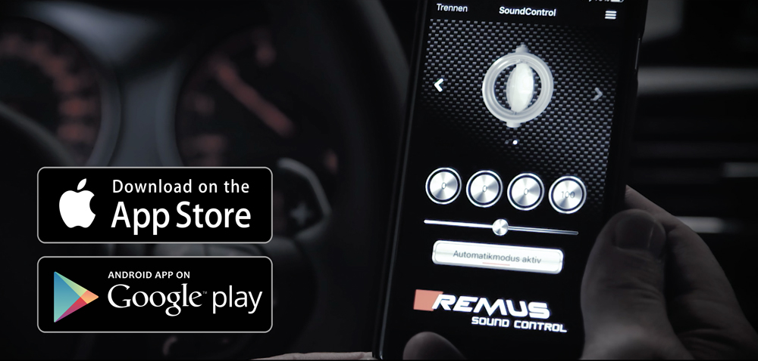

REMUS Sound Control App

The REMUS Sound Control app allows the response of the valve to be adjusted individually when using a valve controlled REMUS sports exhaust system.

The communication between the user's smartphone and the sophisticated REMUS Sound Control electronics is via Bluetooth. After a basic calibration, taking into account the maximum speed of the engine, it is possible to operate the valve either in manual mode or in automatic mode
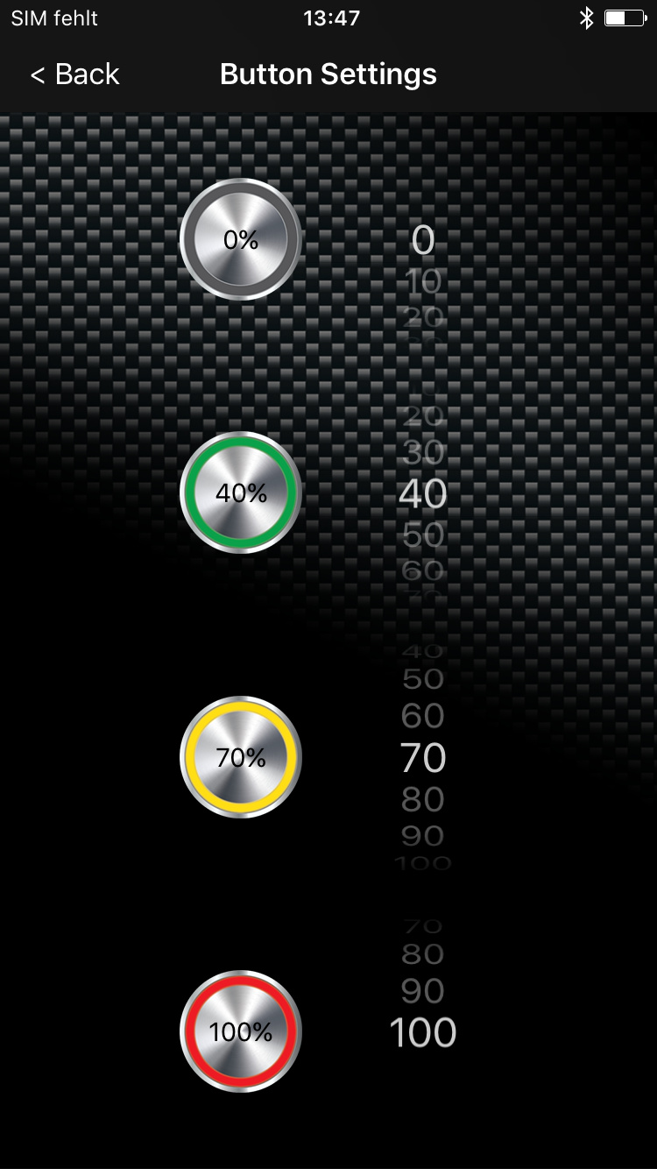
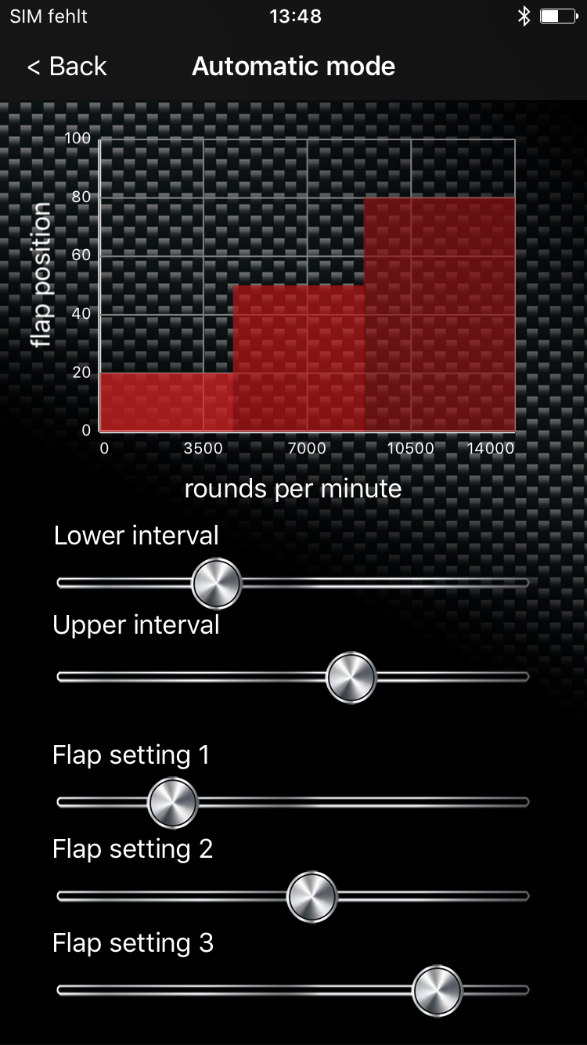
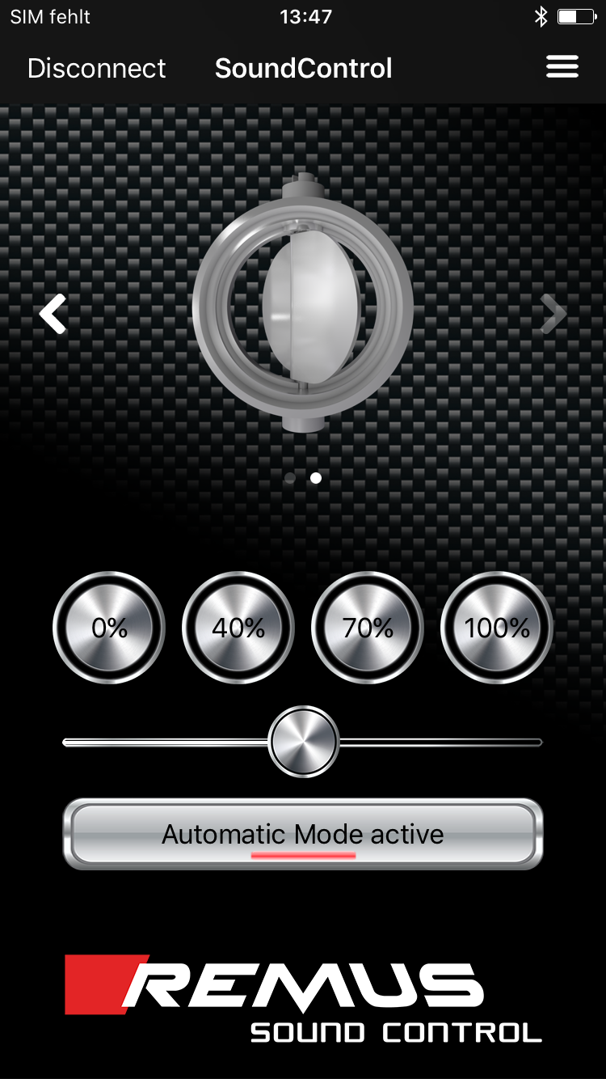

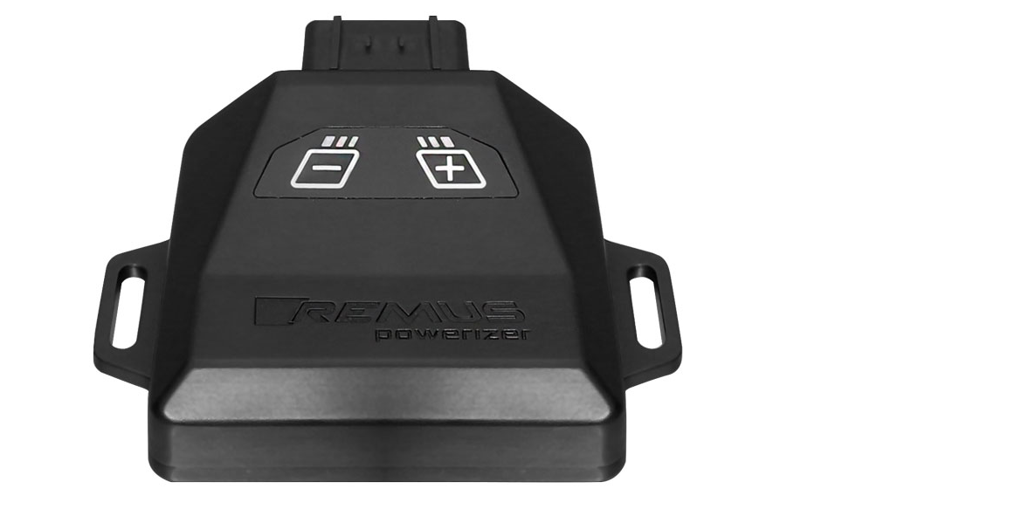
REMUS Powerizer
More power, more torque means more fun!
The perfectly matched electronics and advanced technology of the
REMUS Powerizer enhances Engine ECU mapping is optimized in
excess of 1000 times per second and ensures for a considerable and
noticeable power increase. The engine safety parameters (Check engine light) and engine management remains totally untouched to ensure that individual engine components are not overstrained.
Because of the plug & play concept, the REMUS Powerizer is installed in the engine compartment and connected to sensors such as intake manifold pressure sensor, boost pressure sensor, camshaft position sensor or fuel injection sensor. In real time, the incoming signals are processed, optimized and transmitted to the additional control unit. The Powerizer can be easily removed or decommissioned at any time using the supplied blind connector.
Due to the torque increase, the engine has more power at lower RPM which can lead to a reduction in fuel consumption. The power increase of the engine can easily be fine-tuned by means of seven preset levels via the keypad. The REMUS Powerizer is available for over 3300 petrol and diesel powered cars.
Furthermore, the latest Powerizer is also available for all vehicle engines with SENT technology. This newly developed multi-protocol technology combines analog and digital motor control the same time captures important analog signals of the engine management system which leads to increased engine performance. The capability to tune vehicles with SENT technology is an absolute highlight of the latest Powerizer.

- Up to 30% more power
- Up to 20% more torque
- Easy installation and removal (plug & play)
- Up to 1l/100 km fuel saving
- No vehicle modifications required
- 7 preset power levels

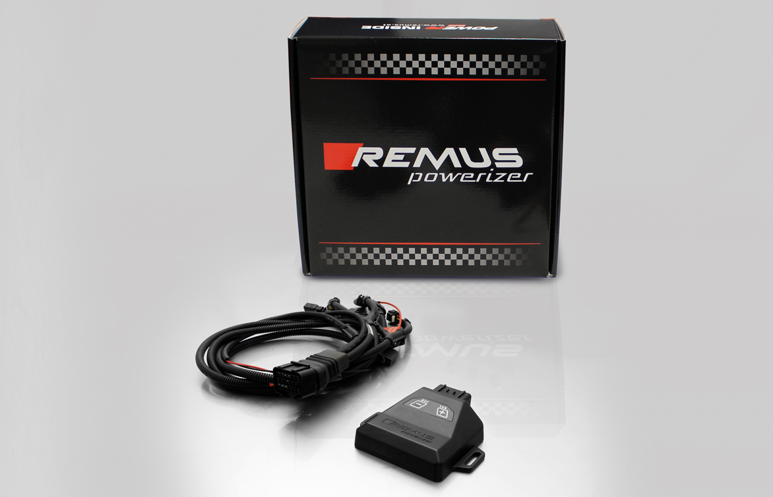

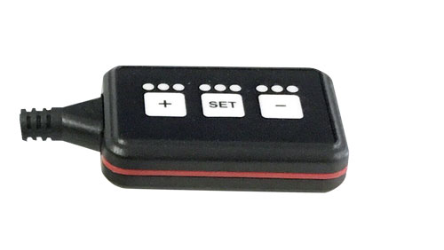
REMUS Responder

Improved throttle response for more driving dynamic!

The REMUS Responder improves throttle response and is the best power boost for
many electronically managed gas pedals. Results of up to 10% better acceleration are not uncommon and no annoying throttle delay and lag during take-off or in between manual / automatic shifts makes driving with the REMUS Responder much more dynamic.

The REMUS Responder attaches between the OEM gas pedal sensor and the OEM wiring loom and is ready to use in minutes due to plug & play technology.

The fully adjustable Responder settings can be adjusted in 20 different stages. The individual user-selectable and adjustable performance settings allow drivers to select according to their own preferences & road conditions.

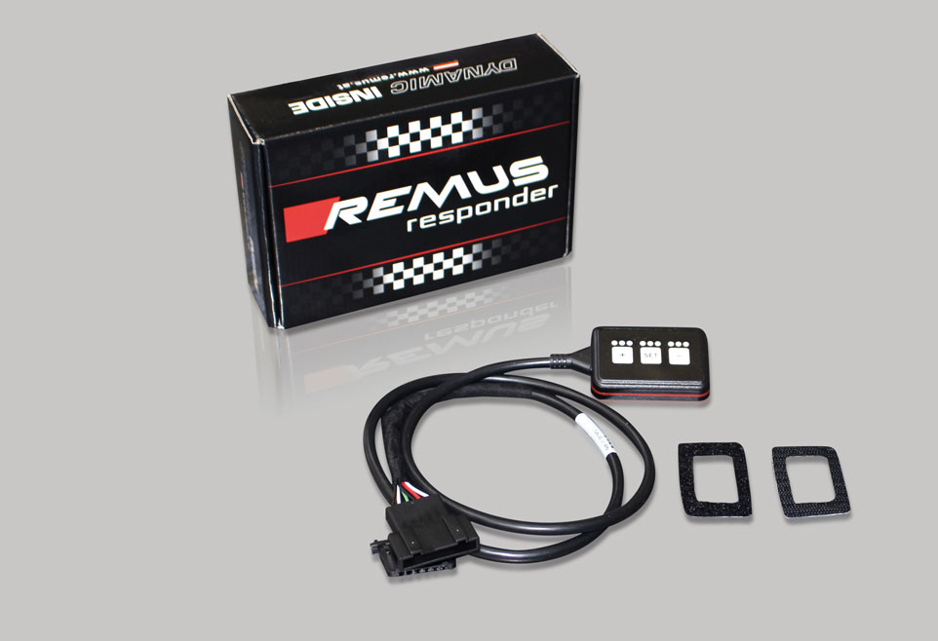

- Improves throttle response and lag during take-off and gear changes
- Quicker reaction times, more driving dynamic
- 20 individual user selectable performance settings
- Vehicle specific programming using OEM quality connectors
- Simple plug & play installation and removal without leaving traces

