REMUS product information 19-2016

SEAT Leon Cupra ST, type 5F, 2014=>

Dear REMUS Partner,

We are pleased to inform you that we have completed our next development:
REMUS RACING downpipe, resonated cat-back section and L&R sport exhaust system with selectable tail pipes for the
SEAT Leon Cupra ST, type 5F, 2014=>

It would be a pleasure for us to receive your orders.

Stay tuned!
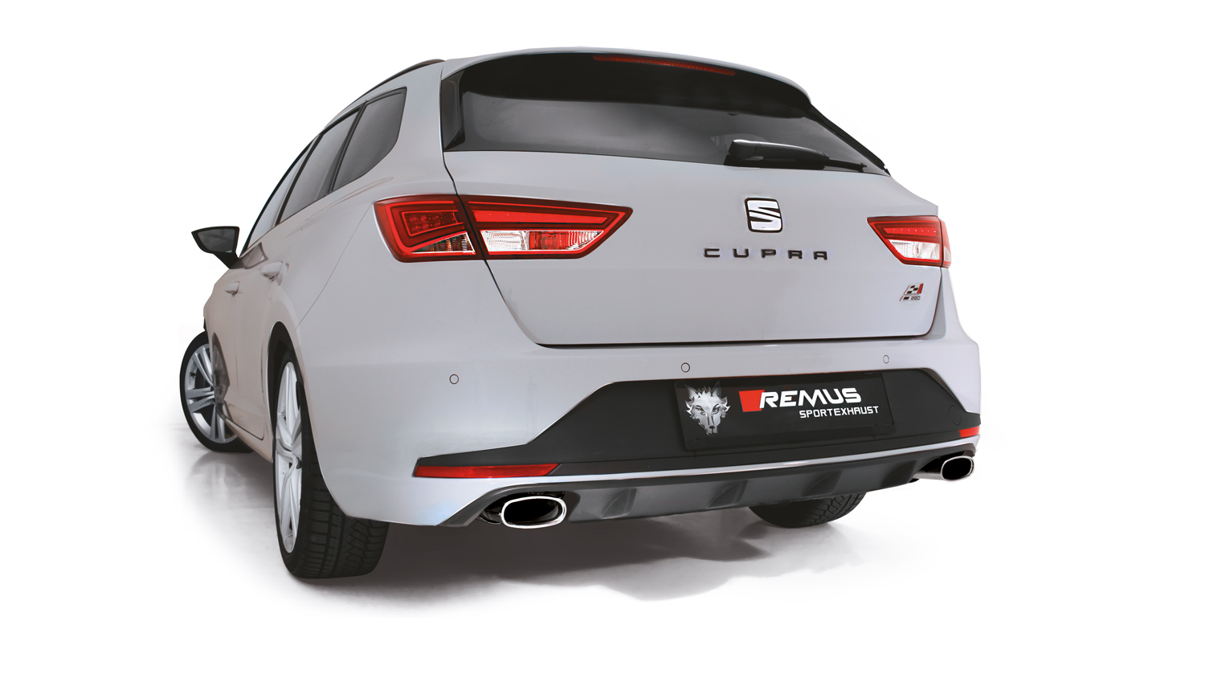
Your REMUS Team

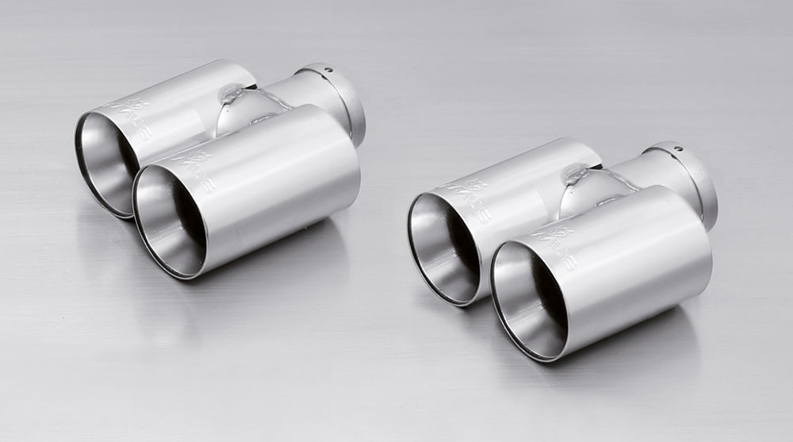
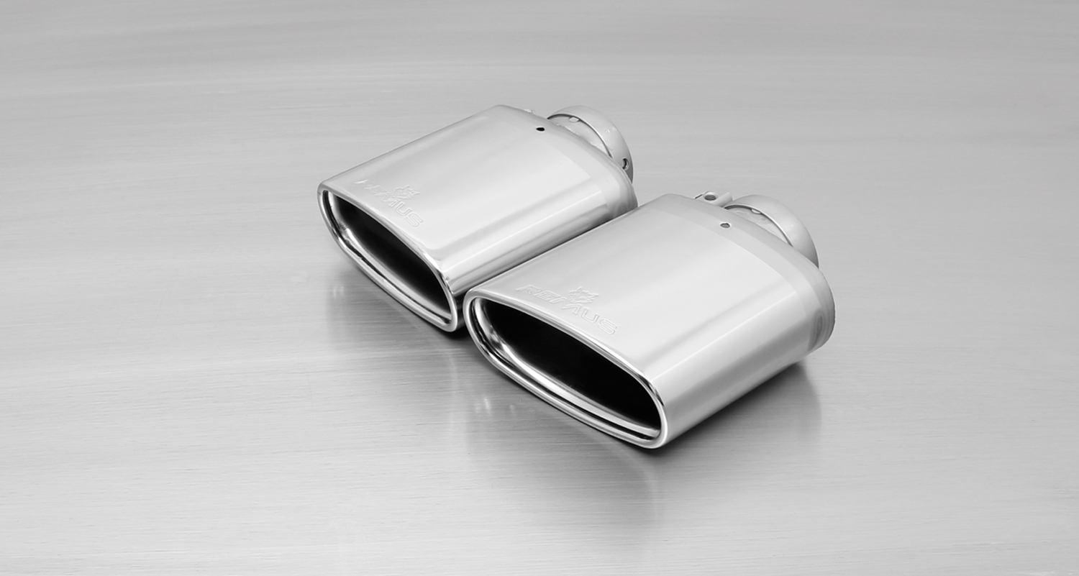
#04G: tail pipe Ø 76 mm,
straight cut, chromed

#14SS: tail pipe 142x72 mm
angled/angled, chromed

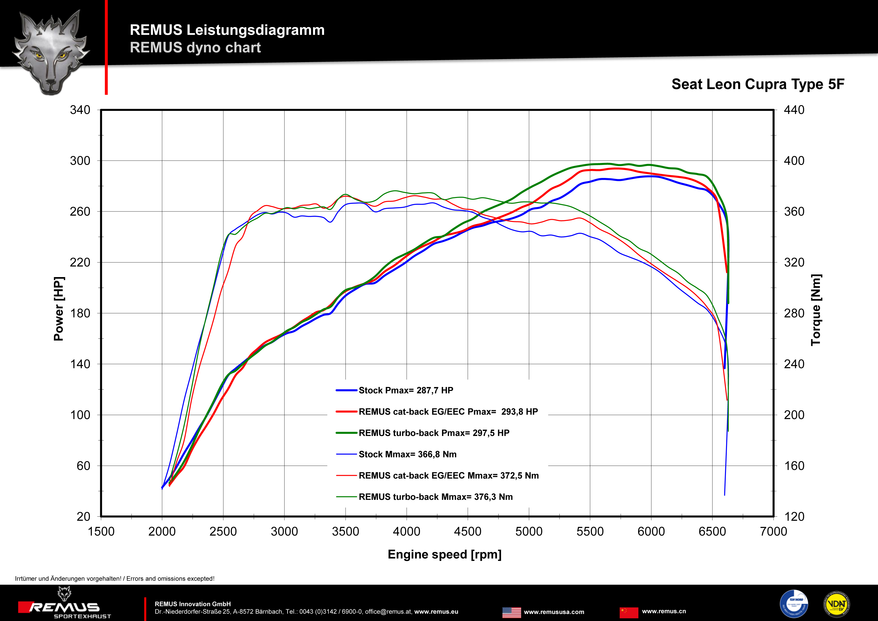

Car and engine specification
SEAT Leon Cupra ST, type 5F, 2014=>
2.0l TSI 195 kW (CJXE); 2.0l TSI 206 kW (CJXA)
2.0l TSI 213 kW (CJXH) – without homologation!
Art.Nr. | Art des Teils | € Preis exkl. MwSt.
955113 1100 | Stainless steel RACING downpipe, with sport catalytic convertor (200 CPSI), without homologation, can only be installed in combination with the REMUS cat-back section.  Original tube Ø 60 mm / REMUS tube Ø 70 mm | 874,--
796515 0300 | Stainless steel resonated cat-back section, can only be installed in combination with the REMUS sport exhaust, with EEC homologation.  Original tube Ø 60 mm / REMUS tube Ø 65 mm | 260,--
796515 0500LR | Stainless steel L&R sport exhaust system (without tail pipes), with EEC homologation.  Original tube Ø 60 mm / REMUS tube Ø 65 mm | 525,--
Choose from following tail pipe package::
0026 04G | Stainless steel tail pipe set L/R consisting of 4 tail pipes Ø 76 mm straight cut, chromed, with adjustable spherical clamp connection | 300,--
0026 14SS | Stainless steel tail pipe set L/R consisting of 2 tail pipes 142x72 mm angled/angled, chromed, with adjustable spherical clamp connection | 190,--
INFOBOX:
- Sport exhaust and tail pipe set only fit as a complete system!
- NOT homologated for 2.0l TSI 213 kW model!
- Axle-back-system: 796515 0500LR + tail pipe set. The original exhaust will need to be cut at the manufacturer marked cutting point! No rear skirt modifications required!
- Cat-back-system: 796515 0300 + 796515 0500LR + tail pipe set. No vehicle modifications required!
- Turbo-Back system: 955113 1100 + 796515 0300 + 796515 0500LR + tail pipe set. No vehicle modifications required!
- When installing REMUS downpipes with or without the racing catalytic convertor, which are only suitable for closed road driving, it is important to note that ECU tuning is required to ensure that the engine runs and performs efficiently and to ensure that the CEL does not come on.

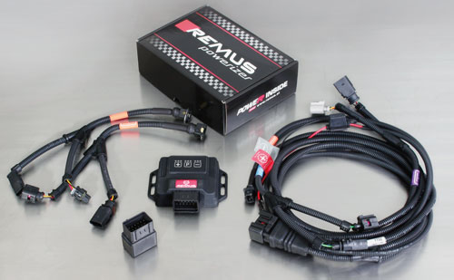

Under http://www.remus.eu/powerizer/ and http://www.remus.eu/remusresponder you will find the entire product range, prices and installation instructions.

REMUS Powerizer: More power, more economy and more fun.
- Up to 25 % more power
- Up to 20 % more torque
- Up to 1l/100 km fuel saving
- Fully adjustable power increase
- Simple DIY installation (Plug & Play)
REMUS POWERIZER: The performance figures represent the maximum achievable values. The actual performance output depends on the original tolerances of each engine. REMUS delivers the POWERIZER with the best possible setting for your vehicle type. You can adjust the performance according to your requirements as per the POWERIZER instructions

Legal references

1. Completion and registration of chip tuning in the car documents
Due to chip tuning, the operating license of the vehicle will terminate if the installation and registration of the POWERIZER is not carried out or immediately reported to an official approved testing facility. Please consider that driving a vehicle without the required operating license will cause legal penalties.

2. Vehicle insurance must be informed upon installing a POWERIZER
The installation of the POWERIZER can have influence on the insurance policy of your vehicle. You must inform the insurance company if you install a POWERIZER in your vehicle.

3. Effect of chip tuning on warranty and guarantee claims
a) When installing a POWERIZER, you will lose all guarantee claims regarding the engine against the vehicle manufacturer.
b) Installing a POWERIZER, can have influence on warranty claims against the seller of the vehicle.
c) REMUS excludes any claims regarding compensation for damages on the engine and drivetrain.

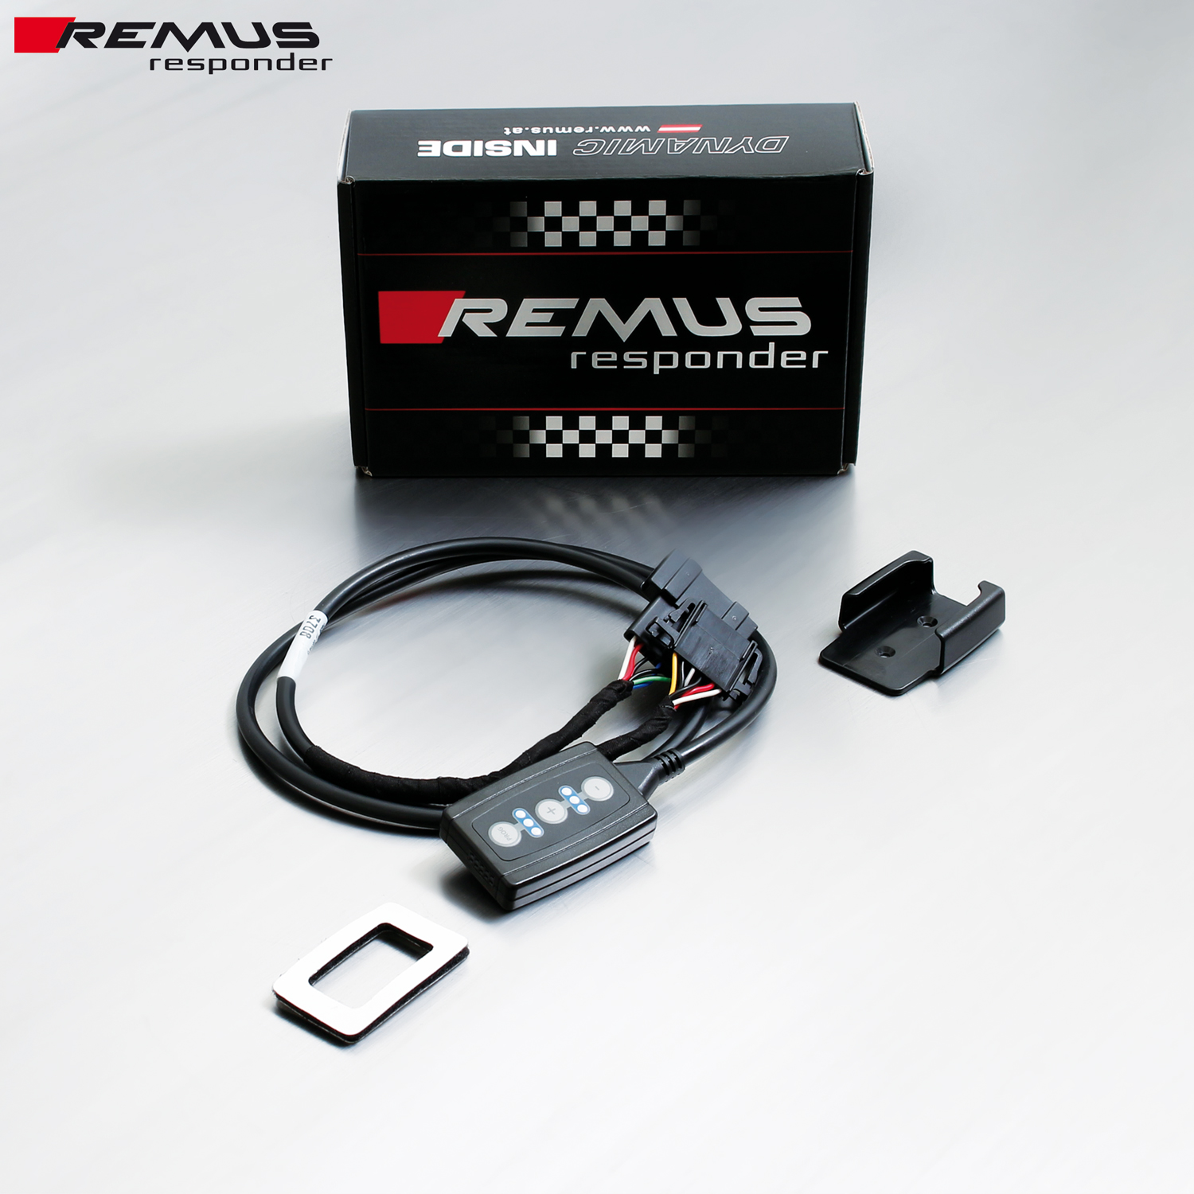

Under http://www.remus.eu/powerizer/ and http://www.remus.eu/remusresponder you will find the entire product range, prices and installation instructions.

REMUS RESPONDER:
Improved throttle response, more dynamic!
The REMUS Responder improves throttle response by means of modifying the accelerator pedal output signal. No more throttle delay and reduced lag during automatic shifting makes driving with the REMUS Responder more fun. The Responder attaches between the OEM pedal sensor and the OEM connector, ready to use in seconds due to plug & play technology. Sophisticated adjustable programming profiles can lead to improved fuel consumption and more efficiency. The 4 individual user selectable and adjustable performance settings allow drivers to select according to their own preferences.
The REMUS Responder totally eliminates the delay in modern electronic accelerator pedals!
