Product information 09/2017
SEAT Leon
SEAT Leon FR / SC FR, type 5F Facelift, 3-/5-türig, ab 2017
1.2l TSI 63 kW; 1.2l TSI 81 kW; 1.4l TSI 92 kW; 1.4l TSI 110 kW;
REMUS Axle-back-system
- 100% stainless steel
- Powerful sound
- Performance and torque increase
- Light weight construction

+ 3,2 HP
+ 2,5 Nm

1.6l TDI 63 kW; 2.0l TDI 110 kW; 2.0l TDI 135 kW;
Not for engines with active cylinder deactivation!

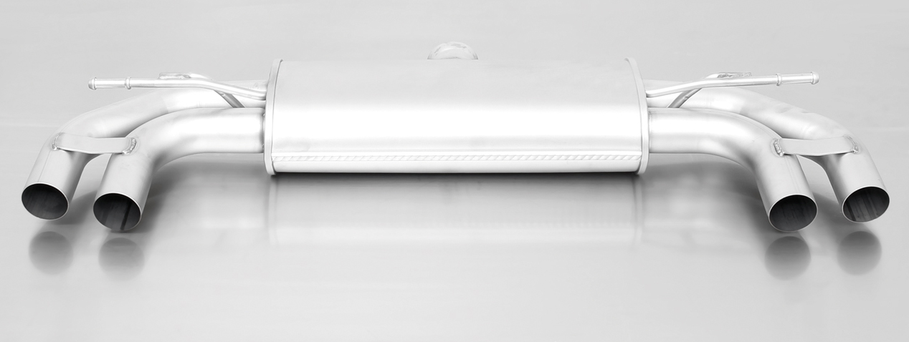

955113 1500

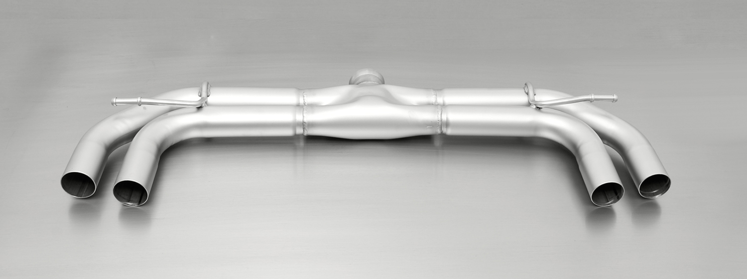

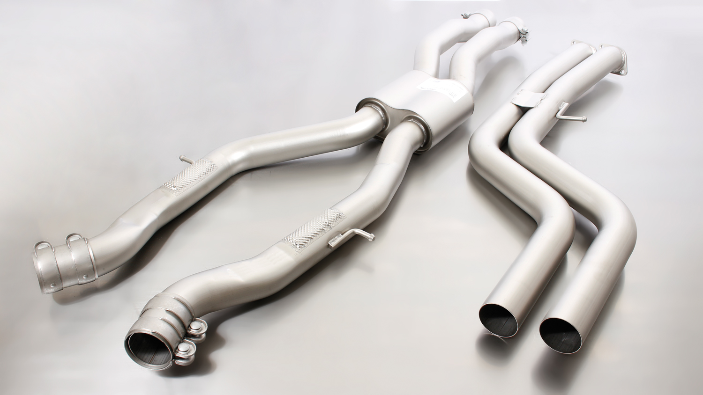

954112 1600

Car and engine specification
SEAT Leon FR, type 5F Facelift, 2017=>
SEAT Leon SC FR, type 5F Facelift, 2017=>
1.2l TSI 63 kW; 1.2l TSI 81 kW; 1.4l TSI 92 kW; 1.4l TSI 110 kW;
1.6l TDI 63 kW; 2.0l TDI 110 kW; 2.0l TDI 135 kW;
Not for engines with active cylinder deactivation!
INFOBOX:
- Axle-back-system L/R: 953612 0000 resp. 954112 0000 + 955113 1500 resp. 954112 1600 (Racing) + tail pipe set + 792405 HES!
Part no. | Description | € RRP price excl. VAT
Choose the connection tube according to engine:
953612 0000 | Stainless steel connection tube (twist beam axle) for mounting on 1.2l TSI 63 kW; 1.2l TSI 81 kW; 1.4l TSI 92 kW; 1.4l TSI 110 kW; 1.6l TDI 63 kW; 2.0l TDI 110 kW | 59,--
954112 0000 | Stainless steel connection tube (multi-link axle) for mounting on 2.0l TDI 135 kW | 59,--
Choose between sport exhaust L/R incl. EC homologation or non-resonated RACING section L/R without homologation:
955113 1500 | Stainless steel sport exhaust centered L/R system (without tail pipes), REMUS tube Ø 70 mm, EC homologation | 303,--
954112 1600 | Stainless steel non resonated RACING L/R system (without tail pipes), without homologation | 130,--
Choose from following tail pipe package:
0046 55S | Stainless steel tail pipe set 4 tail pipes Ø 84 mm angled, rolled edge, chromed, with adjustable spherical clamp connection | 320,--
0046 83C | Stainless steel tail pipe set 4 tail pipes Ø 84 mm Street Race, straight, carbon insert, with adjustable spherical clamp connection | 392,--
0046 83CS | Stainless steel tail pipe set 4 tail pipes Ø 84 mm Carbon Race, angled, carbon ring, with adjustable spherical clamp connection | 408,--
0046 83CB | Stainless steel tail pipe set 4 tail pipes Ø 84 mm Street Race Black Chrome, straight, carbon insert, with adjustable spherical clamp connection | 440,--
0046 83CTS | Carbon tail pipe set 4 tail pipes Ø 84 mm angled, Titanium internals, with adjustable spherical clamp connection | 780,--
ABS rear diffusor:
792405 HES | ABS rear diffusor left/right, satin black, only for Facelift models | 199,--
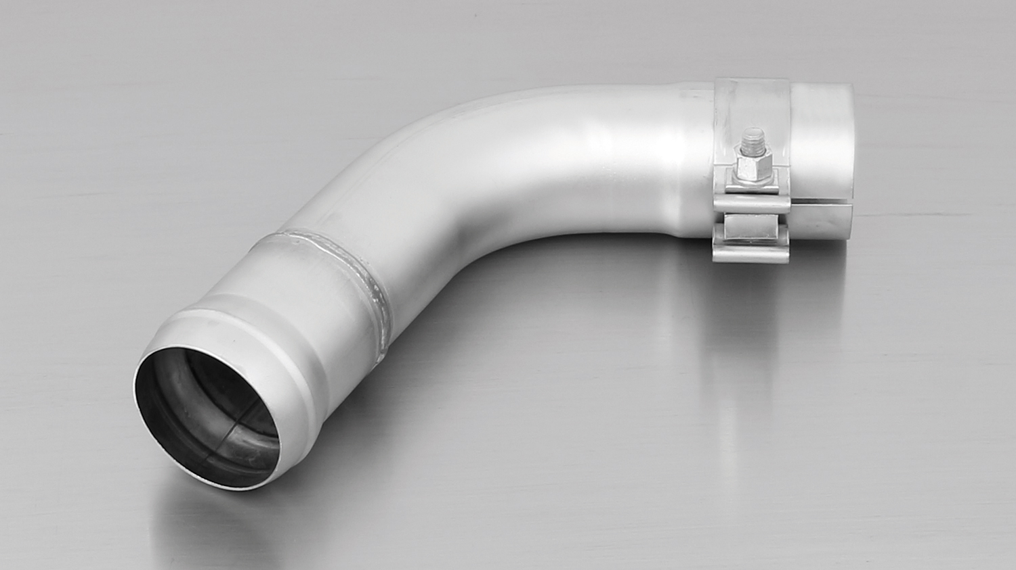
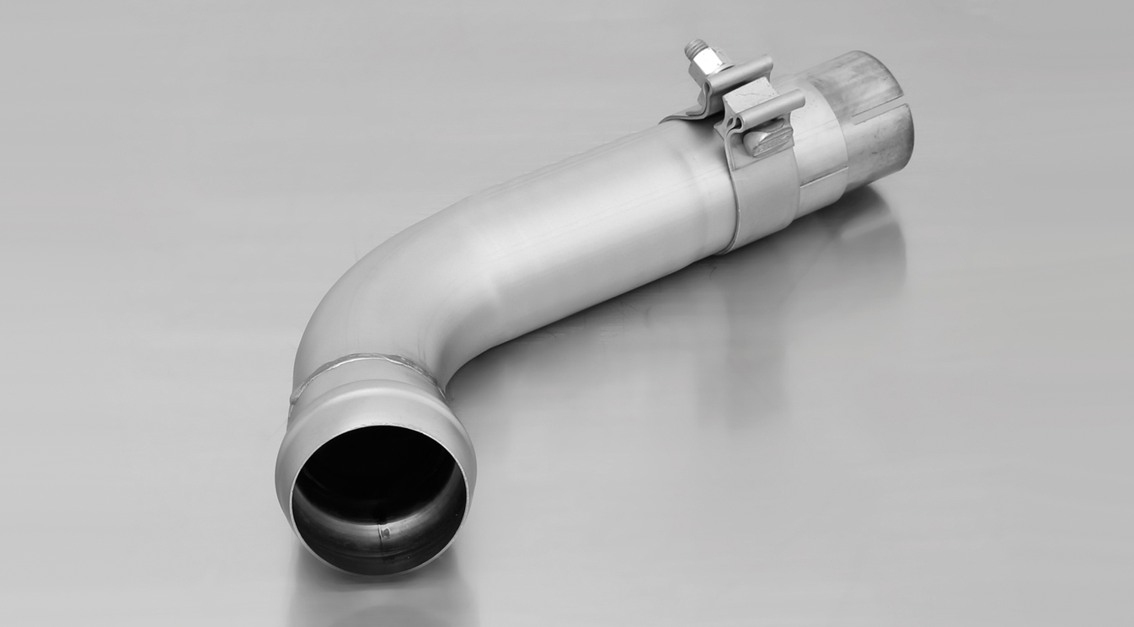

954112 0000
953612 0000

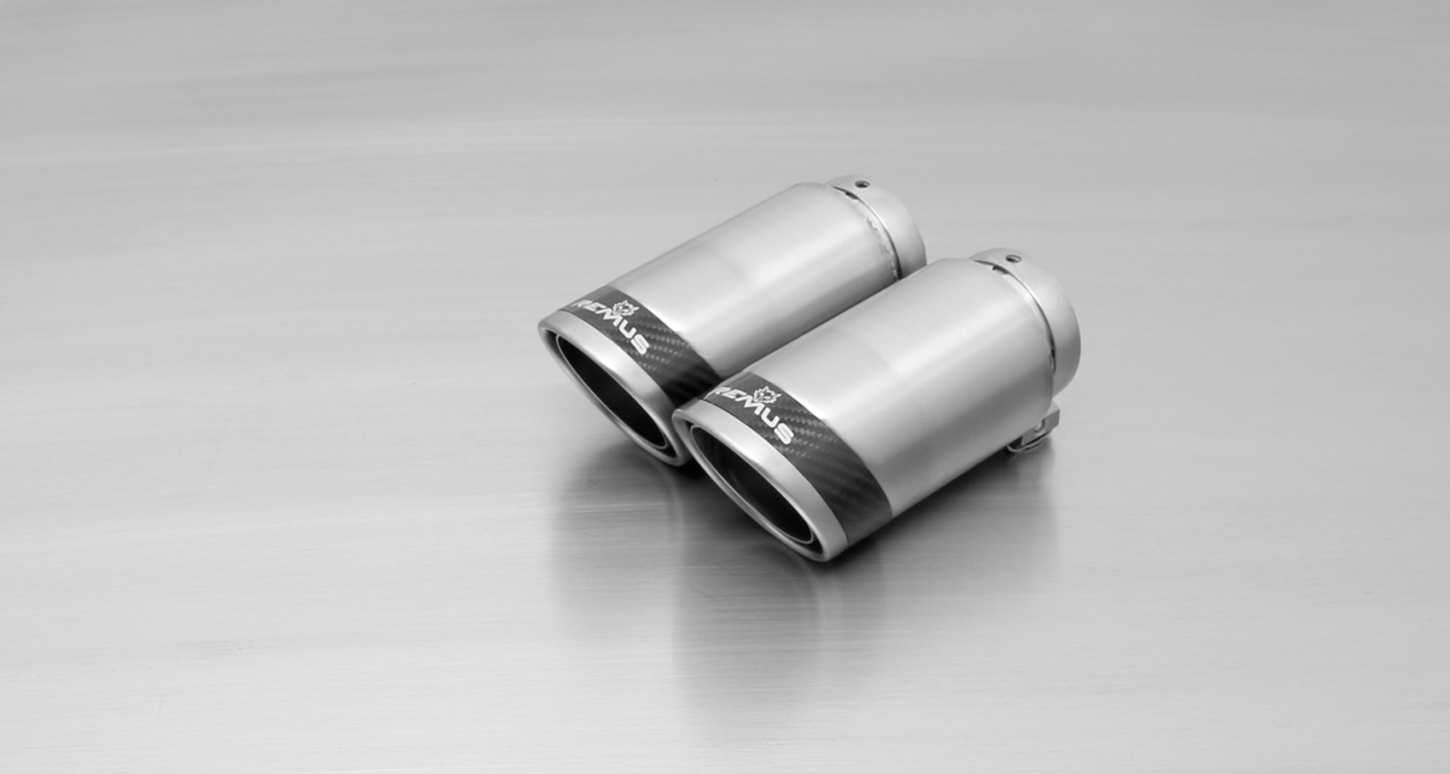
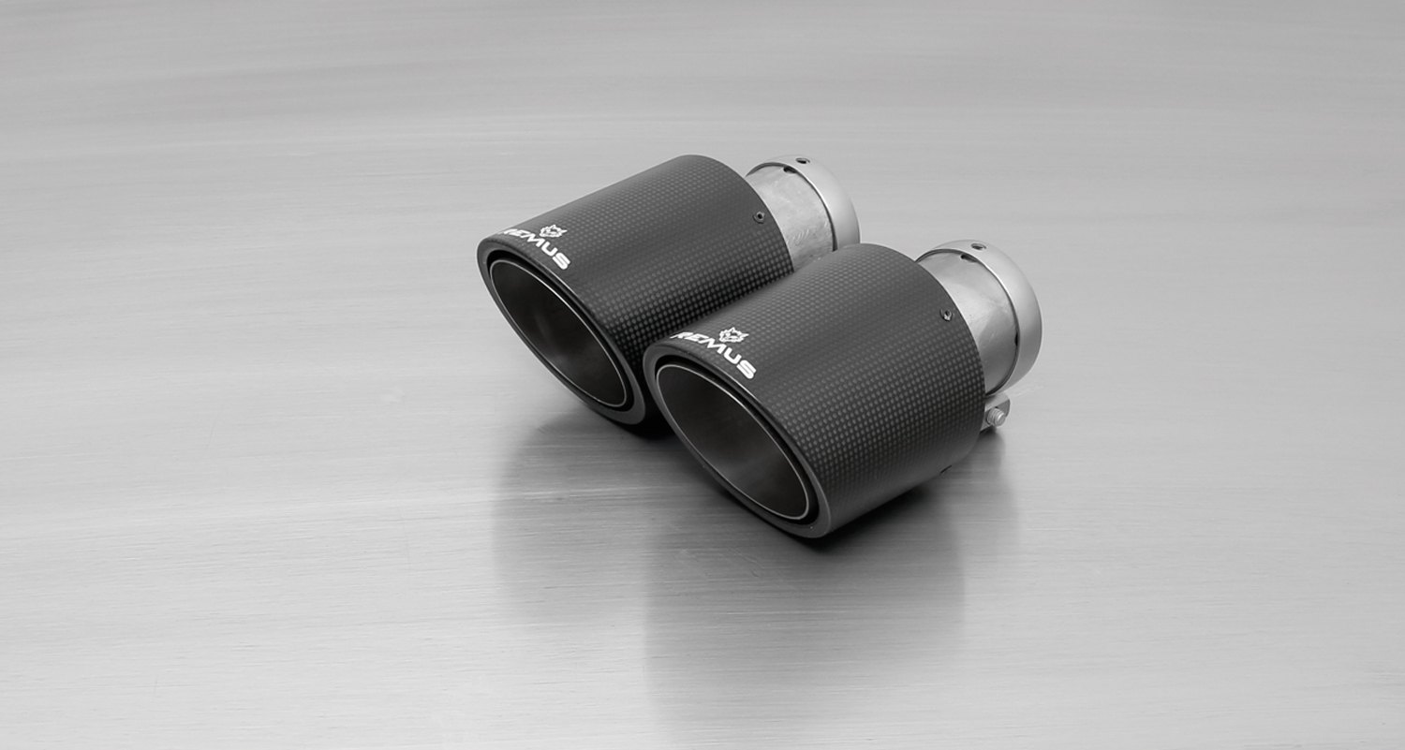
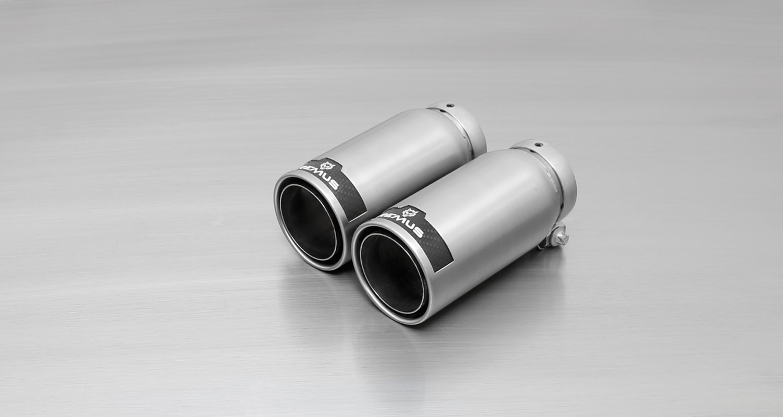
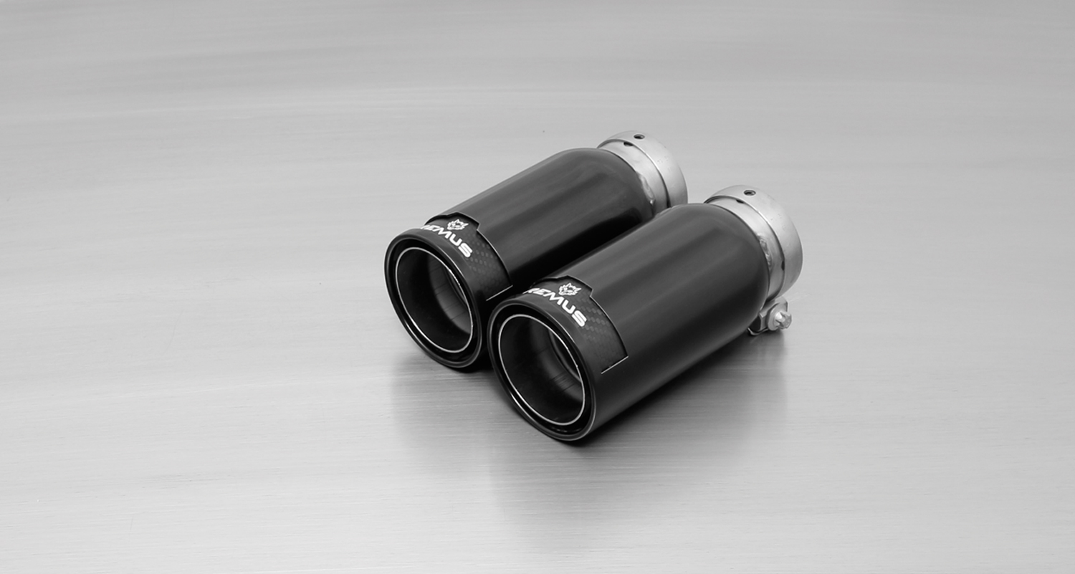
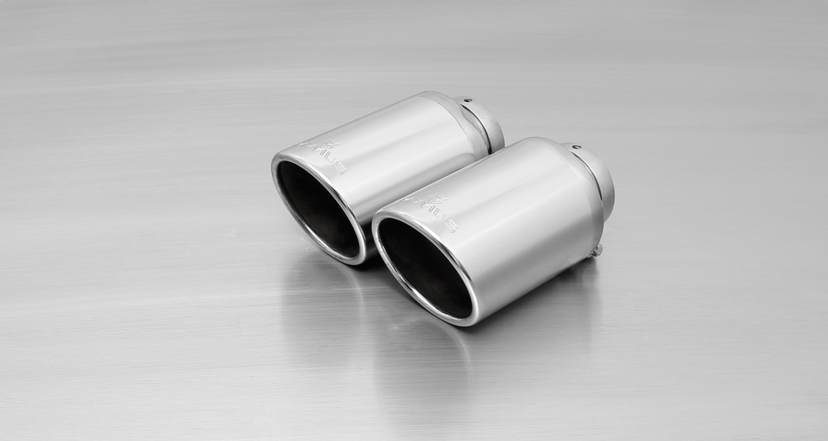
#83CS: tail pipes Ø 84 mm
Carbon Race, polished
#83C: tail pipes Ø 84 mm
Street Race, polished
#83CTS: Carbon-tail pipes
Ø 84 mm angled, Titanium internals

#83CB: tail pipes Ø 84 mm
Street Race Black Chrome
#55S: tail pipes Ø 84 mm
angled, chromed

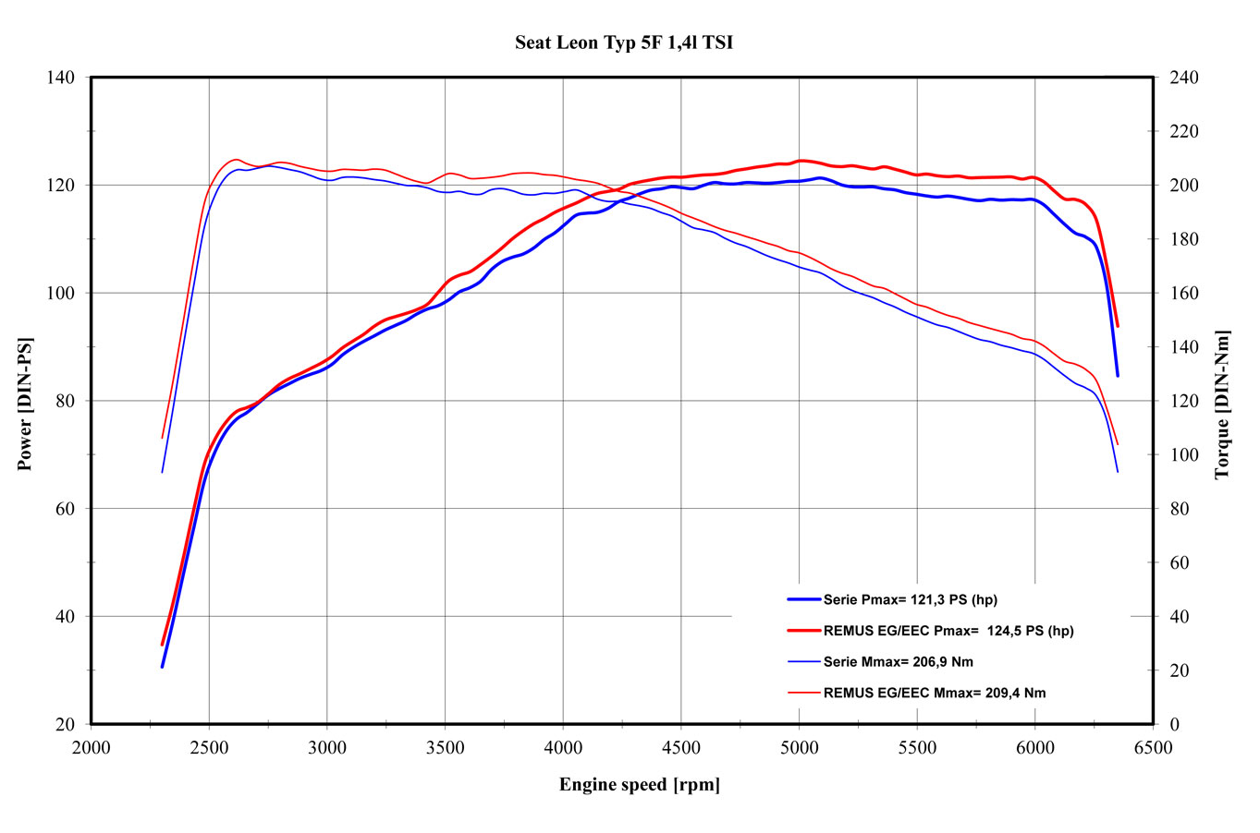

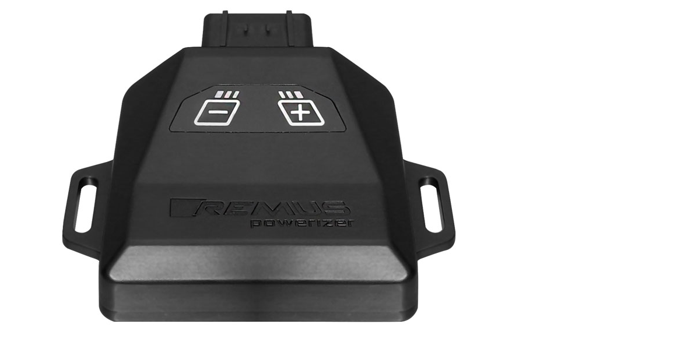
REMUS Powerizer
More power, more torque means more fun!
The perfectly matched electronics and advanced technology of the
REMUS Powerizer enhances Engine ECU mapping is optimized in
excess of 1000 times per second and ensures for a considerable and
noticeable power increase. The engine safety parameters (Check engine light) and engine management remains totally untouched to ensure that individual engine components are not overstrained.
Because of the plug & play concept, the REMUS Powerizer is installed in the engine compartment and connected to sensors such as intake manifold pressure sensor, boost pressure sensor, camshaft position sensor or fuel injection sensor. In real time, the incoming signals are processed, optimized and transmitted to the additional control unit. The Powerizer can be easily removed or decommissioned at any time using the supplied blind connector.
Due to the torque increase, the engine has more power at lower RPM which can lead to a reduction in fuel consumption. The power increase of the engine can easily be fine-tuned by means of seven preset levels via the keypad. The REMUS Powerizer is available for over 3300 petrol and diesel powered cars.
Furthermore, the latest Powerizer is also available for all vehicle engines with SENT technology. This newly developed multi-protocol technology combines analog and digital motor control the same time captures important analog signals of the engine management system which leads to increased engine performance. The capability to tune vehicles with SENT technology is an absolute highlight of the latest Powerizer.

- Up to 30% more power
- Up to 20% more torque
- Easy installation and removal (plug & play)
- Up to 1l/100 km fuel saving
- No vehicle modifications required
- 7 preset power levels

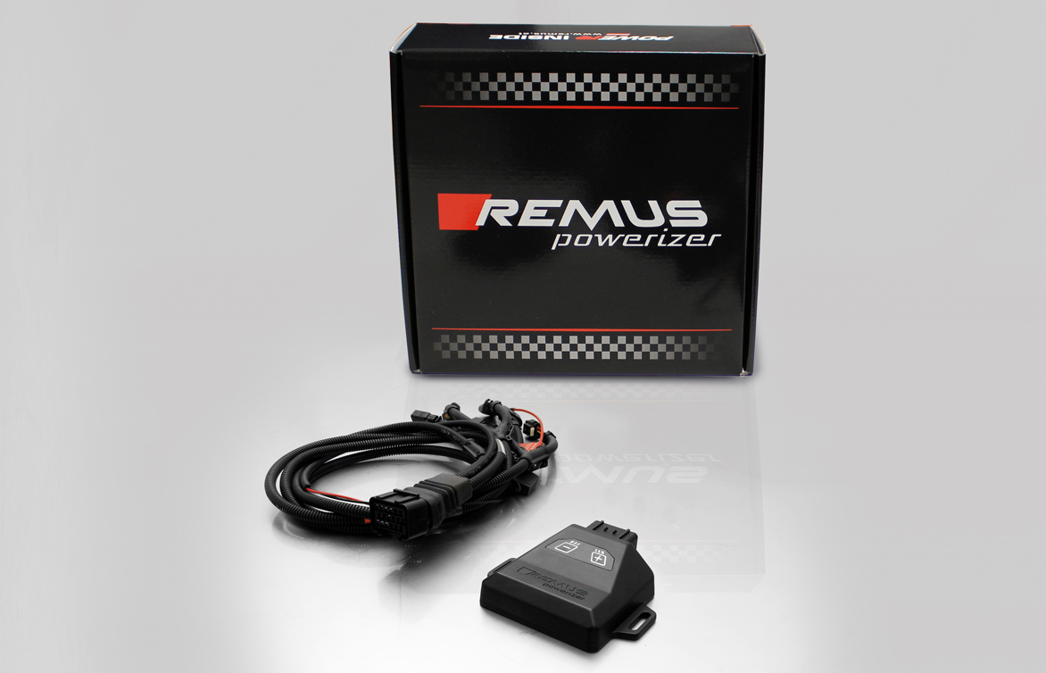

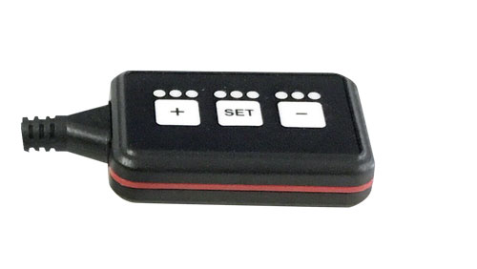
REMUS Responder

Improved throttle response for more driving dynamic!

The REMUS Responder improves throttle response and is the best power boost for
many electronically managed gas pedals. Results of up to 10% better acceleration are not uncommon and no annoying throttle delay and lag during take-off or in between manual / automatic shifts makes driving with the REMUS Responder much more dynamic.

The REMUS Responder attaches between the OEM gas pedal sensor and the OEM wiring loom and is ready to use in minutes due to plug & play technology.

The fully adjustable Responder settings can be adjusted in 20 different stages. The individual user-selectable and adjustable performance settings allow drivers to select according to their own preferences & road conditions.

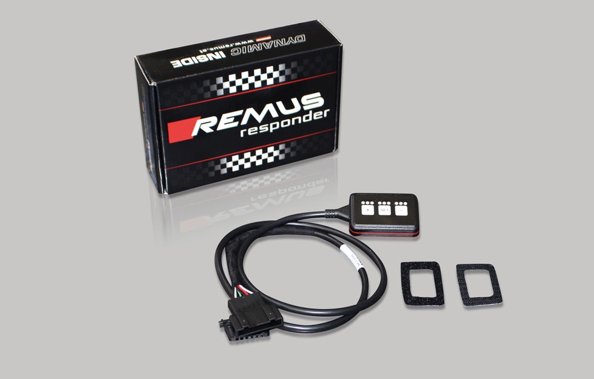

- Improves throttle response and lag during take-off and gear changes
- Quicker reaction times, more driving dynamic
- 20 individual user selectable performance settings
- Vehicle specific programming using OEM quality connectors
- Simple plug & play installation and removal without leaving traces

