Product information 07/2017
BMW M3 / M4
BMW M3 LCI F80 Sedan, from 01/2015
REMUS Cat-back-system
- 100% stainless steel
- Powerful sound
- Performance and torque increase
- Light weight construction

+ 11,5 HP
+ 11,3 Nm

BMW M3 LCI F80 Sedan, from 2017
3.0l 331 kW (S55B30A)
BMW M4 LCI F82 Coupe, from 05/2016
3.0l 331 kW (S55B30A)

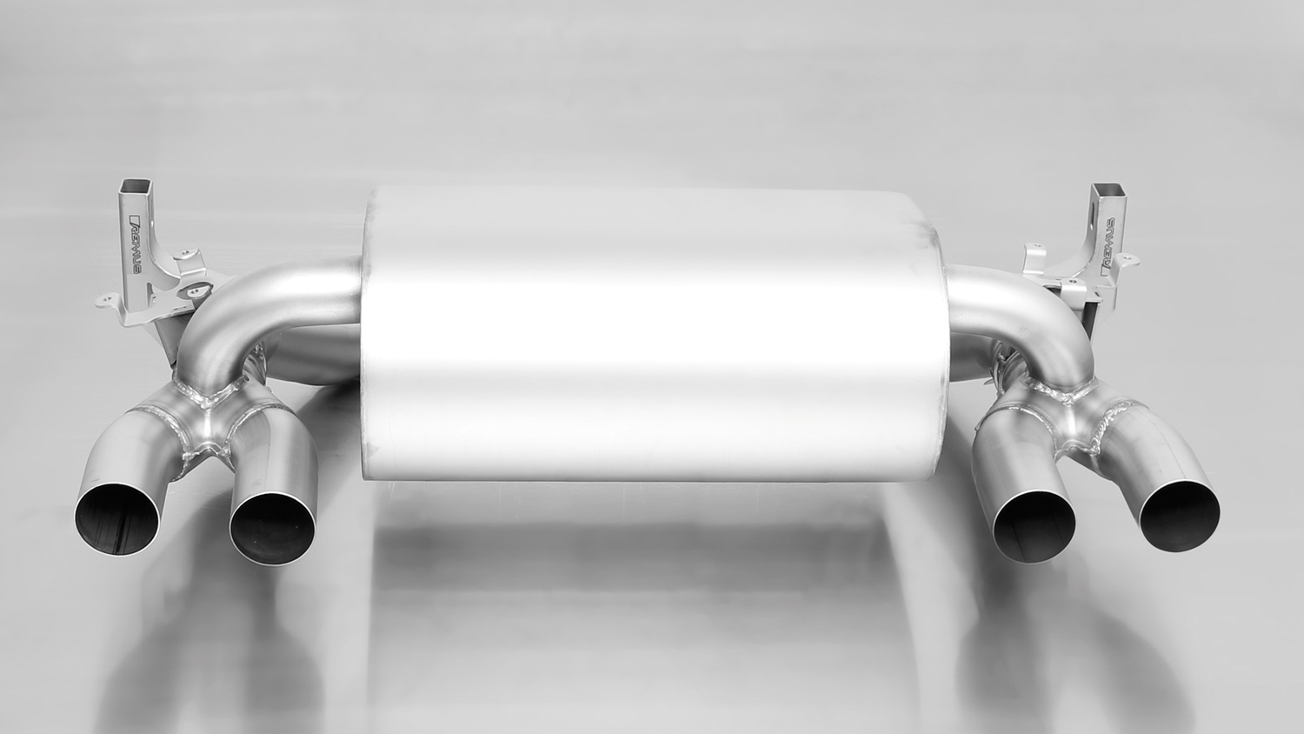

089014 0500

Car and engine specification
BMW M3 LCI F80 Sedan, 01/2015=>
BMW M3 LCI F80 Sedan, 2017=>
3.0l 331 kW (S55B30A)
BMW M4 LCI F82 Coupe, 05/2016=>
3.0l 331 kW (S55B30A)
INFOBOX:
- Axle-back-system L/R: 089014 0500 + tail pipe set! The original exhaust will need to be cut at the manufacturer marked cutting point!
- Cat-back-system L/R: 089014 0000 (Racing) resp. 089014 0300 (Racing) + 089014 0500 + tail pipe set! No cutting of the original exhaust system required!
Part no. | Description | € RRP price excl. VAT
089014 0000 | Stainless steel RACING X-pipe NON-resonated front section (eliminating front silencer and secondary catalytic convertors), without homologation  Original tube Ø 65 mm, REMUS tube Ø 70 mm | 672,--
089014 0300 | Stainless steel RACING X-pipe RESONATED front section (eliminating front silencer and secondary catalytic convertors), without homologation  Original tube Ø 65 mm, REMUS tube Ø 70 mm | 790,--
089014 0500 | Stainless steel sport exhaust, L/R axle back-system (without tail pipes),  with 2 integrated valves, incl. EC homologation  Original tube Ø 65 mm, REMUS tube Ø 70 mm  The activation of the valve is carried out using the original actuator via the vehicle onboard electronics. | 1.614,--
Choose from following tail pipe package:
0046 98C | Stainless steel tail pipe set 4 tail pipes Ø 98 mm Street Race, straight, carbon insert, with adjustable spherical clamp connection | 444,--
0046 98CB | ess steel tail pipe set 4 tail pipes Ø 98 mm Street Race Black Chrome, straight, carbon insert, with adjustable spherical clamp connection | 492,--
0046 70SG | Stainless steel tail pipe set 4 tail pipes Ø 102 mm angled, straight cut, chromed, with adjustable spherical clamp connection | 296,--
0046 70S | Stainless steel tail pipe set 4 tail pipes Ø 102 mm angled, rolled edge, chromed, with adjustable spherical clamp connection | 340,--
0046 70CS | Carbon tail pipe set 4 tail pipes Ø 102 mm angled, Titanium internals, with adjustable spherical clamp connection | 840,--
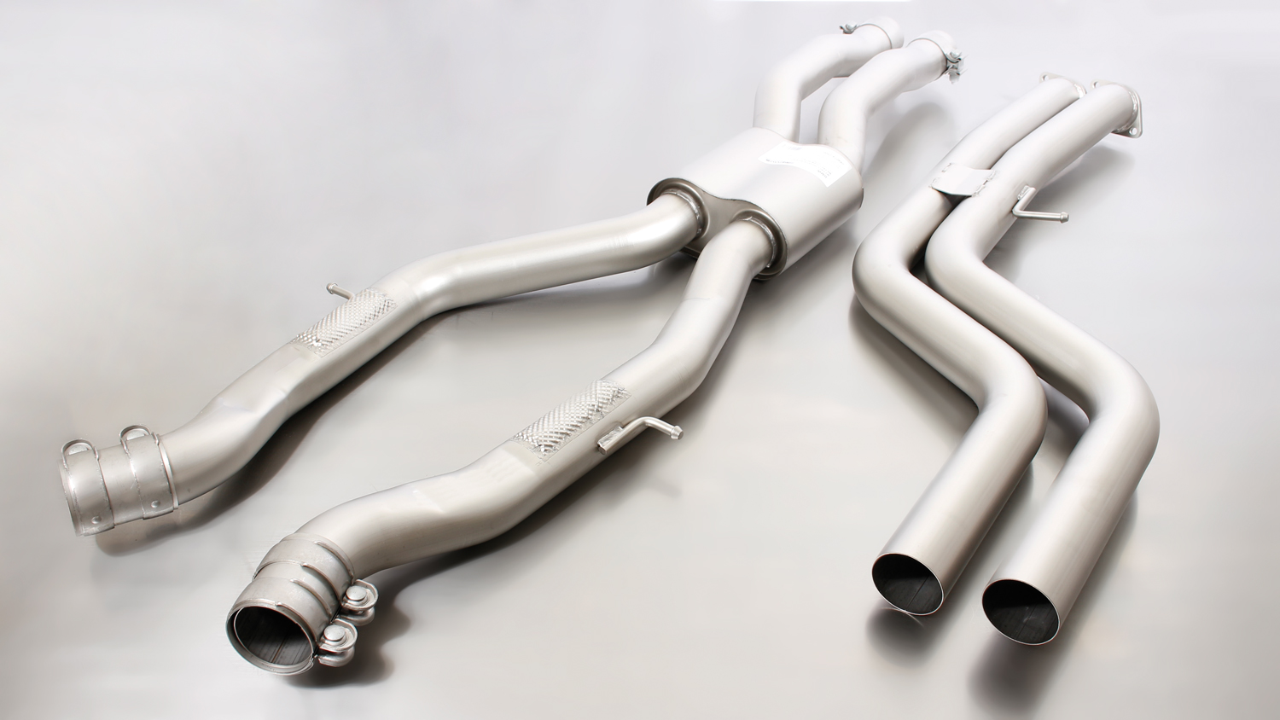
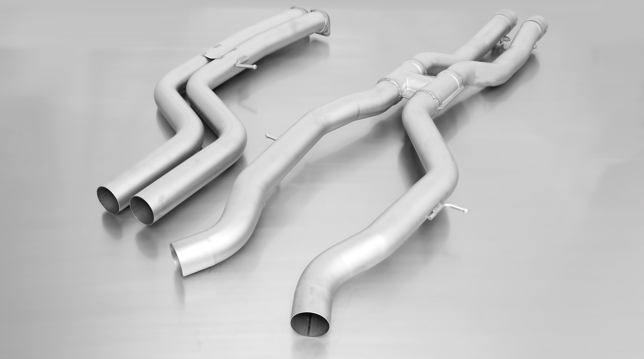

089014 0300
089014 0000

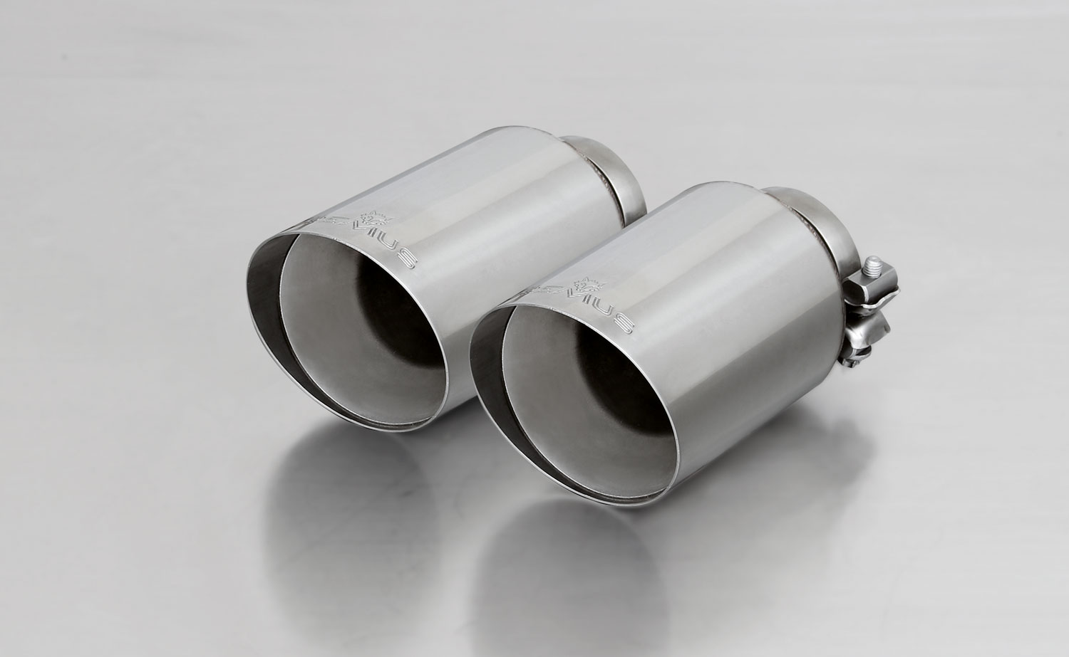
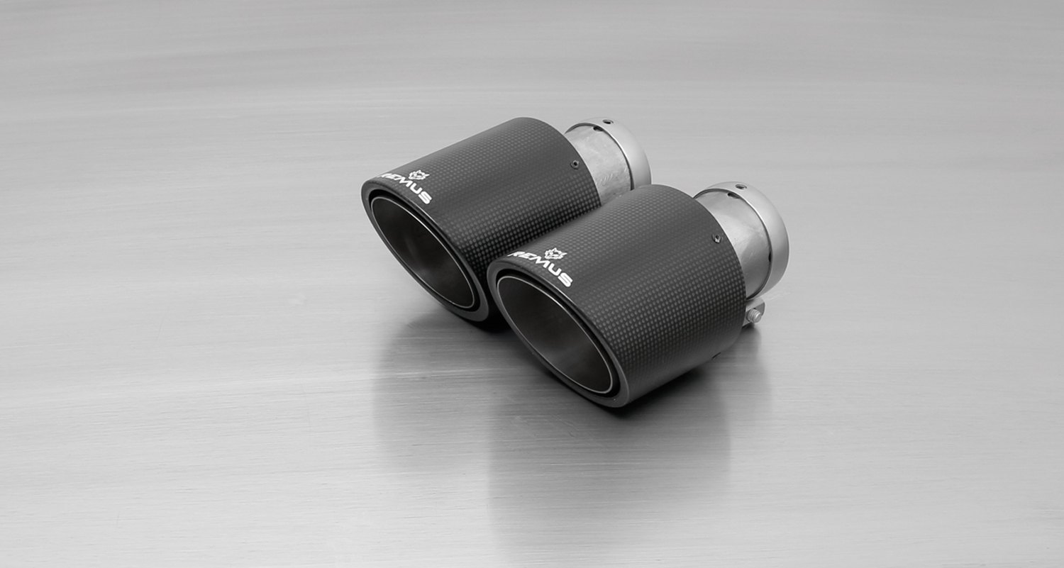
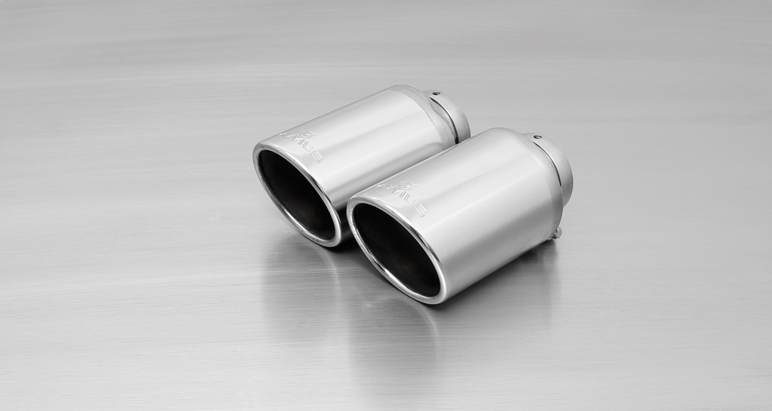

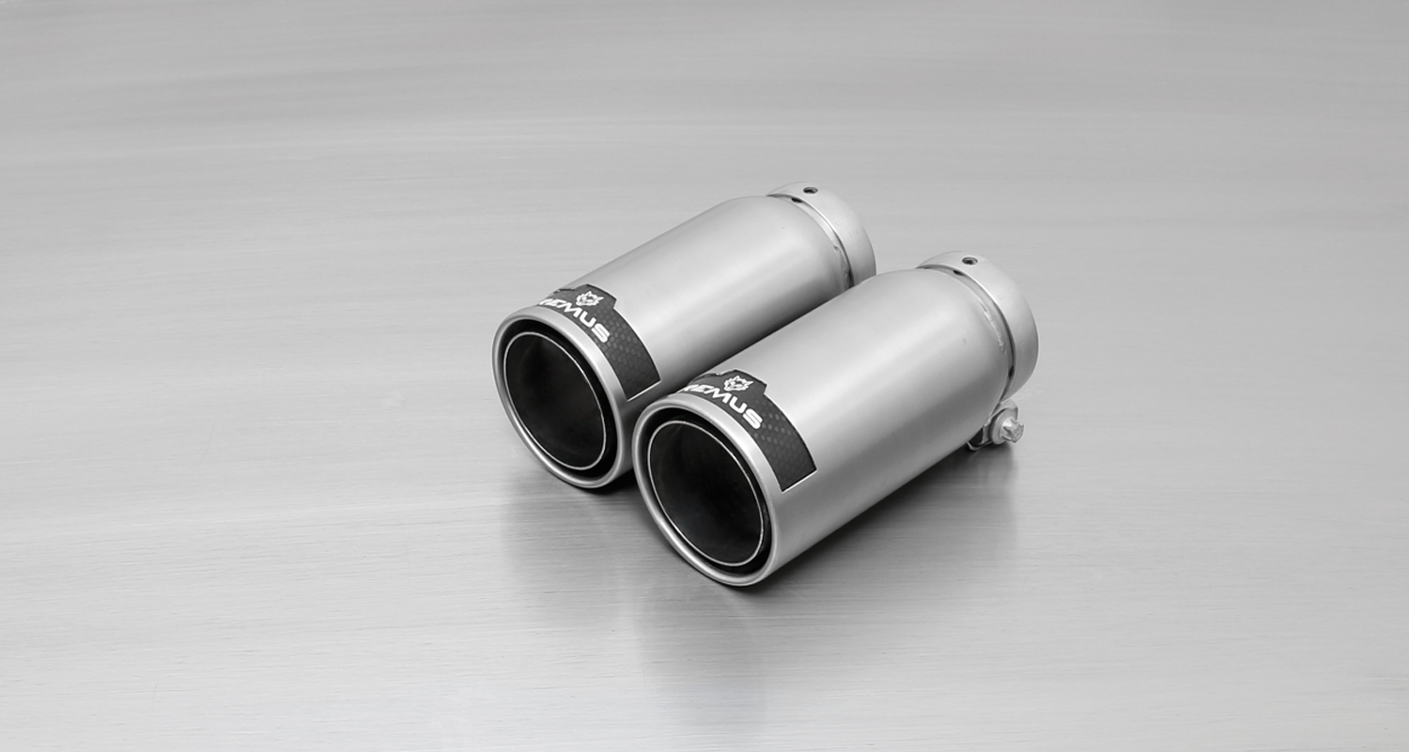
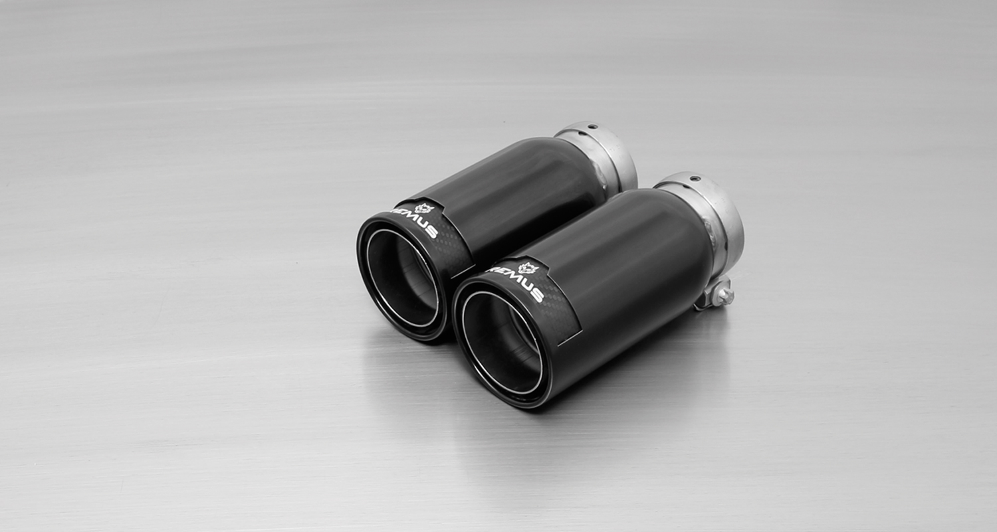

#70SG: tail pipes Ø 102 mm
angled, straight cut, chromed
#70S: tail pipes Ø 102 mm
angled, chromed

#98CB: tail pipes Ø 98 mm
Street Race Black Chrome
#98C: tail pipes Ø 98 mm
Street Race, polished
#70CS: Carbon tail pipes Ø 84 mm angled, Titanium internals

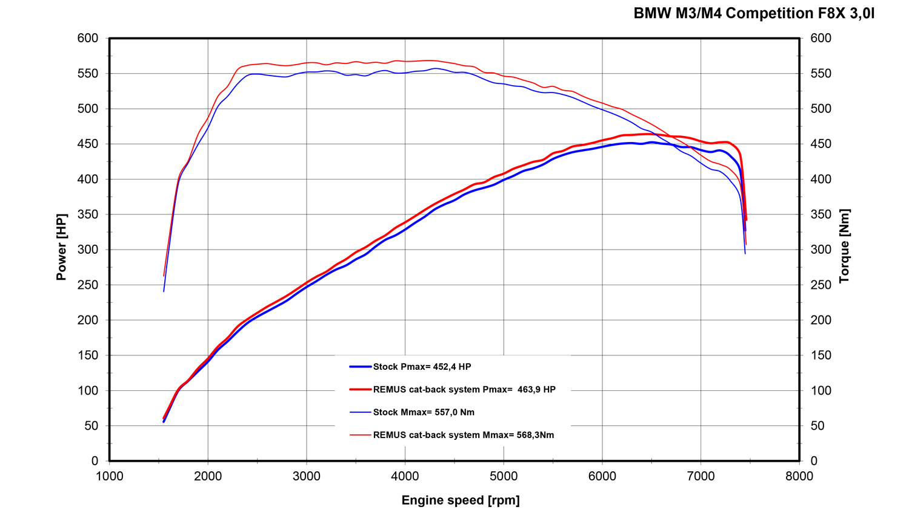

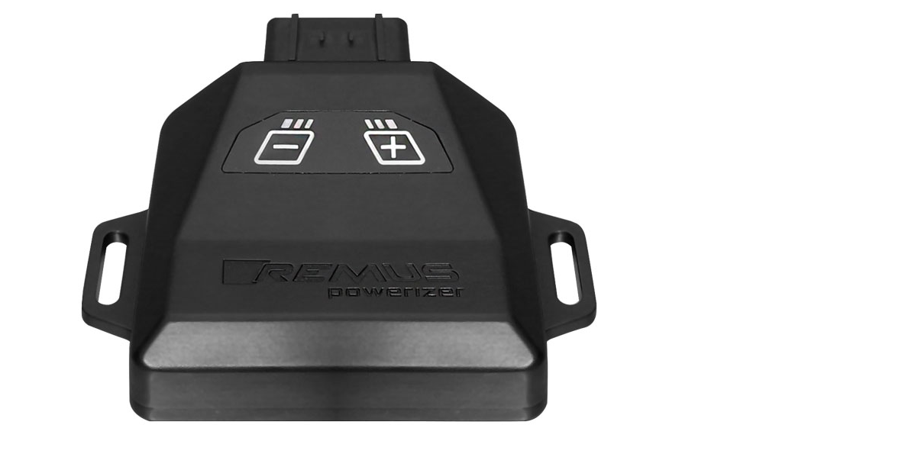
REMUS Powerizer
More power, more torque means more fun!
The perfectly matched electronics and advanced technology of the
REMUS Powerizer enhances Engine ECU mapping is optimized in
excess of 1000 times per second and ensures for a considerable and
noticeable power increase. The engine safety parameters (Check engine light) and engine management remains totally untouched to ensure that individual engine components are not overstrained.
Because of the plug & play concept, the REMUS Powerizer is installed in the engine compartment and connected to sensors such as intake manifold pressure sensor, boost pressure sensor, camshaft position sensor or fuel injection sensor. In real time, the incoming signals are processed, optimized and transmitted to the additional control unit. The Powerizer can be easily removed or decommissioned at any time using the supplied blind connector.
Due to the torque increase, the engine has more power at lower RPM which can lead to a reduction in fuel consumption. The power increase of the engine can easily be fine-tuned by means of seven preset levels via the keypad. The REMUS Powerizer is available for over 3300 petrol and diesel powered cars.
Furthermore, the latest Powerizer is also available for all vehicle engines with SENT technology. This newly developed multi-protocol technology combines analog and digital motor control the same time captures important analog signals of the engine management system which leads to increased engine performance. The capability to tune vehicles with SENT technology is an absolute highlight of the latest Powerizer.

- Up to 30% more power
- Up to 20% more torque
- Easy installation and removal (plug & play)
- Up to 1l/100 km fuel saving
- No vehicle modifications required
- 7 preset power levels

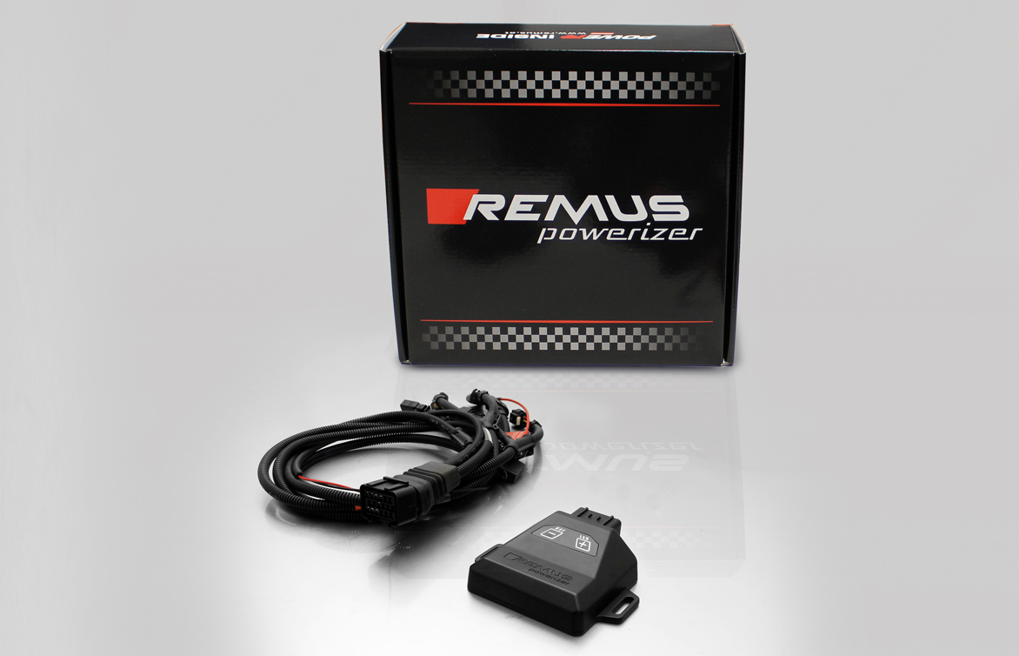

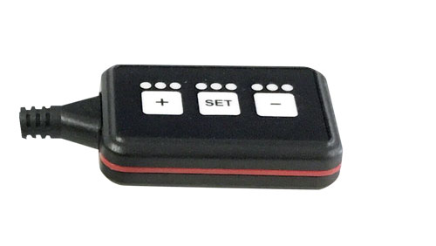
REMUS Responder

Improved throttle response for more driving dynamic!

The REMUS Responder improves throttle response and is the best power boost for
many electronically managed gas pedals. Results of up to 10% better acceleration are not uncommon and no annoying throttle delay and lag during take-off or in between manual / automatic shifts makes driving with the REMUS Responder much more dynamic.

The REMUS Responder attaches between the OEM gas pedal sensor and the OEM wiring loom and is ready to use in minutes due to plug & play technology.

The fully adjustable Responder settings can be adjusted in 20 different stages. The individual user-selectable and adjustable performance settings allow drivers to select according to their own preferences & road conditions.

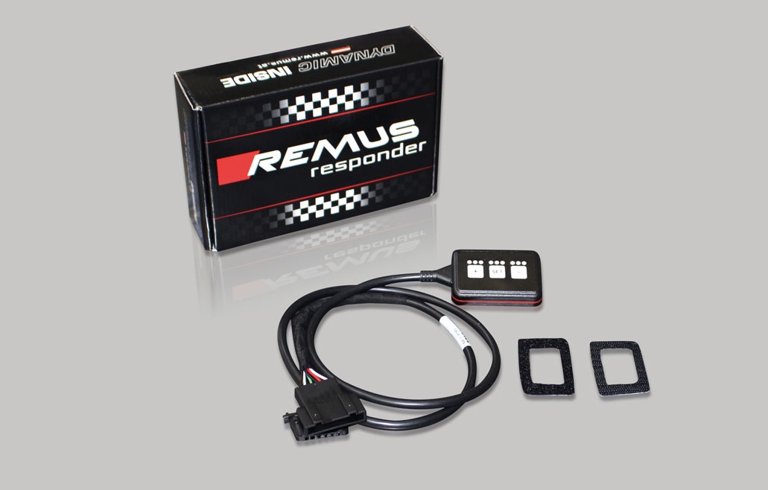

- Improves throttle response and lag during take-off and gear changes
- Quicker reaction times, more driving dynamic
- 20 individual user selectable performance settings
- Vehicle specific programming using OEM quality connectors
- Simple plug & play installation and removal without leaving traces

