REMUS product information 05-2016

MERCEDES BENZ CLA 45 AMG Facelift, C117 and 245G, 2015=>

MERCEDES BENZ A 45 AMG Facelift, W176 and 245G, 2015=>

Dear REMUS Partner,

We are pleased to inform you that we have completed our next development:
REMUS Cat-Back system with non-resonated front section and optional REMUS Sound Controller as well as Racing downpipe for the
Mercedes Benz CLA 45 AMG Facelift, C117 and 245G, 2015=>
Mercedes Benz A 45 AMG Facelift, W176 and 245G, 2015=>.

It would be a pleasure for us to receive your order.

Stay tuned!
Your REMUS Team

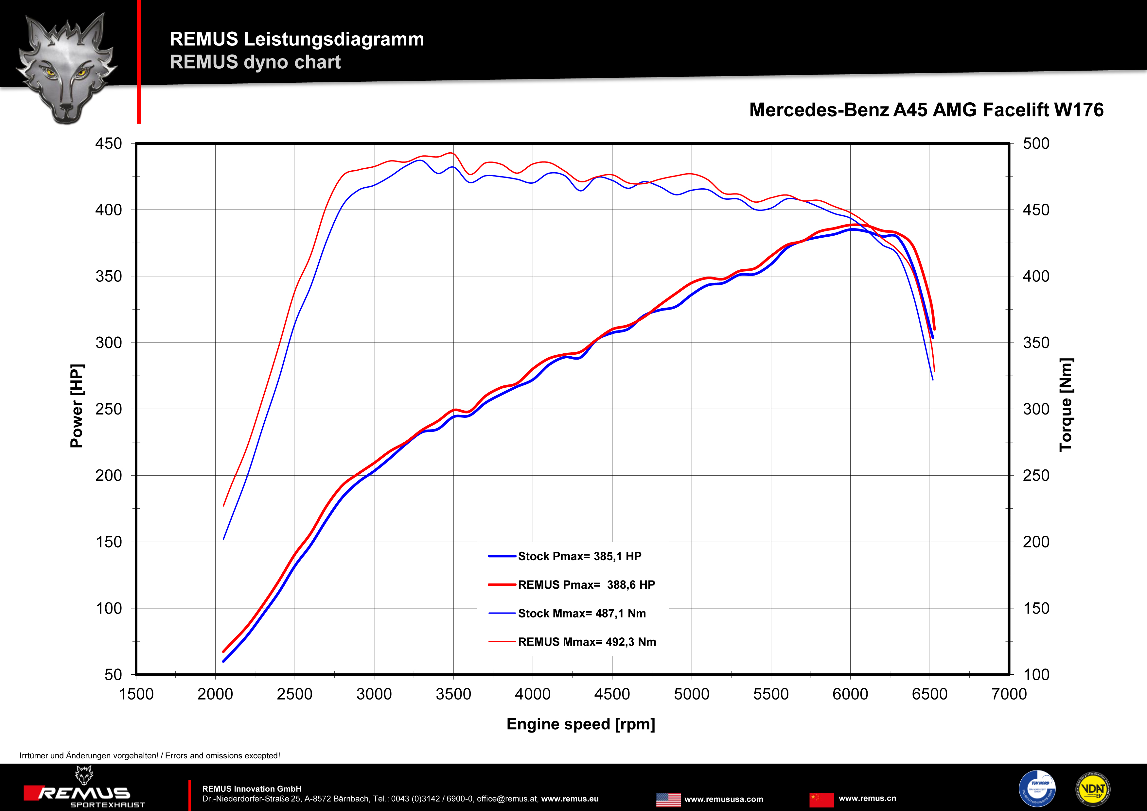

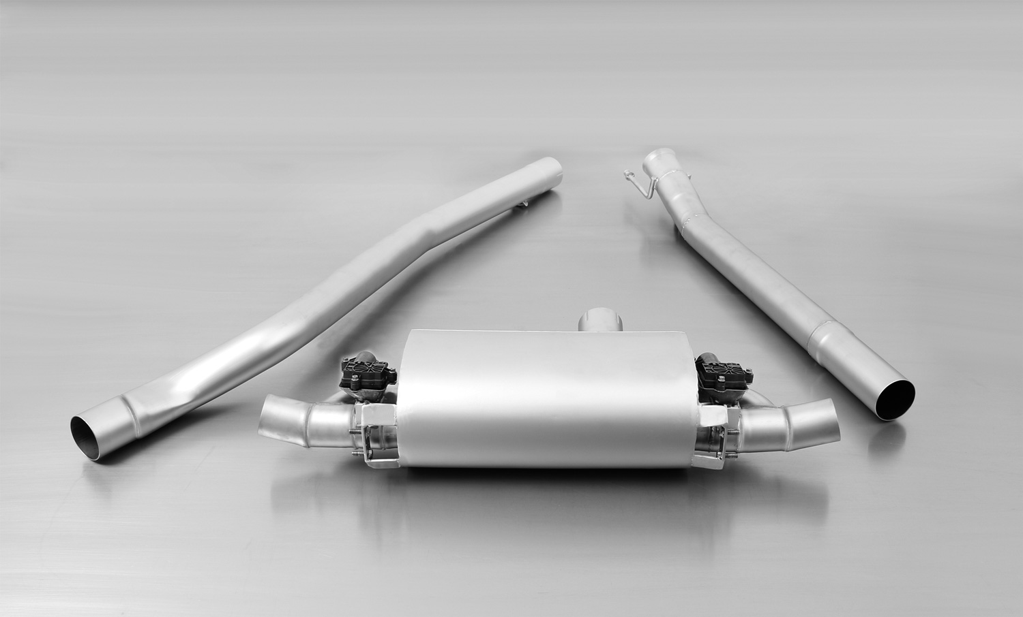
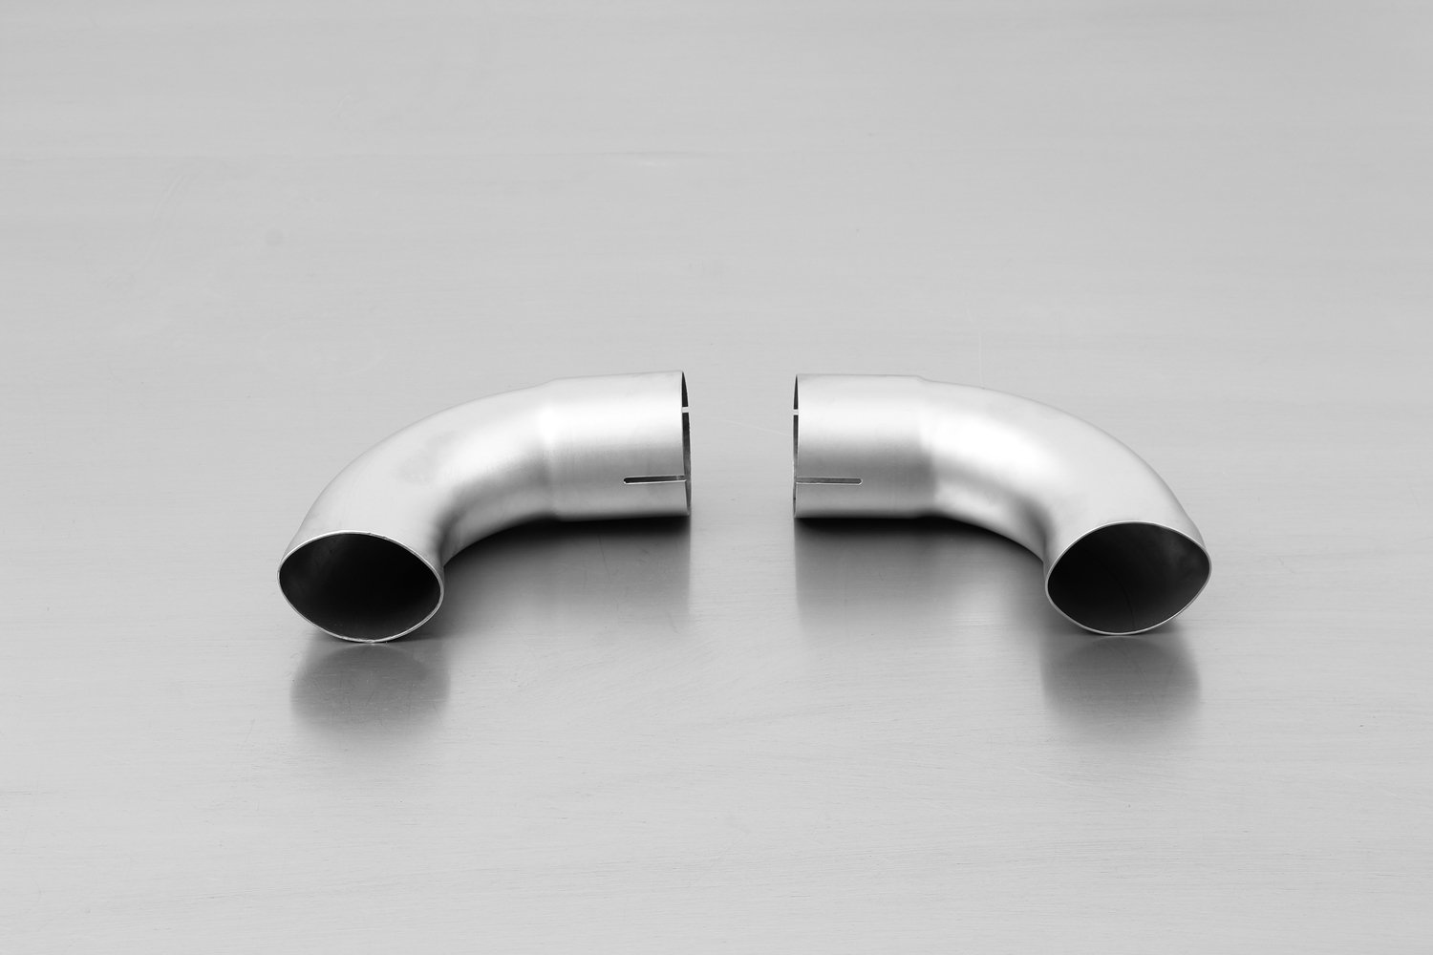
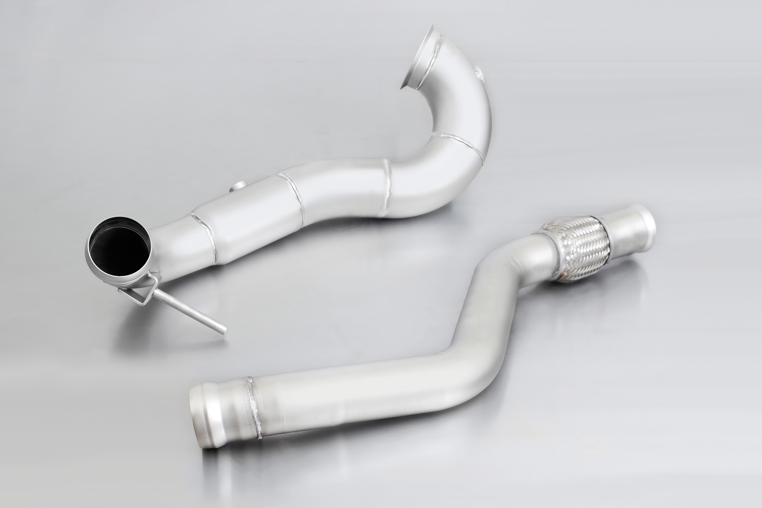
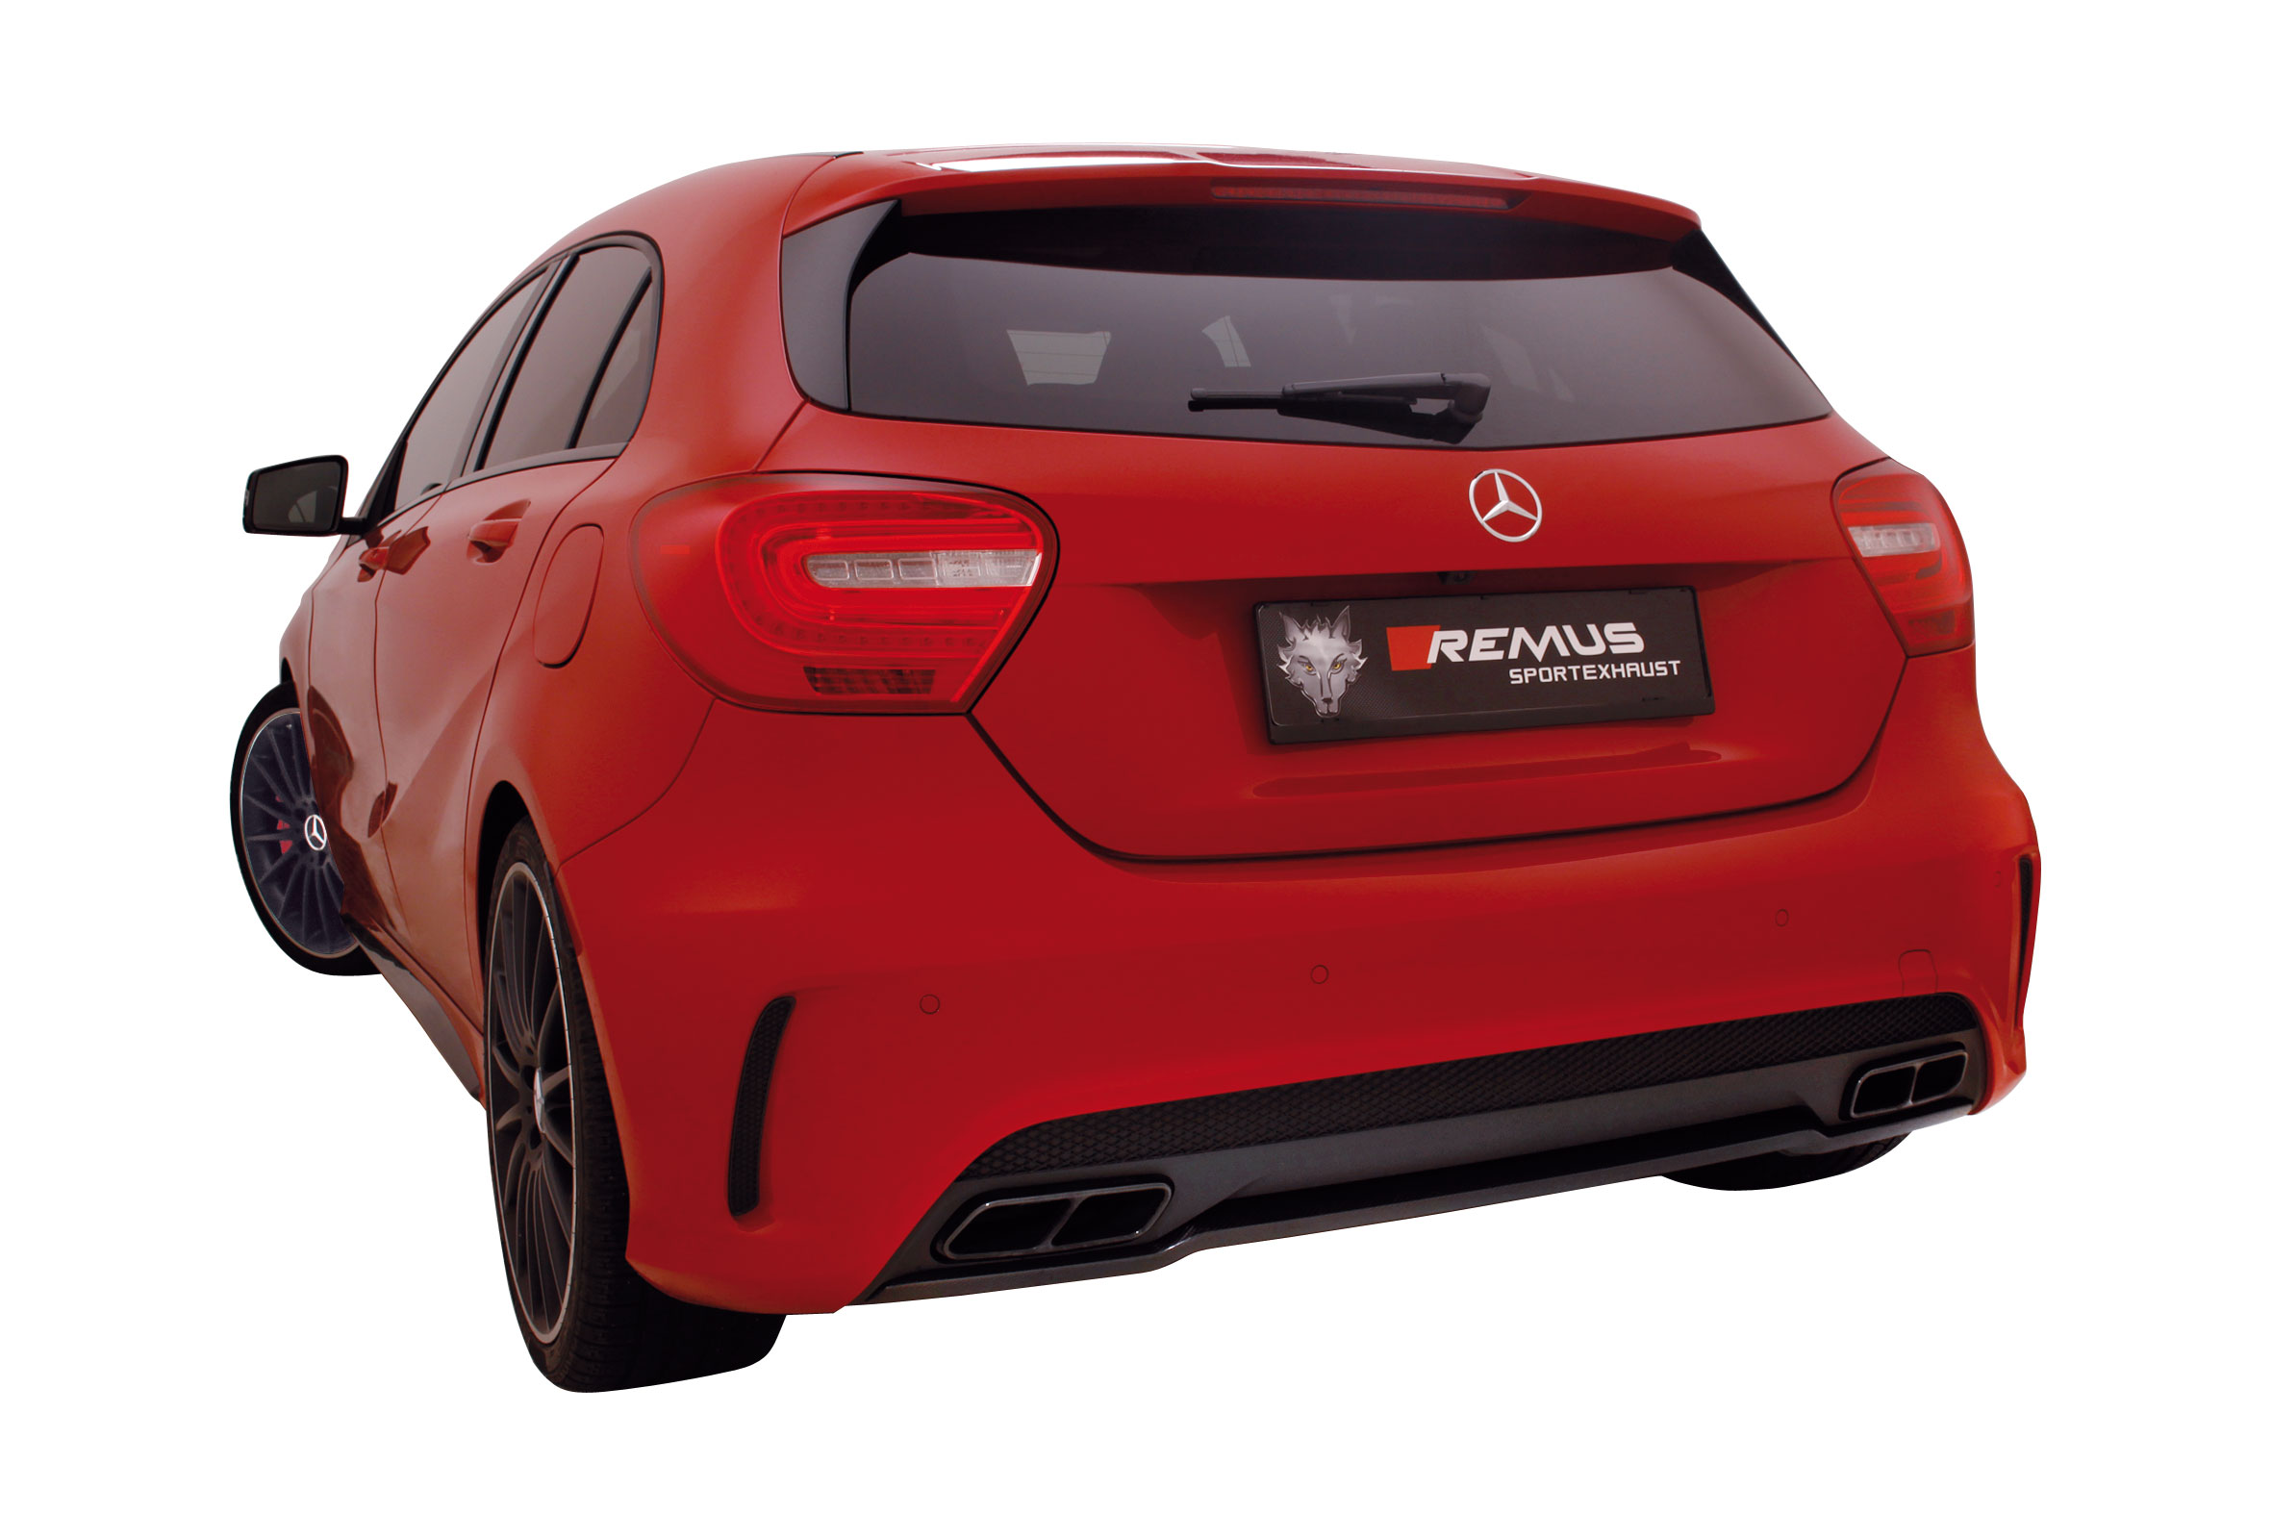
504013 1500
504513 1600
504013 1100

Car and engine specification
Mercedes Benz CLA 45 AMG, C117 and 245G, 2014=>
Mercedes Benz A 45 AMG, W176 and 245G, 2013=>
2.0l 265 kW
Mercedes Benz CLA 45 AMG Facelift, C117 and 245G, 2015=>
Mercedes Benz A 45 AMG Facelift, W176 and 245G, 2015=>
2.0l 280 kW
Part no. | Description | € RRP price excl. VAT
504013 1100 | Stainless steel RACING downpipe without catalytic convertor, without homologation | 670,--
504013 1500 | Stainless steel Cat-Back system, centered including electronic controlled valve and non-resonated front section, incl. EEC homologation | 1.199,--
choose from following outlet tubes:
504013 1600 | Outlet tubes for A 45 AMG / A45 AMG Facelift incl. installation kit, suitable for the original exhaust outlet | 112,--
504513 1600 | Outlet tubes for CLA 45 AMG / CLA 45 AMG Facelift incl. installation kit, suitable for the original exhaust outlets | 112,--
Optional: REMUS Sound Controller
STE 0002 | Sound Controller consisting of:  Electronic module incl. remote control for individual sound in 4 levels, no homologation | 296,--
ATTENTION:
- Cat-back system can only be installed using the required outlet tubes!
- Check engine light can be light up using the Racing downpipes.
- Turbo-Back system: Cat-Back system in connection with Racing downpipe.
- When installing REMUS down-pipes with and without the racing catalytic convertors, which are only suitable for closed road driving, it is important to note that ECU tuning is required to ensure that the engine runs and performs efficiently and to ensure that the CEL does not come on.

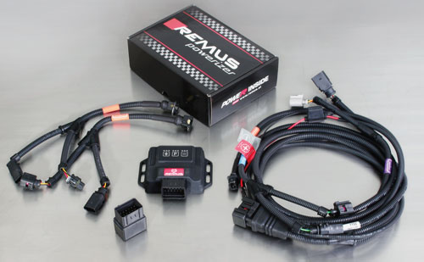

Under http://www.remus.eu/powerizer/ and http://www.remus.eu/remusresponder you will find the entire product range, prices and installation instructions.

REMUS Powerizer: More power, more economy and more fun.
- Up to 25 % more power
- Up to 20 % more torque
- Up to 1l/100 km fuel saving
- Fully adjustable power increase
- Simple DIY installation (Plug & Play)
REMUS POWERIZER: The performance figures represent the maximum achievable values. The actual performance output depends on the original tolerances of each engine. REMUS delivers the POWERIZER with the best possible setting for your vehicle type. You can adjust the performance according to your requirements as per the POWERIZER instructions

Legal references

1. Completion and registration of chip tuning in the car documents
Due to chip tuning, the operating license of the vehicle will terminate if the installation and registration of the POWERIZER is not carried out or immediately reported to an official approved testing facility. Please consider that driving a vehicle without the required operating license will cause legal penalties.

2. Vehicle insurance must be informed upon installing a POWERIZER
The installation of the POWERIZER can have influence on the insurance policy of your vehicle. You must inform the insurance company if you install a POWERIZER in your vehicle.

3. Effect of chip tuning on warranty and guarantee claims
a) When installing a POWERIZER, you will lose all guarantee claims regarding the engine against the vehicle manufacturer.
b) Installing a POWERIZER, can have influence on warranty claims against the seller of the vehicle.
c) REMUS excludes any claims regarding compensation for damages on the engine and drivetrain.

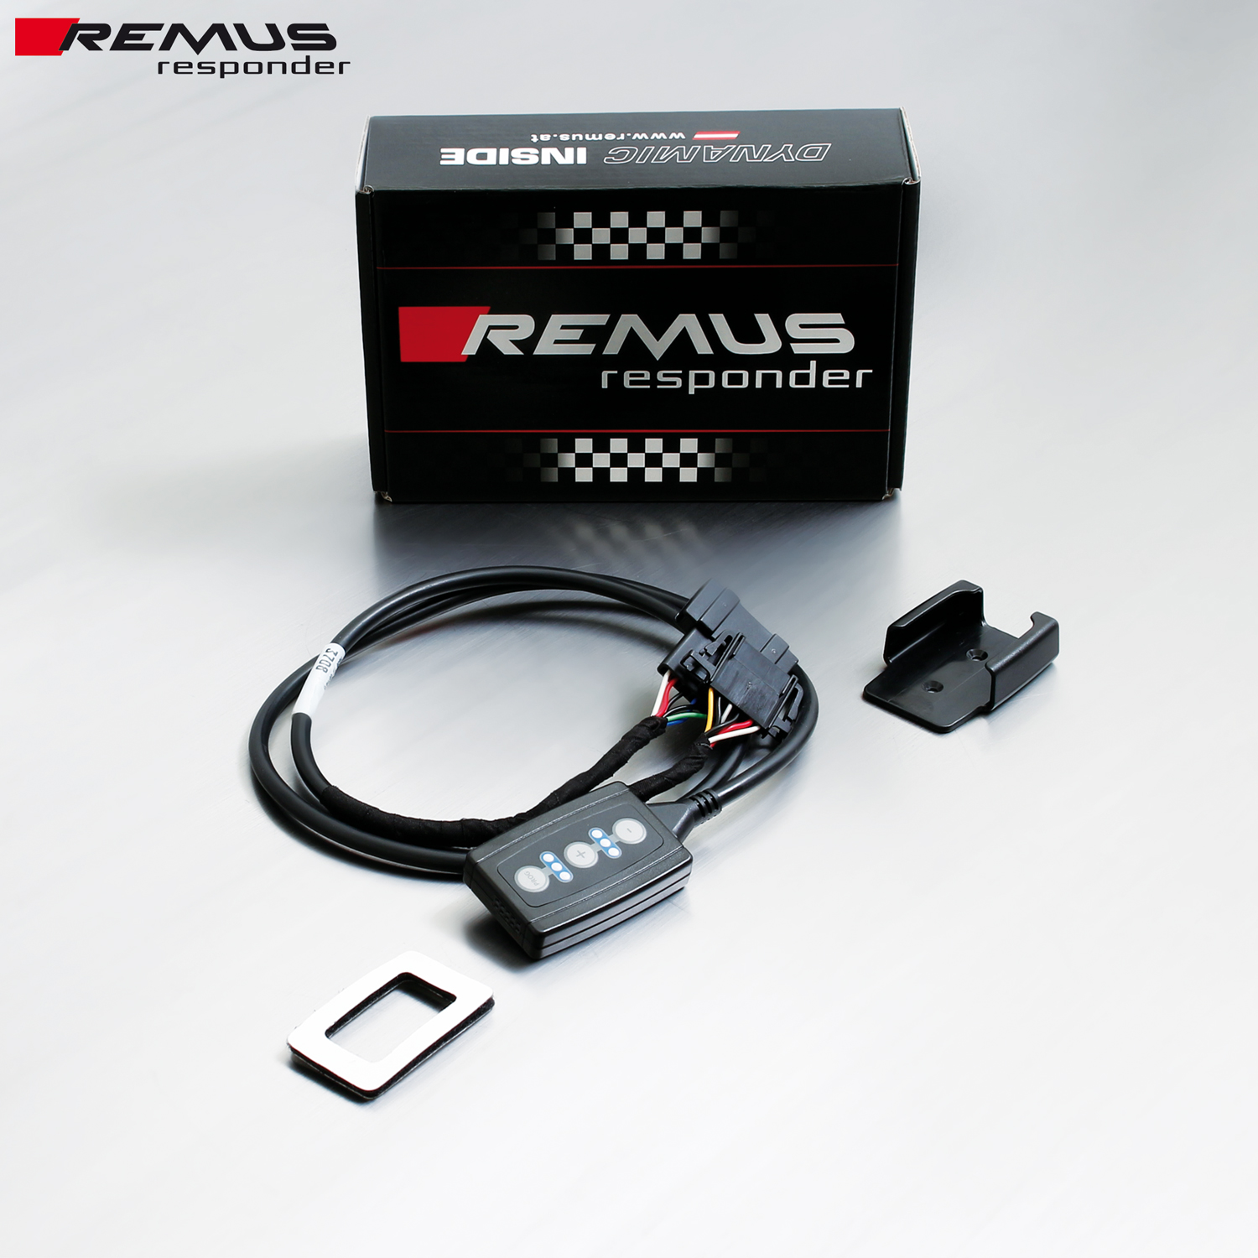

Under http://www.remus.eu/powerizer/ and http://www.remus.eu/remusresponder you will find the entire product range, prices and installation instructions.

REMUS RESPONDER:
Improved throttle response, more dynamic!
The REMUS Responder improves throttle response by means of modifying the accelerator pedal output signal. No more throttle delay and reduced lag during automatic shifting makes driving with the REMUS Responder more fun. The Responder attaches between the OEM pedal sensor and the OEM connector, ready to use in seconds due to plug & play technology. Sophisticated adjustable programming profiles can lead to improved fuel consumption and more efficiency. The 4 individual user selectable and adjustable performance settings allow drivers to select according to their own preferences.
The REMUS Responder totally eliminates the delay in modern electronic accelerator pedals!

