Product information 03/2017

BMW 3 Series / 4 Series

BMW 3 Series F30 LCI Sedan type 3L / F31 LCI Touring type 3L, from 09/2014 with engine code B48B20A (!)
320i(x) LCI 2.0l 135 kW (B48B20A) from 09/2014

BMW 4 Series F32 & F32 LCI Coupe / F36 & F36 LCI Gran Coupe with engine code B48B20A (!)
420i(x) F32 2.0l 135 kW (B48B20A) from 05/2015
420i(x) F32 LCI 2.0l 135 kW (B48B20A) from 09/2016
420i(x) F36 2.0l 135 kW (B48B20A) from 03/2015

BMW 3 Series F30 LCI Sedan / F31 LCI Touring, from 09/2014
330i(x) LCI 2.0l 185 kW (B48B20)
REMUS Cat-back-system
- 100% stainless steel
- Powerful sound
- Performance and torque increase
- EC homologation
+ 5,3 HP
+ 6,5 Nm

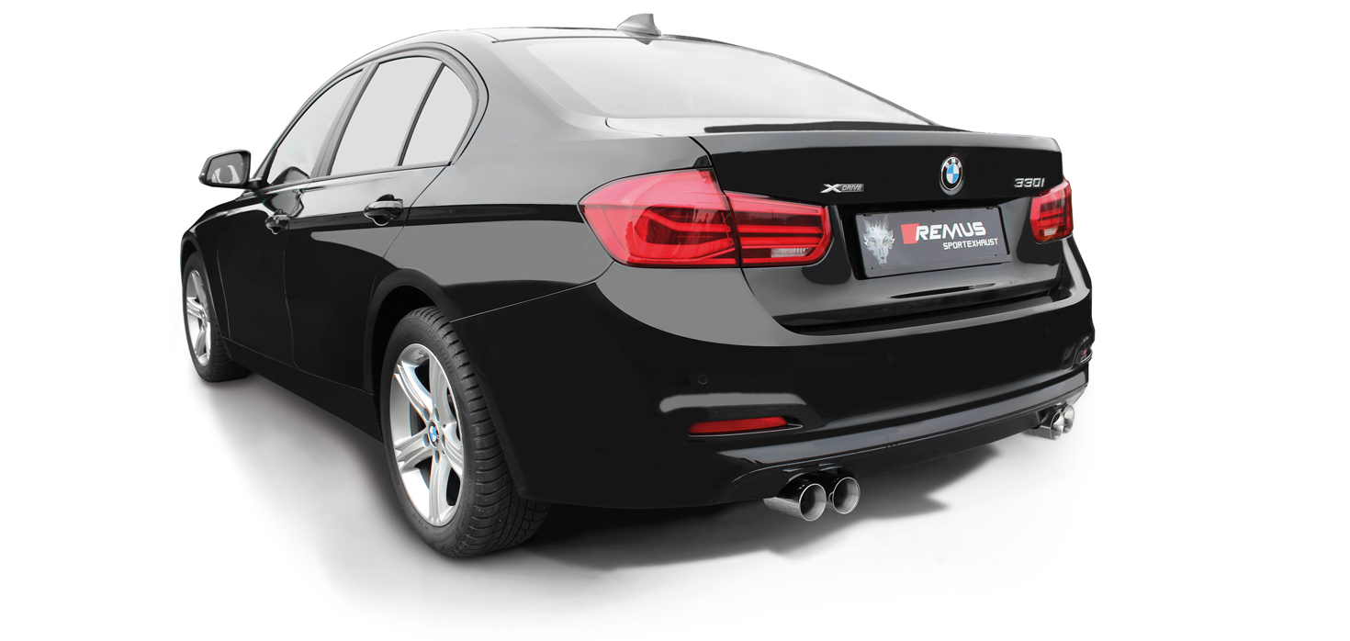

Car and engine specification
BMW 3 Series F30 LCI Sedan type 3L / F31 LCI Touring type 3L, 09/2014=>
with engine code B48B20A (!)
320i(x) LCI 2.0l 135 kW (B48B20A) 09/2014=>

BMW 4 Series F32 LCI Coupe / F36 LCI Gran Coupe
with engine code B48B20A (!)
420i(x) F32 2.0l 135 kW (B48B20A) 05/2015=>
420i(x) F32 LCI 2.0l 135 kW (B48B20A) 09/2016=>
420i(x) F36 2.0l 135 kW (B48B20A) 03/2015=>
420i(x) F36 LCI 2.0l 135 kW (B48B20A) 06/2016=>
INFOBOX:
- Cat-back-system: 086514 0400 or 086214 0000 (Racing) + 086214 0500 + tail pipe set! No vehicle modifications required! Not for M sport option!
Part no. | Description | € RRP price excl. VAT
086514 0400 | Stainless steel resonated front section instead of original center silencer, incl. EC homologation  Original tube Ø 65 mm, REMUS tubes 2x Ø 60 mm into 1x Ø 80 mm | 570,--
086214 0000 | Stainless steel non resonated front section instead of front silencer, no homologation  Original tube Ø 65 mm, REMUS tubes 2x Ø 60 mm into 1x Ø 80 mm | 290,--
086214 0500 | Stainless steel sport exhaust (without tail pipes), incl. EC homologation  Original tube Ø 65 mm, REMUS tubes Ø 80 mm | 390,--
Choose from following tail pipe package:
0026 03 | Stainless steel tail pipe set 2 tail pipes Ø 76 mm, rolled edge, chromed, with adjustable spherical clamp connection | 150,--
0026 03G | Stainless steel tail pipe set 2 tail pipes Ø 76 mm, straight cut, chromed, with adjustable spherical clamp connection | 150,--
0026 03GB | Stainless steel tail pipe set 2 tail pipes Ø 76 mm, straight cut, Black Chrome, with adjustable spherical clamp connection | 174,--

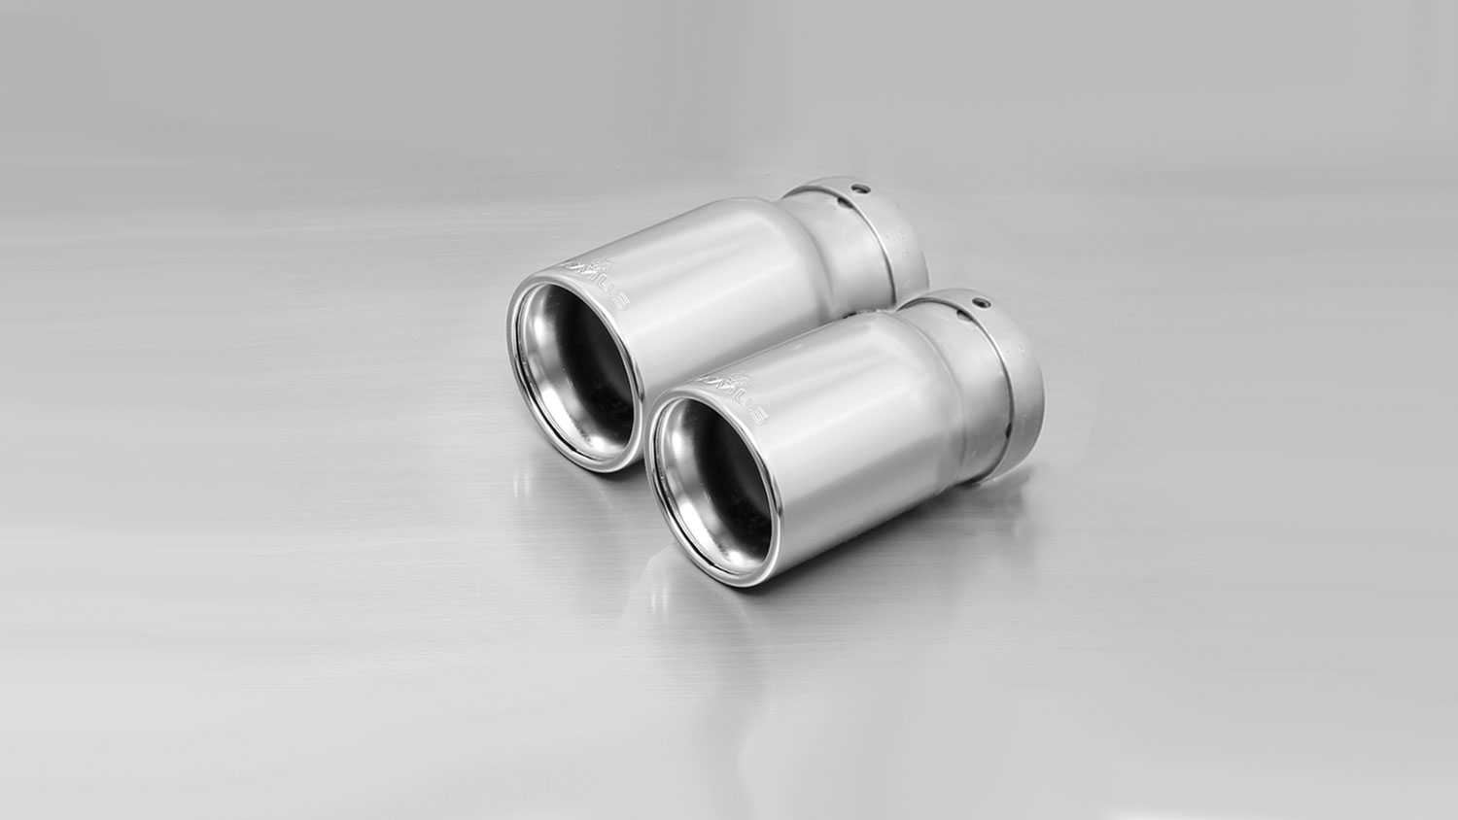
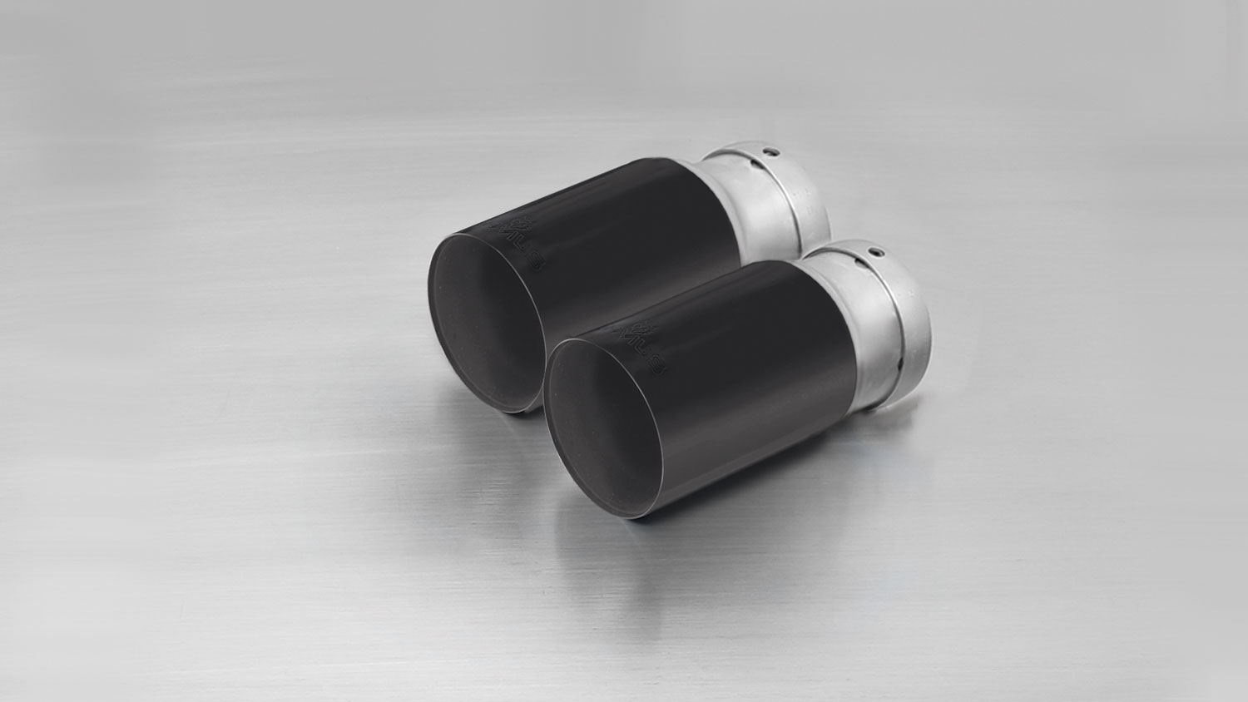
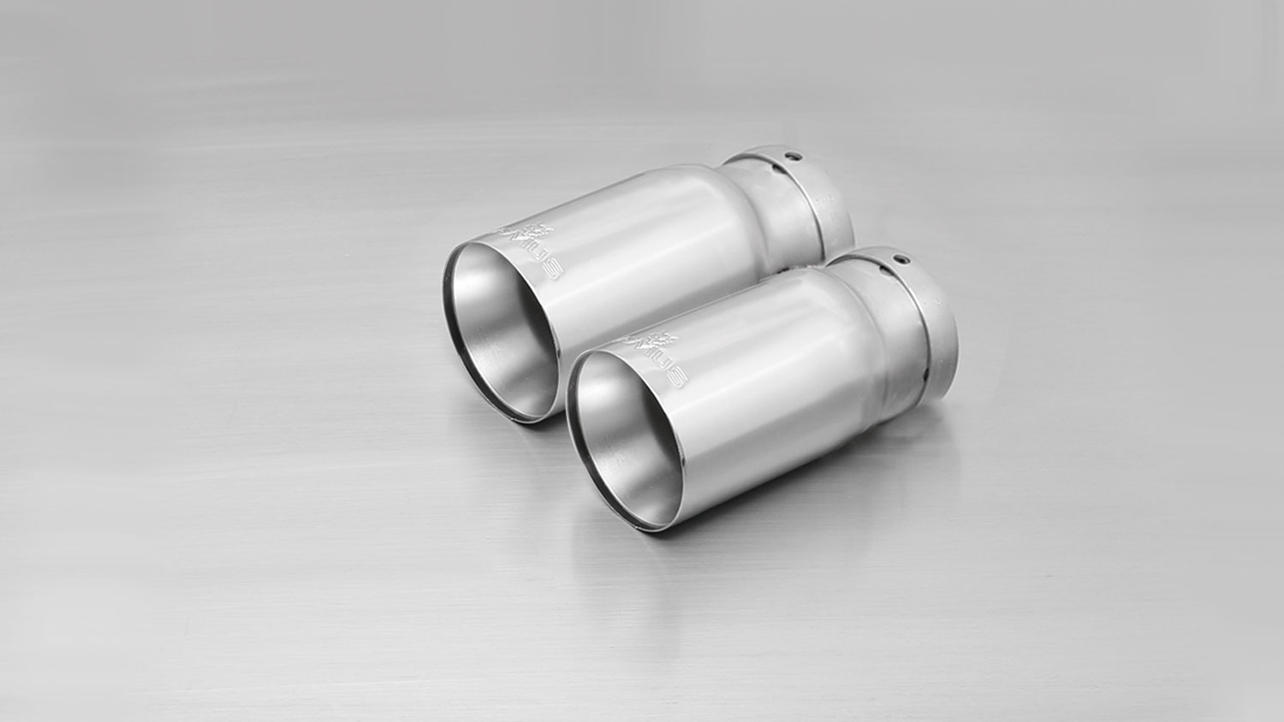
#03GB: tail pipes Ø 76 mm, straight cut, Black Chrome

#03G: tail pipes Ø 76 mm, straight cut, chromed

#03: tail pipes Ø 76 mm, rolled edge, chromed

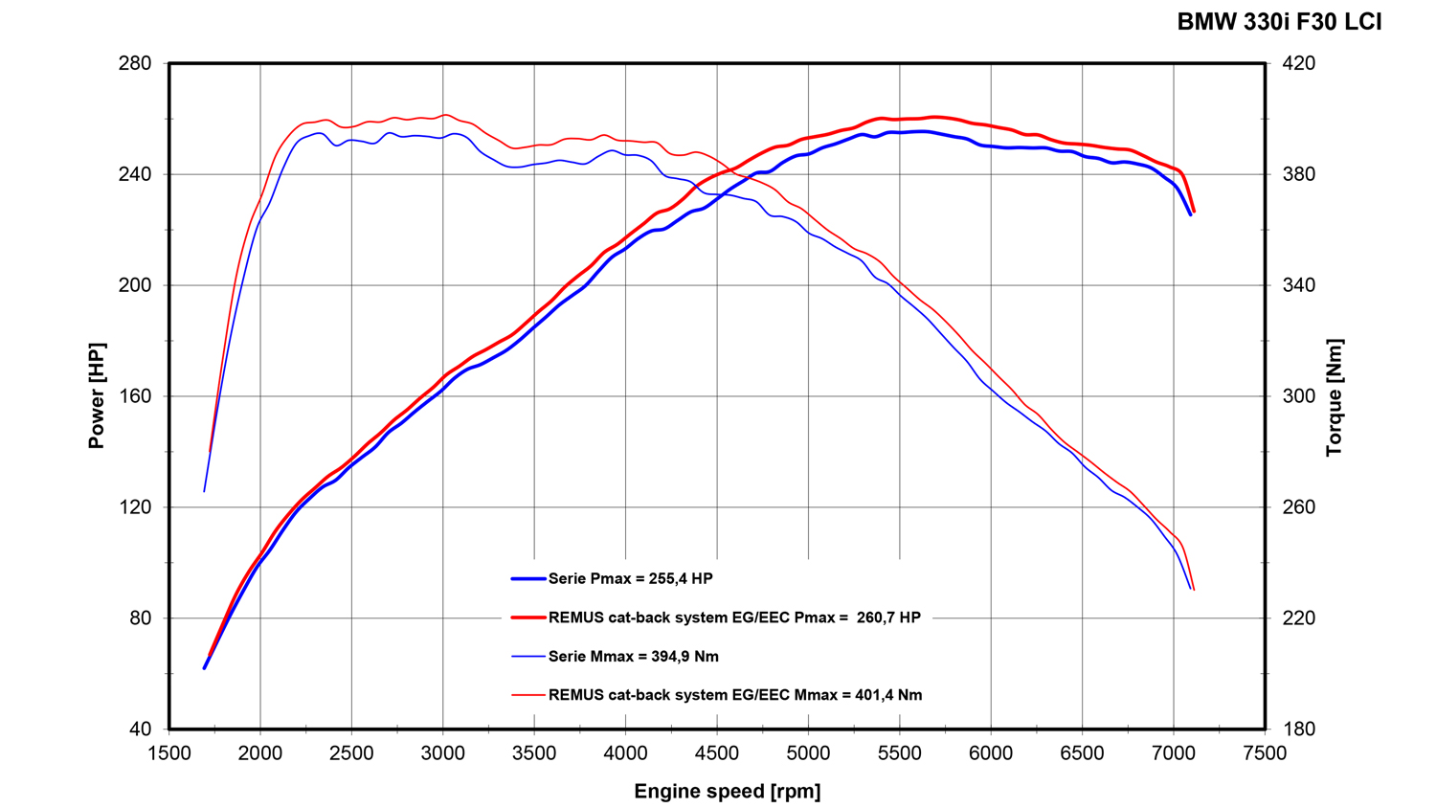
Car and engine specification
BMW 3 Series F30 LCI Sedan / F31 LCI Touring, 09/2014=>
330i(x) LCI 2.0l 185 kW (B48B20)
INFOBOX:
- Axle-back-system L/R: 086514 1500 + tail pipe set! The original exhaust will need to be cut at the manufacturer marked cutting point! Suitable for standard bumper and M sport option! The right side skirt outlet must be trimmed as per the enclosed template!
- Cat-back-system L/R: 086514 0400 + 086514 1500 + tail pipe set! No cutting of the original exhaust system required! Suitable for standard bumper and M sport option! The right side skirt outlet must be trimmed as per the enclosed template!
Part no. | Description | € RRP price excl. VAT
086514 0400 | Stainless steel resonated front section instead of original center silencer, incl. EC homologation  Original tube Ø 76 mm, REMUS tubes 2x Ø 60 mm into 1x Ø 80 mm | 570,--
086214 0000 | Stainless steel non resonated front section instead of front silencer  Original tube Ø 76 mm, REMUS tubes 2x Ø 60 mm into 1x Ø 80 mm | 290,--
086514 1500 | Stainless steel sport exhaust centered for L/R system (without tail pipes), incl. EC homologation  Original tube Ø 76 mm, REMUS tubes Ø 80 mm | 380,--
Choose from following tail pipe package:
086514 1604G | Stainless steel tail pipe set L/R consisting of 4 chromed tail pipes Ø 76 mm straight cut, with integrated valve  The activation of the valve is carried out using the original actuator via the vehicle onboard electronics. | 545,--
086514 1604GB | Stainless steel tail pipe set L/R consisting of 4 black chrome tail pipes Ø 76 mm straight cut, with integrated valve  The activation of the valve is carried out using the original actuator via the vehicle onboard electronics. | 580,--
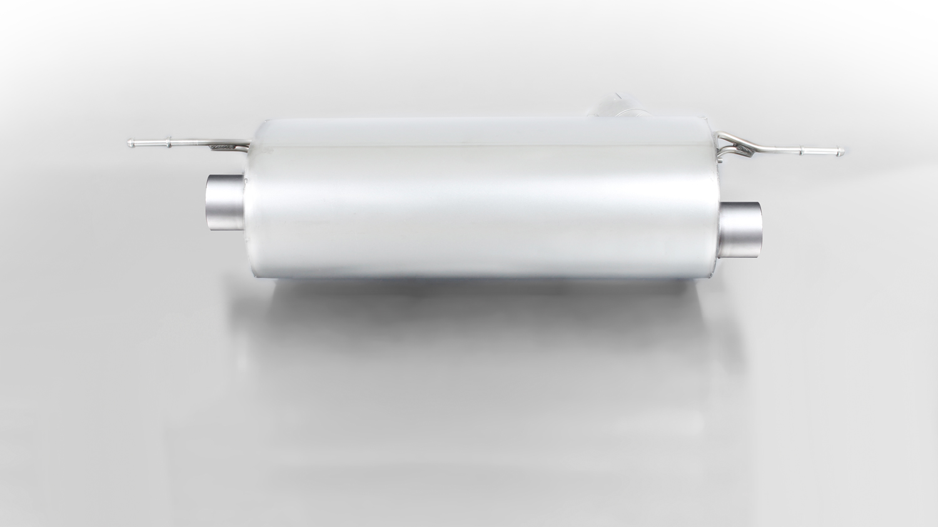
086514 1500

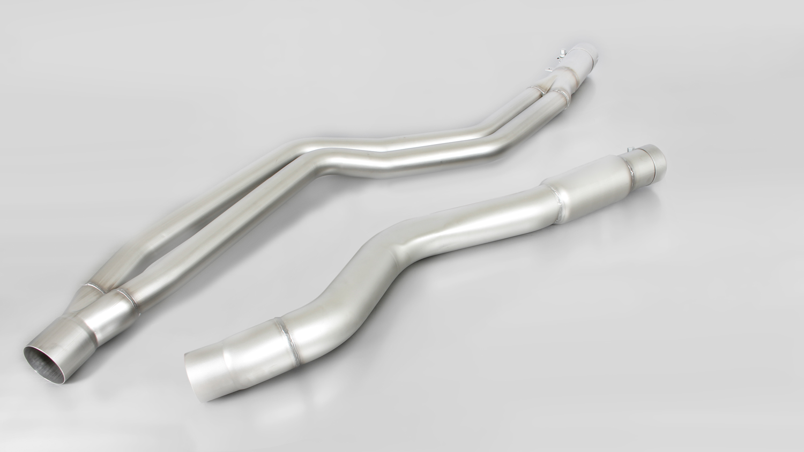

086514 0400

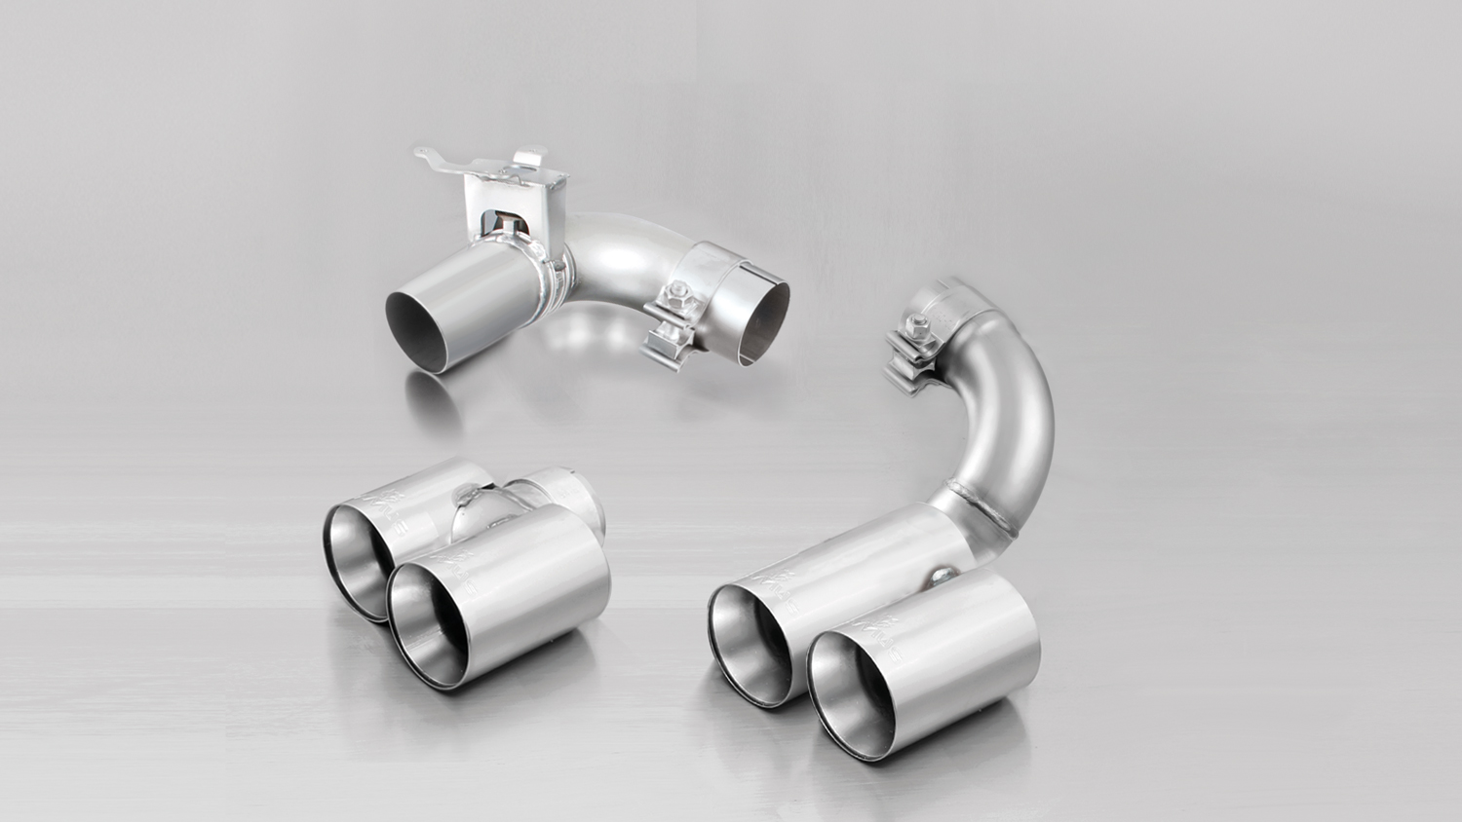

Cat-back: 088015 0300 + 088015 1500
+ tail pipe set

086514 1604G

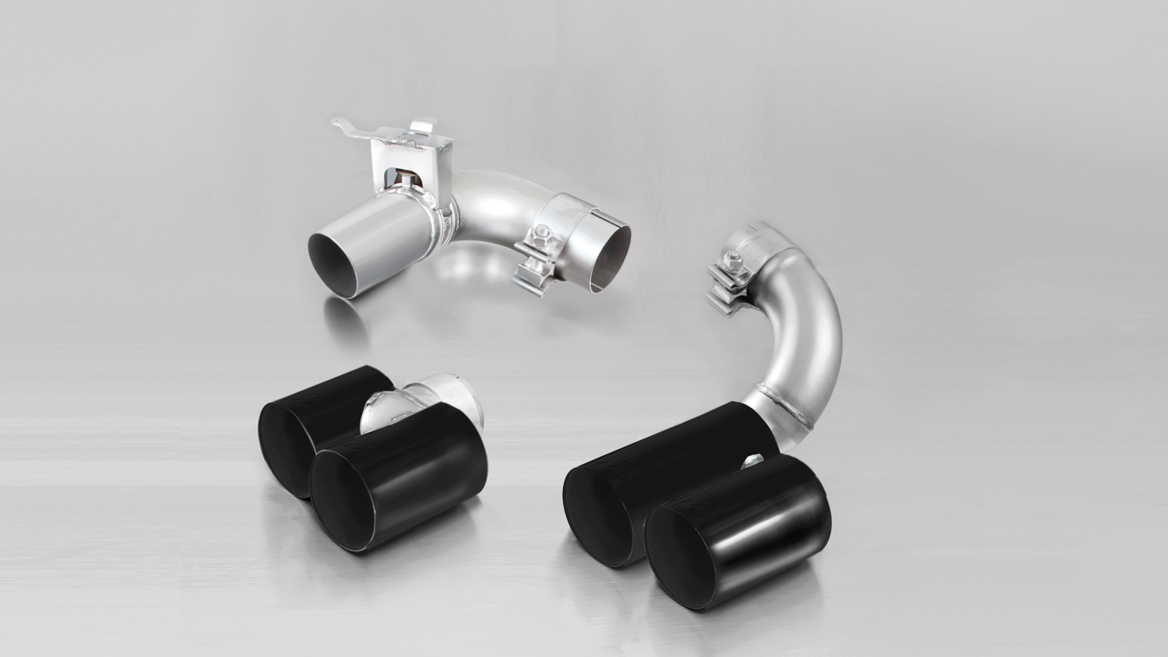

086514 1604GB

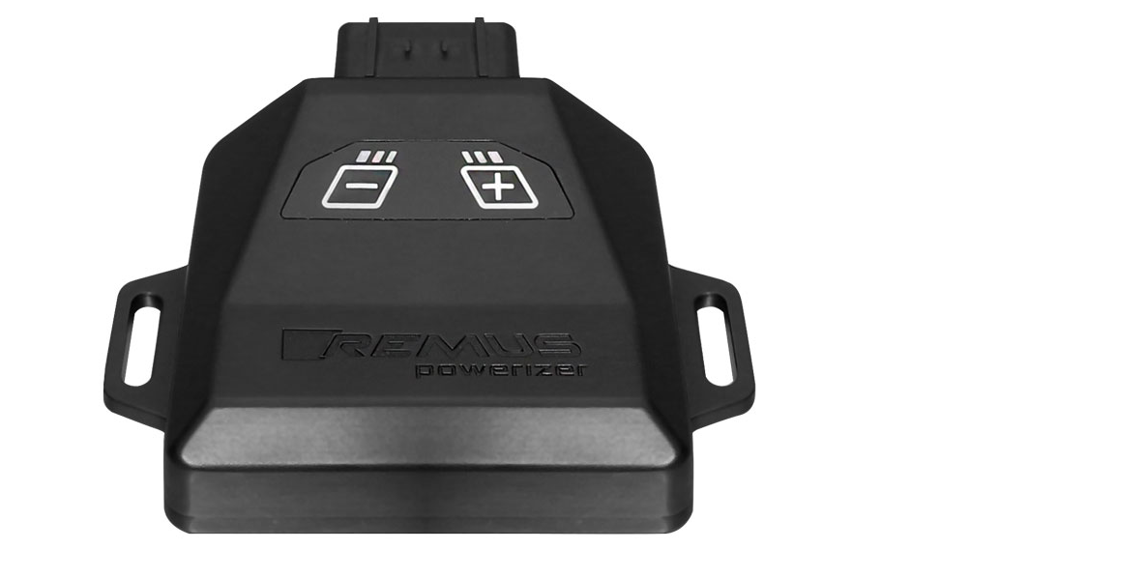
REMUS Powerizer
More power, more economy and more fun!
The electronics of the REMUS Powerizer enhances in real time
the engine management parameters. The engine mapping
is optimized in excess of 1000 times per second and ensures for a
considerable and noticeable power increase. The engine safety parameters and management remains totally original to ensure that individual engine components are not overstrained. Furthermore, the original mapping software remains totally untouched.
Due to the plug & play concept, the REMUS Powerizer is simple to install and can be easily removed or decommissioned using the supplied blind connector. Due to the torque increase, the engine has more power at lower RPM which leads to a reduction in fuel consumption. The power increase of the engine can be fine-tuned by means of seven preset levels. The REMUS Powerizer is available for over 3000 petrol and diesel powered cars.

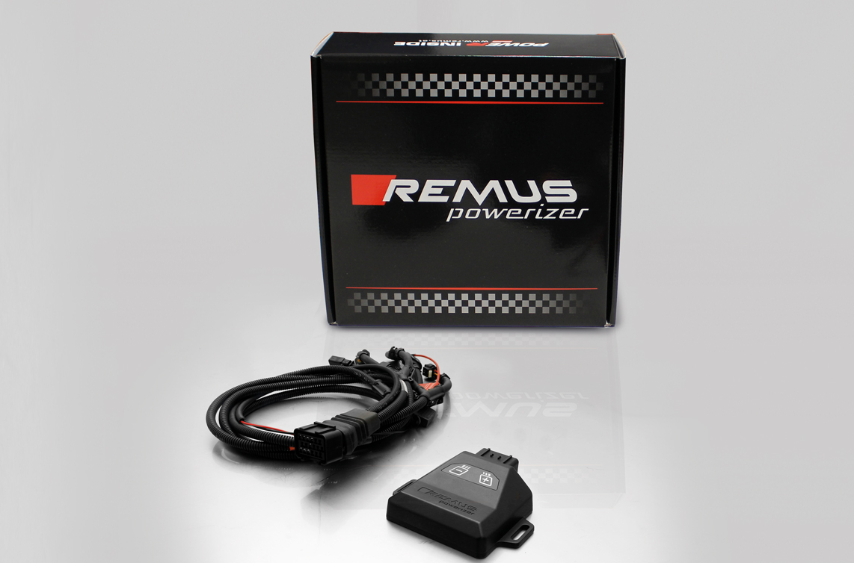

- Up to 25% more power
- Up to 20% more torque
- Easy installation and removal (plug & play)
- Up to 1l/100 km fuel saving
- No modifications on the ECU
- 7 preset power levels

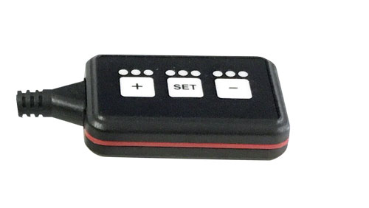
REMUS Responder

Improved throttle response, more dynamic!

The REMUS Responder improves throttle response by means
of modifying the accelerator pedal output signal.

No more throttle delay and reduced lag during automatic shifting makes driving
with the REMUS Responder more fun. The Responder attaches between the
OEM pedal sensor and the OEM connector, ready to use in seconds due to plug & play technology.

Sophisticated adjustable programming profiles can lead to improved fuel consumption and
more efficiency. The four individual user selectable and adjustable performance settings
allow drivers to select according to their own preferences. The REMUS Responder totally eliminates the delay in modern electronic accelerator pedals!

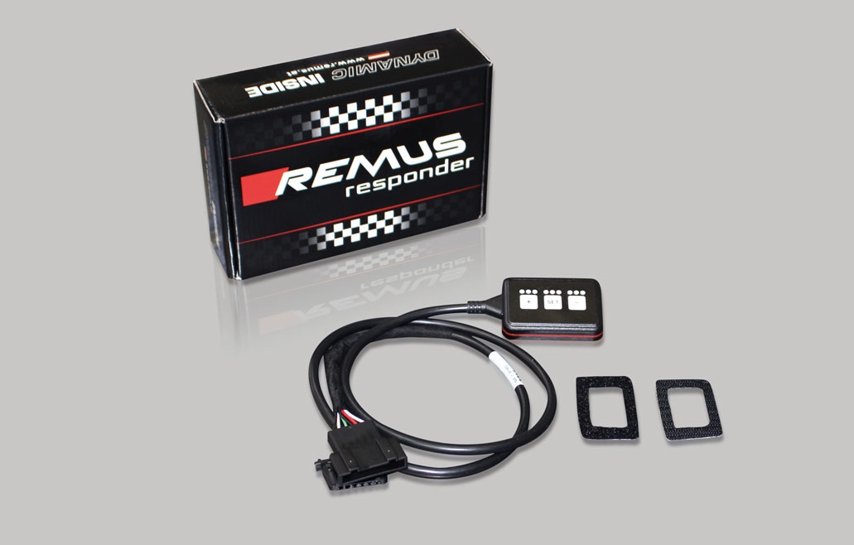

- Improved throttle response, reduced lag during gear changes
- Quicker reaction times, more dynamic without changing engine parameters
- 4 individual user selectable and adjustable performance settings
- Vehicle specific programming using OEM quality connectors
- Simple plug & play installation and easily removed without leaving traces

