REMUS customer information 03-2016

MAZDA 3 Sport, Type BM, 2013=>

Dear REMUS-Partner,

We are pleased to inform you that we have completed our next development:
REMUS sport exhaust left/right for the
MAZDA 3 Sport, Type BM, 2013=>.

It would be a pleasure for us to receive your order.

Stay tuned!
Your REMUS Team

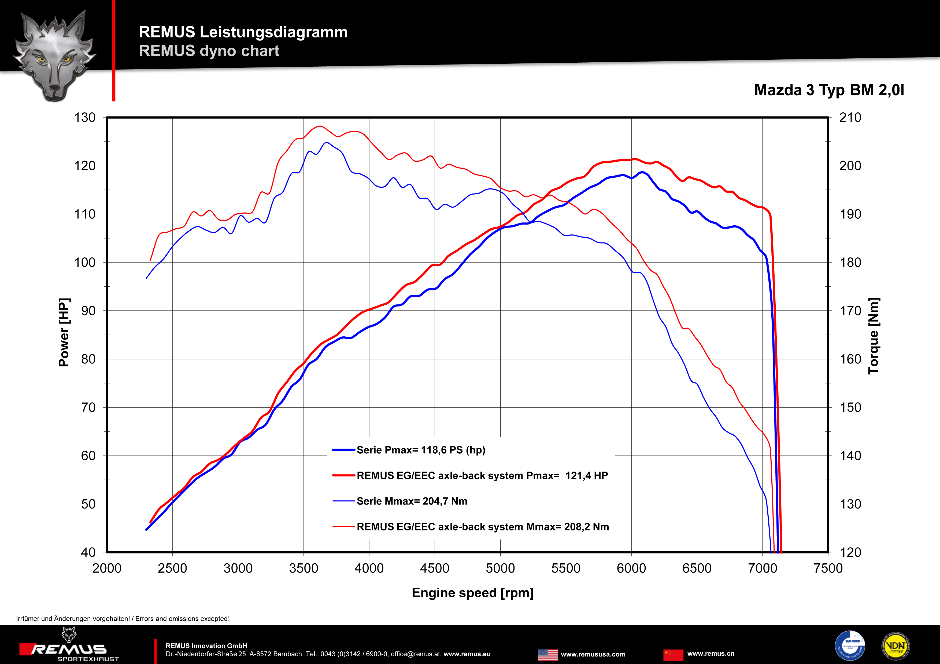

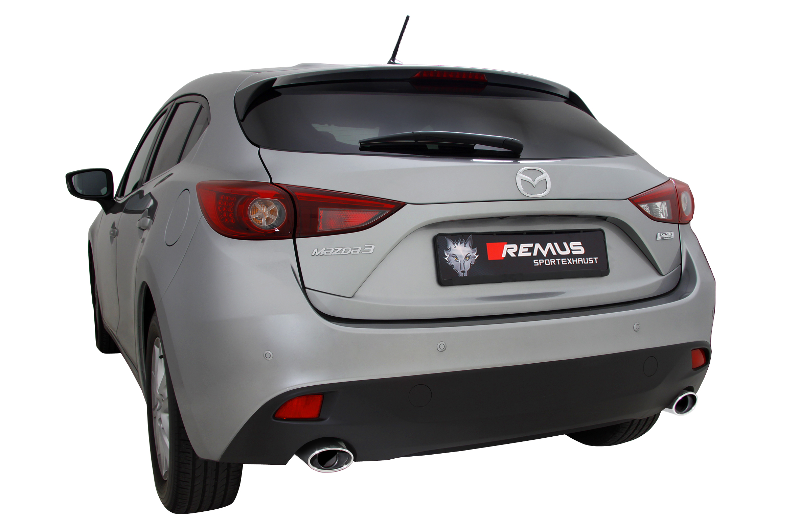

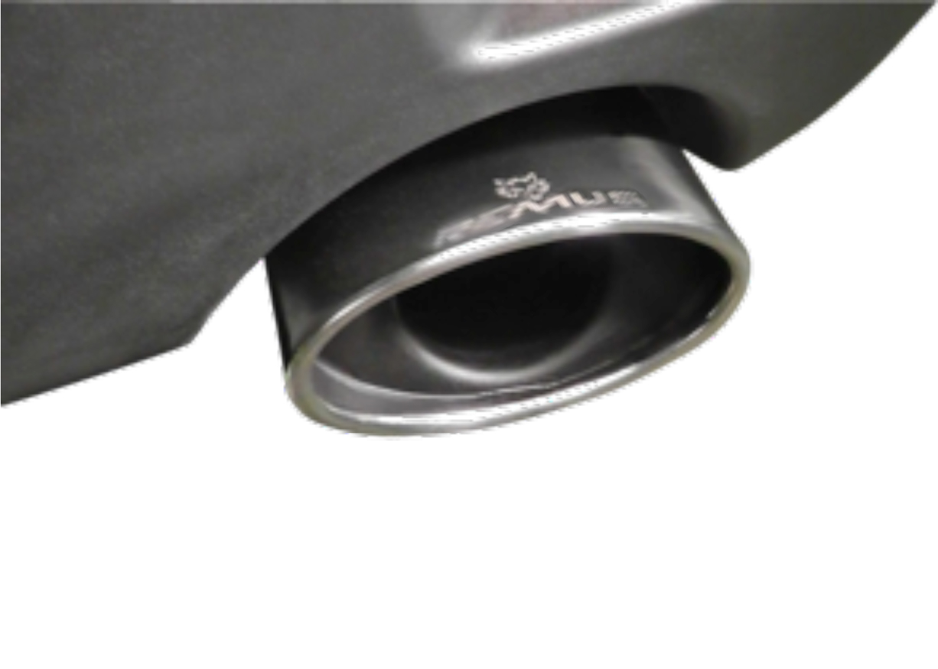
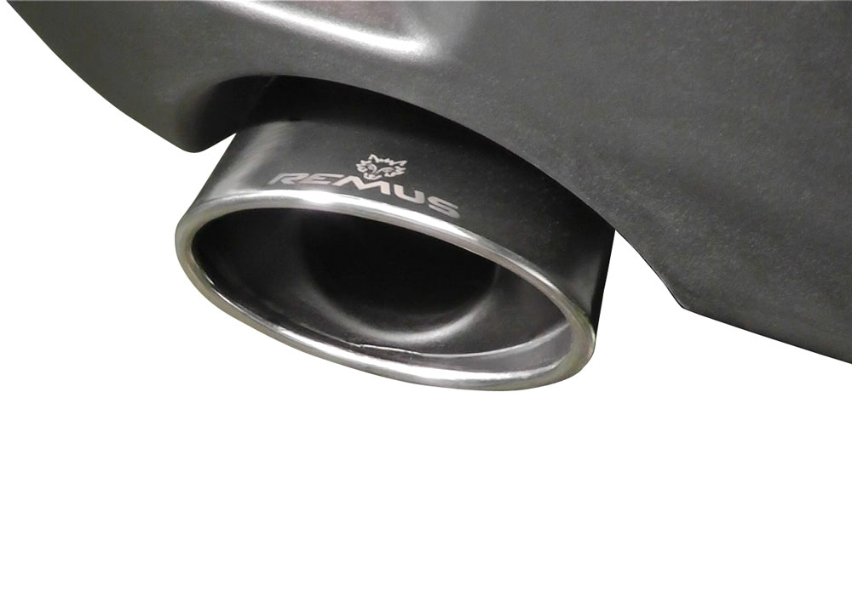

#13S: tail pipe 120x74 mm rolled/angled, chromed

Car and engine specification
MAZDA 3 Sport, Hatchback, 5 door, type BM, 2013=>
1.5i 74 kW (P5); 2.0i 88/121 kW (PE); 2.2l CD 110 kW (SH)
Part no. | Description | € RRP price excl. VAT
456513 1500 | Stainless steel sport exhaust centered for L/R system (without tail pipes), incl. EEC homologation | 271,--
456513 1613S | Tail pipe set L/R consisting of 2 chromed tail pipes, laser etched REMUS logo, 120x74 mm rolled/angled | 252,--
ATTENTION:
- Sport exhaust and tail pipe set only fit as a complete system!
- Bolt-on Axle-back system, no vehicle modifications required!

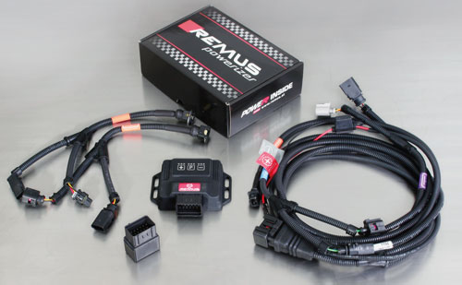

Under http://www.remus.eu/powerizer/ and http://www.remus.eu/remusresponder you will find the entire product range, prices and installation instructions.

REMUS Powerizer: More power, more economy and more fun.
- Up to 25 % more power
- Up to 20 % more torque
- Up to 1l/100 km fuel saving
- Fully adjustable power increase
- Simple DIY installation (Plug & Play)
REMUS POWERIZER: The performance figures represent the maximum achievable values. The actual performance output depends on the original tolerances of each engine. REMUS delivers the POWERIZER with the best possible setting for your vehicle type. You can adjust the performance according to your requirements as per the POWERIZER instructions

Legal references

1. Completion and registration of chip tuning in the car documents
Due to chip tuning, the operating license of the vehicle will terminate if the installation and registration of the POWERIZER is not carried out or immediately reported to an official approved testing facility. Please consider that driving a vehicle without the required operating license will cause legal penalties.

2. Vehicle insurance must be informed upon installing a POWERIZER
The installation of the POWERIZER can have influence on the insurance policy of your vehicle. You must inform the insurance company if you install a POWERIZER in your vehicle.

3. Effect of chip tuning on warranty and guarantee claims
a) When installing a POWERIZER, you will lose all guarantee claims regarding the engine against the vehicle manufacturer.
b) Installing a POWERIZER, can have influence on warranty claims against the seller of the vehicle.
c) REMUS excludes any claims regarding compensation for damages on the engine and drivetrain.
c) REMUS schließt Ansprüche des Kunden auf Schadenersatz für etwaige Schäden an Motor und Antriebsstrang aus..
c) REMUS schließt Ansprüche des Kunden auf Schadenersatz für etwaige Schäden an Motor und Antriebsstrang aus.

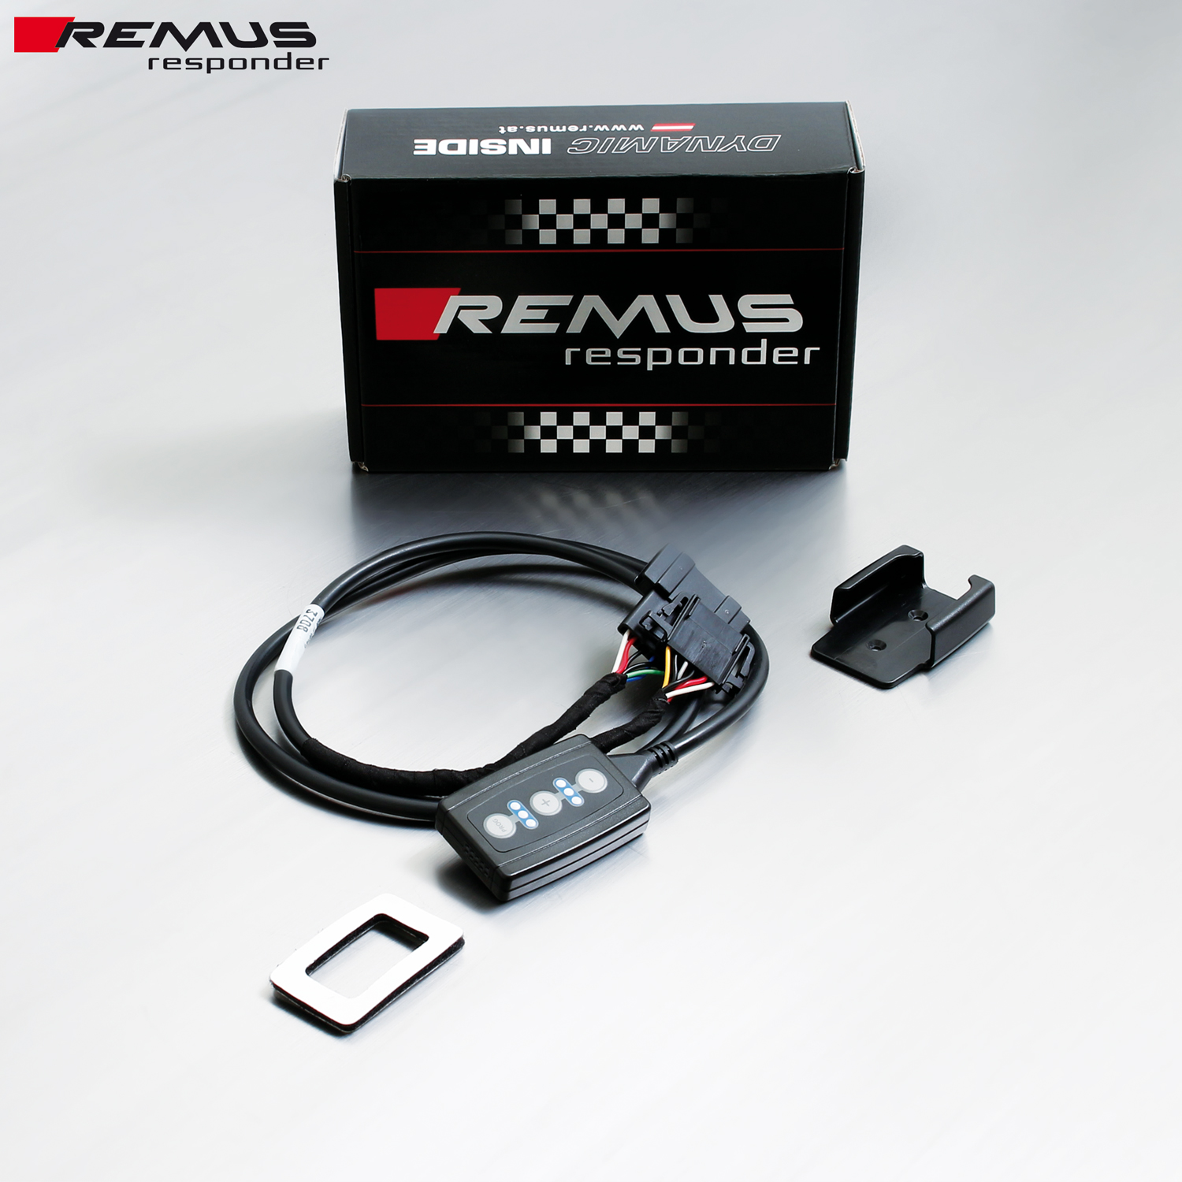

Under http://www.remus.eu/powerizer/ and http://www.remus.eu/remusresponder you will find the entire product range, prices and installation instructions.

REMUS RESPONDER:
Improved throttle response, more dynamic!
The REMUS Responder improves throttle response by means of modifying the accelerator pedal output signal. No more throttle delay and reduced lag during automatic shifting makes driving with the REMUS Responder more fun. The Responder attaches between the OEM pedal sensor and the OEM connector, ready to use in seconds due to plug & play technology. Sophisticated adjustable programming profiles can lead to improved fuel consumption and more efficiency. The 4 individual user selectable and adjustable performance settings allow drivers to select according to their own preferences.
The REMUS Responder totally eliminates the delay in modern electronic accelerator pedals!

