REMUS Product information 01-2016

REMUS tail pipe 70SG

Dear REMUS-Partner,

We are pleased to inform you that we have completed our next development:
New tail pipes for REMUS “New Wolf” sport exhausts
#70SG: tail pipe Ø 102 mm angled, straight cut, chromed,
with adjustable spherical clamp connection

It would be a pleasure for us to receive your order.

Stay tuned!
Your REMUS Team

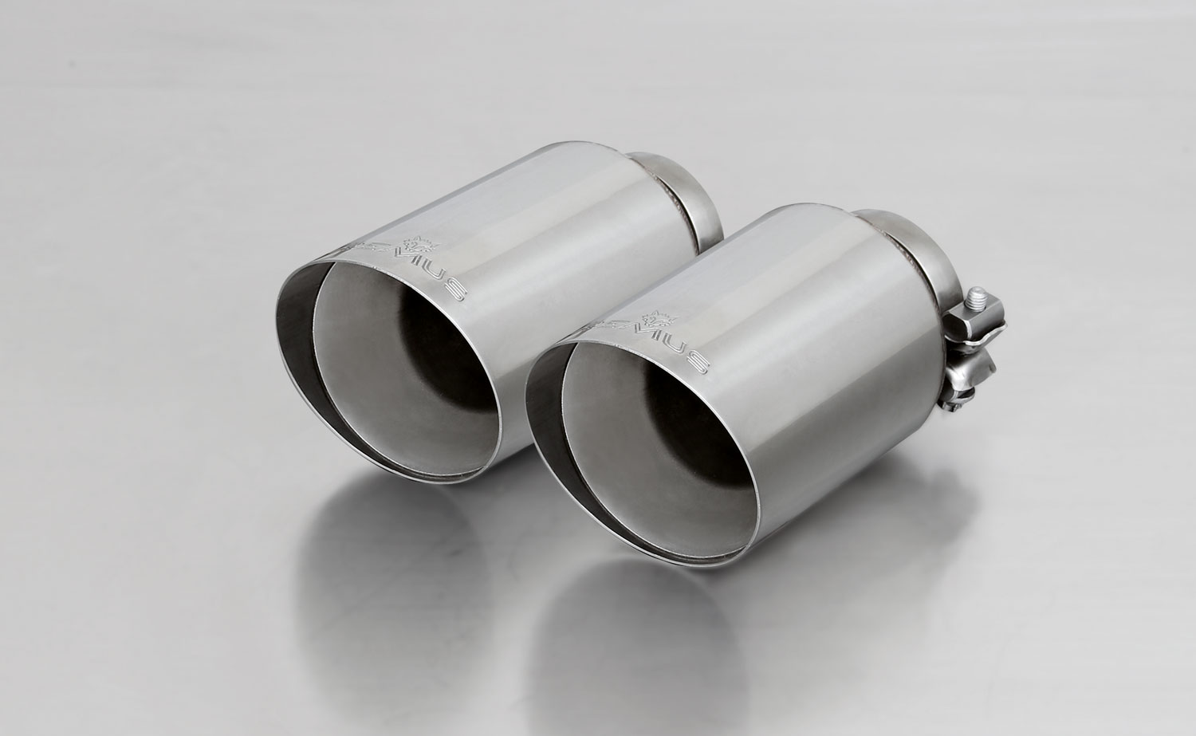

#70SG: tail pipe Ø 102 mm angled,
Straight cut, chromed

Part no. | Description | € RRP price excl. VAT
0006 70SG | 1 tail pipe Ø 102 mm angled, straight cut, chromed, with adjustable spherical clamp connection | 70,--
Application range:
ALFA: 025105 0500
MINI: 754514 0500, 754014 0500
UNIVERSAL: 001115 0500
0026 70SG | Tail pipe set consisting of 2 tail pipes Ø 102 mm angled, straight cut, chromed, with adjustable spherical clamp connection | 140,--
Application range:
ABARTH: 182510 0500
AUDI: 045014 1500
BMW: 089204 0500LR
FORD: 206515 0500LR, 206815 0500LR
LAND ROVER: 709013 0500LR
MAZDA: 454015 1500
MINI: 755514 097, 755014 097, 756515 397, 756015 397, 754011 0500
VW: 956008 0500
0046 70SG | Tail pipe set consisting of 4 tail pipes Ø 102 mm angled, straight cut, chromed, with adjustable spherical clamp connection | 280,--
Application range:
BMW: 089014 0500
MASERATI: 428014 0500LR
VW: 956014 0500

